Grass to Garden in Franklin County Food Desert
IMPACT Statement by Veronica Bullock
According to the Distressed Communities Index, Laurel scores a 76.8 in the At-Risk category and is an underserved part of Franklin County. Laurel is considered a food desert with limited access to fresh, healthy, affordable food with 18.0% of the population falling below the poverty line. Currently, Laurel does not have a food pantry and residents must travel to Brookville for distribution. According to the Franklin County data Snapshot in 2019, 9.2% of the total Franklin County population is in poverty and 13.2% of minors under the age of 18 are in poverty.
The Grass to Garden Signature Program provides interdisciplinary education aimed at strengthening agricultural and community development efforts, resulting in healthier communities with improved access to local food. Due to requests for community-based gardens in Franklin County, I offered 4 sessions of the Grass to Garden series: Session 1: Pre-Garden Planning, Session 2: Garden Policies and Community Engagement Plan, Session 3: Site Selection and Preparation, Session 4: Growing and Harvesting Guide. We held all 3-hour session at the Brookville Public Library for a total of 12-hours of instruction. Each session included an overview of session objectives, group activities, instruction, and a debrief and review. Participants were also assigned homework assignment to do outside of class including creating a draft agenda for a meeting, researching garden costs, creating budget, and drawing a garden layout.
We had 17 participants for the Grass to Garden program representing four different communities within Franklin County, Laurel, Metamora, Whitcomb, and Brookville. Community leaders and residents in attendance included the Franklin County Community Foundation Director, Franklin County Public Libraries Director, Franklin County Public Libraries Adult Services Librarian, Brookville Garden Club President, Whitcomb Boosters 4-H Club Leader, Sam's Jams Farms Director and Manager, Head Start Family Service Workers for Laurel and Brookville, Franklin County Purdue Extension Homemakers President and Treasurer, Purdue Extension Community Wellness Coordinator, a local beekeeper, and garden enthusiasts from Laurel, Brookville, and Metamora. 15 participants self-reported demographics. We had 3 males and 12 females with 100% white and 100% non-Hispanic.
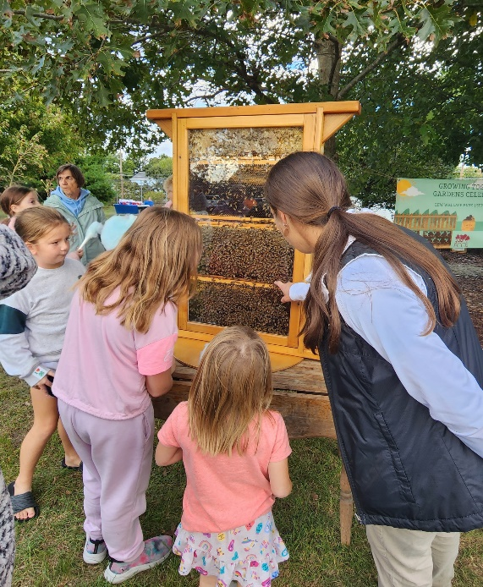
We collected pre- and post-course evaluations to measure knowledge gain and increased confidence. 100% of participants reported gaining more confidence after completing Grass to Garden with identifying community resources, creating garden goals, vision, and outcomes, connecting with stakeholders, identifying leadership roles, identifying a community garden site, preparing a garden site, and growing, harvesting, handling, and maintaining garden produce. We started two new community-based gardens in Franklin County this year after completing Grass to Garden with community partners and volunteers. We applied for and received a $1,500 Growing Together mini-grant through the Purdue Extension Nutrition Education and Master Gardener Program. One of the new community-based gardens is located in Laurel at Laurel Public Library and the other in Brookville at the Lew Wallace Park located at the Franklin County Government Center. I helped oversee the maintenance of 4 raised beds in Laurel with tomatoes, peppers, squash, strawberries, and cilantro; lead efforts to water and maintain the 7 straw bales planted with tomatoes, squash, and pumpkins; 2 raised beds planted with strawberries and herbs in Brookville; and provided technical assistance and education at both garden sites.
The excitement and energy around the new community-based garden in Laurel inspired a new group of community advocates to form Growing Laurel. This is a new organization focused on increasing community pride and cleanliness in Laurel. To date, we have harvested over 150lbs of fresh produce that has been distributed in Laurel at the Laurel Public Library and at Red Life Food Pantry in Brookville. Additionally, the new community connections made in Laurel are providing an opportunity for Gleaners to set up a brick and mortar food pantry in Laurel at the Laurel Community Center.
Community partners involved in developing the new community-based gardens include the Purdue Extension Franklin County, Franklin County Public Libraries, Franklin County Community Foundation, Purdue Extension Nutrition Education Program, Growing Laurel, Brookville Garden Club, Whitcomb Boosters 4-H Club, Franklin County Extension Homemakers, and other community volunteers. We celebrated the first season of both gardens with our community partners and invited the whole community to the celebrations. The Laurel Harvest Celebration was September 8th with around 200 participants and the Growing Together Gardens Celebration was September 27th in Brookville with around 190 participants. We plan to continue expanding the gardens by establishing relationships with new partners and volunteers to provide access to fresh produce and educational opportunities. We partnered with the Franklin County Community Foundation to apply for a Duke Energy Nature Grant to expand the gardens. We received $10,000 from Duke Energy and the FCCF is matching an additional $10,000. In addition, the new community-based gardens are leading to more community involvement. New 4-H club leaders are restarting the Laurel Willing Workers 4-H Club and we have more involvement with Extension. We are excited to see the continued positive ripple effect of the community-based gardens in Franklin County.
