Cass County 4-H FairEntry works in cooperation with 4-H Online, so you will use the same username and password as 4-H Online. Families will use FairEntry to pre-enter projects for the fair. This program will be used to create project labels, check in sheets, judging sheets, show programs, media reports, ribbon placings, award placings and more.

Please enter projects for the Cass County fair by June 7th, 2024. For projects by grade level you will use the grade you were enrolled in as of January 1. The 4-H projects will be listed under a specific Department. The following is a guide to help you find projects in FairEntry.

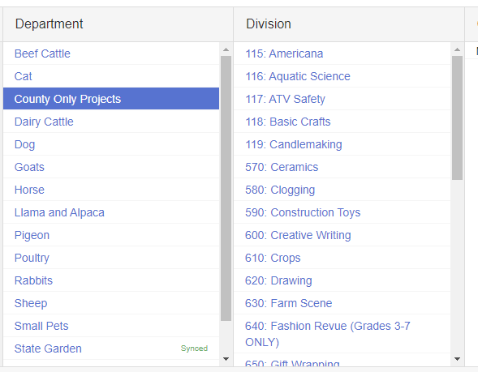

Department: County Only Projects
- Collections
- Crops
- Toy Farm Scene/ Dollhouse
- Gift Wrapping
- Junior Leaders
- Horse Poster
- Mini 4-H
- Kinder Clover
- Recycling
- Sports
- Weeds
- Microwave
- Pocket Pets
- Lego Crafts

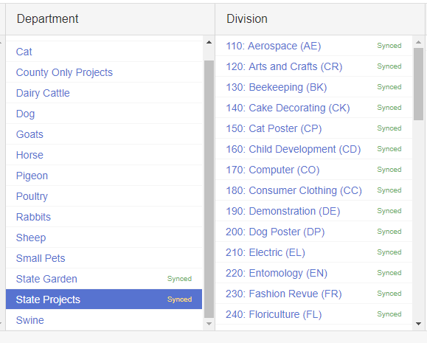

Department: State Projects
- Aerospace
- ATV Safety Education
- Beekeeping
- Cake Decorating
- Cat Poster or Display
- Child Development
- Computer (Includes Robotics)
- Consumer Clothing
- Creative Writing
- Demonstration
- Dog Poster or Display
- Electric
- Entomology
- Fashion Revue (Grades 8-12)
- Floriculture
- Foods, Baked
- Foods, Preserved
- Forestry

- Genealogy
- Geology
- Health
- Home Environment
- Informative 4-H Presentation
- Lawn and Garden Tractor Operator Skills
- Lawn and Garden Tractor Safety Education
- Llama-Alpaca Crafts
- Llama-Alpaca Poster or Display
- Photography
- Poultry Poster or Display
- Professional Persuasive Presentation
- Public Speaking
- Rabbit Ambassador
- Rabbit Poster or Display
- Sewing Construction, Non-wearable
- Sewing Construction, Wearable
- Shooting Sports Education
- Small Engines
- Soil and Water Science
- Sport Fishing
- Tractor Operator Skills
- Tractor Safety Education
- Veterinary Science
- Weather and Climate Science
- Wildlife
- Woodworking
- Zero-Turn Radius Mower Operator Skills
- Zero-Turn Radius Mower Safety Education

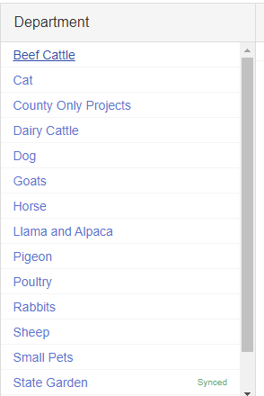

Department: State Garden
- Education (Poster)
- Garden Collection
- Herb
- Potato Tray
- Single Vegetable
- Tomato

Other Departments:
Beef Cattle – All classes includes Mini 4-H Showmanship
Cat – All classes
Dairy Cattle – All classes includes Mini 4-H Showmanship
Dog – All Classes
Goats – All Classes includes Mini 4-H showmanship
Horses – All Classes includes Pre 4-H showmanship
Llama and Alpaca – Exhibition
Pigeon – All Classes
Poultry – All Classes
Rabbits – All Classes includes Mini 4-H showmanship
Sheep – All Classes includes Mini 4-H showmanship
Small Pets – All Classes
Swine – All Classes includes Mini 4-H showmanship

