Mini 4-H

Cass County

Mini 4-H Robotic Project

Created 12/2018

Materials adopted from Wabash County

Revised 01/2023
Revised 01/2024

Mini 4-H Robotics

Working with robotics can be fun.
It lets you use your hands to create something useful, or something for pleasure.
It gives you a good feeling to know that something you have made is useful.

Mini 4-H lets you learn some robotics skills as you put together a project from a kit.

Requirements
- Do the activities in the manual for the grade you are in.
  - First Grade: “Robot Friends”, “Connect the Dots” and “Build a Robot”
  - Second Grade: “Eco-Friendly Robot”, “All-About-Me Robot” and “Construct a Robot”
- Obtain/Purchase a kit that is available at the Extension Office. A different one is available each year in this project.
  - Read and follow instructions carefully.
- Exhibit one item at the 4-H Fair.
- Leave a 5"x 6" space in the lower right-hand corner for the exhibit card the Purdue Extension staff will provide at Fair check-in.
- Your exhibit must be turned in at the Community Center on the Saturday designated in the 4-H Handbook from 7:30 - 9 a.m.

Exhibit Options:
In this project, you should obtain/purchase a grade-specific kit from the Extension Office. With the help of an adult, assemble the kit. Kits are available at the Extension Office on the 3rd floor of the Court House.
- First Grade: Tin Can Robot and record sheet
- Second Grade: Solar Robot and record sheet
- If choosing not to obtain a kit, exhibit one of your activity pages from your manual and your record sheet.

We hope you enjoy working with your Mini 4-H robotics project this year.
Keep up your enthusiasm and when you’re in the 3rd grade you can join in more fun by becoming a member of 4-H and enrolling in other projects.

If you have any questions or problems with your Mini 4-H project call or stop in the Extension Office (8-4 M-F). We are located on the 3rd floor of the courthouse.
Our phone number is 574-753-7750.
The 4-H pledge
A pledge is a promise to yourself and the people around you.

I pledge my head to clearer thinking
My heart to greater loyalty
My hands to larger service
My health to better living

For My Club, My Community, My Country, and My World

The 4-H motto is “to make the best better.”

When making your Robotics project you will use a kit. Ask a grown-up to help you and always use safety habits.

Kits

You can buy your robotics kit at the Extension Office. We are located on the 3rd floor of the Court House. There will be a kit for each grade shown below.
- Read the instructions with the kit so you know how to put it together properly.
- Bring your finished project to the 4-H Fair with your record sheet.

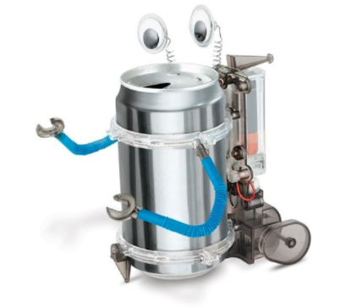

First Grade:
Tin Can Robot

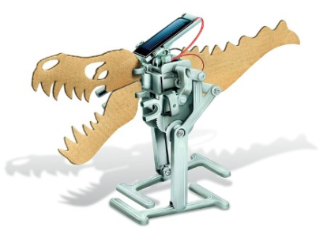
Second Grade:
Solar Robot

First Grade Activity: Robot Friends

Use red, yellow, blue, and purple crayons or colored pencils to complete the picture. Show a family member your masterpiece!
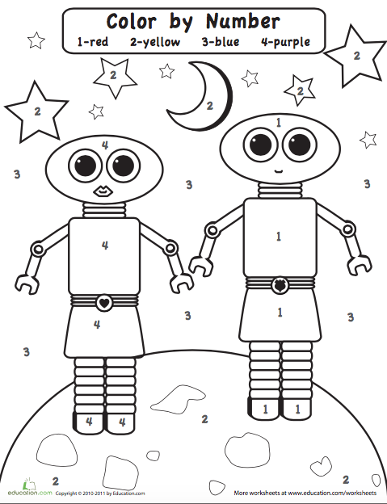
First Grade Activity: Connect the dots

Connect the dots to complete the picture!
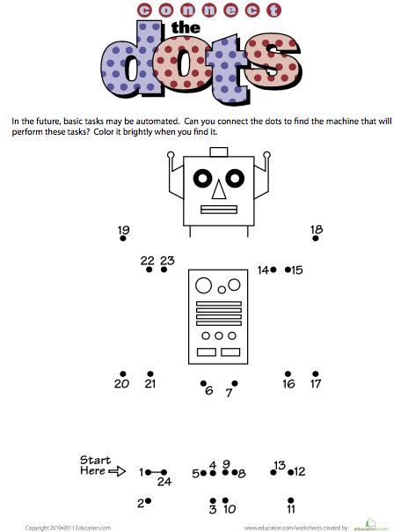
First Grade Activity: Build a Robot

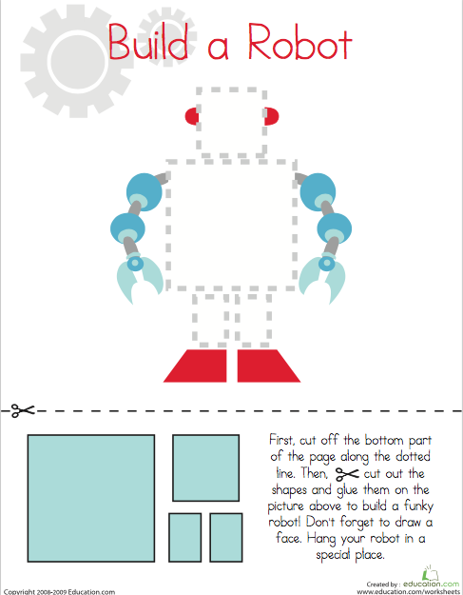
Cut, draw, and glue to build your robot!

Second Grade Activity: Eco friendly Robot

Use crayons, colored pencils, markers, or any other art supplies to color your robot. Then write a story about your robot. Show a family member your finished picture!
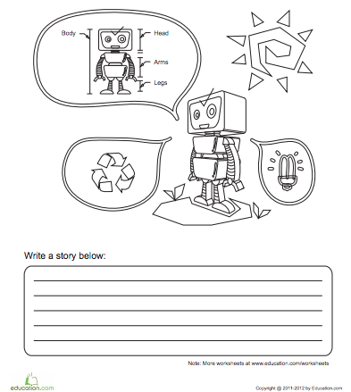

Second Grade Activity: All-About-Me Robot

Use colored pencils, crayons, markers, or any other art supplied to decorate your robot. Fill out the information about yourself.
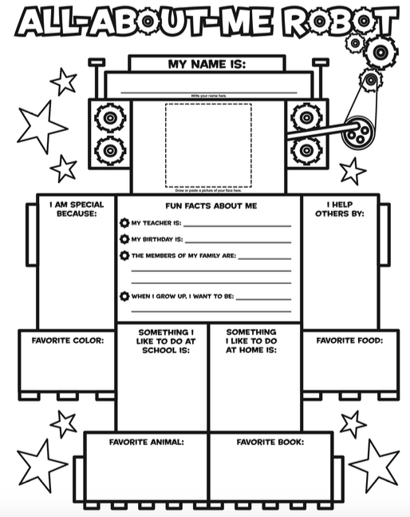

Second Grade Activity: Construct a Robot

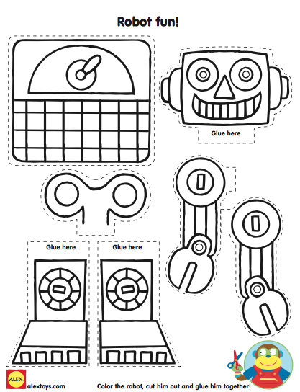
First color the robot, then cut him out, and glue him together!

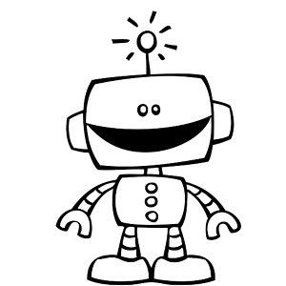

MINI 4-H ROBOTICS RECORD SHEET
EXHIBIT YOUR PROJECT OR ONE OF THE ACTIVITY PAGES. FILL OUT THIS MINI 4-H ROBOTICS RECORD SHEET AND BRING WITH YOUR EXHIBIT TO THE 4-H FAIR. ATTACH YOUR GREEN MINI 4-H EXHIBIT LABEL TO THE BOTTOM RIGHT-HAND CORNER OF YOUR PAGE OR PROJECT.
NAME _________________________________ GRADE IN SCHOOL ______
YEAR IN MINI 4-H ROBOTICS PROJECT (circle) 1st or 2nd
CLUB ATTENDED _______________________________________________
WHAT DID YOU LEARN MOST FROM YOUR MINI 4-H ROBOTICS PROJECT?
_______________________________________________________________________________________________________________________________________________________________________________________
WHO HELPED YOU WITH THIS PROJECT? ___________________________
_____________________________________________________________
DID YOU HAVE ANY PROBLEMS WITH YOUR MINI 4-H ROBOTICS ACTIVITY(S)?
____________________________________________________________________________________________________________________________________________________________________________________________________________________________________________________
WHAT WAS THE MOST FUN PART OF DOING THIS PROJECT?
________________________________________________________________________________________________________________________________________________________________________________________________________________________________

MINI 4-H ROBOTICS RECORD SHEET
EXHIBIT YOUR PROJECT OR ONE OF YOUR ACTIVITY PAGES. FILL OUT THIS MINI 4-H ROBOTICS RECORD SHEET AND BRING WITH YOUR EXHIBIT TO THE 4-H FAIR. ATTACH YOUR GREEN MINI 4-H EXHIBIT LABEL TO THE BOTTOM RIGHT-HAND CORNER OF YOUR PAGE OR PROJECT.
NAME _________________________________ GRADE IN SCHOOL ______
YEAR IN MINI 4-H ROBOTICS PROJECT (circle) 1st or 2nd
CLUB ATTENDED _______________________________________________
WHAT DID YOU LEARN MOST FROM YOUR MINI 4-H ROBOTICS PROJECT?
_______________________________________________________________________________________________________________________________________________________________________________________
WHO HELPED YOU WITH THIS PROJECT? ___________________________
_____________________________________________________________
DID YOU HAVE ANY PROBLEMS WITH YOUR MINI 4-H ROBOTICS ACTIVITY(S)?
____________________________________________________________________________________________________________________________________________________________________________________________________________________________________________________
WHAT WAS THE MOST FUN PART OF DOING THIS PROJECT?
________________________________________________________________________________________________________________________________________________________________________________________________________________________________

