**CASS COUNTY**

**RABBIT**

**MINI 4-H**

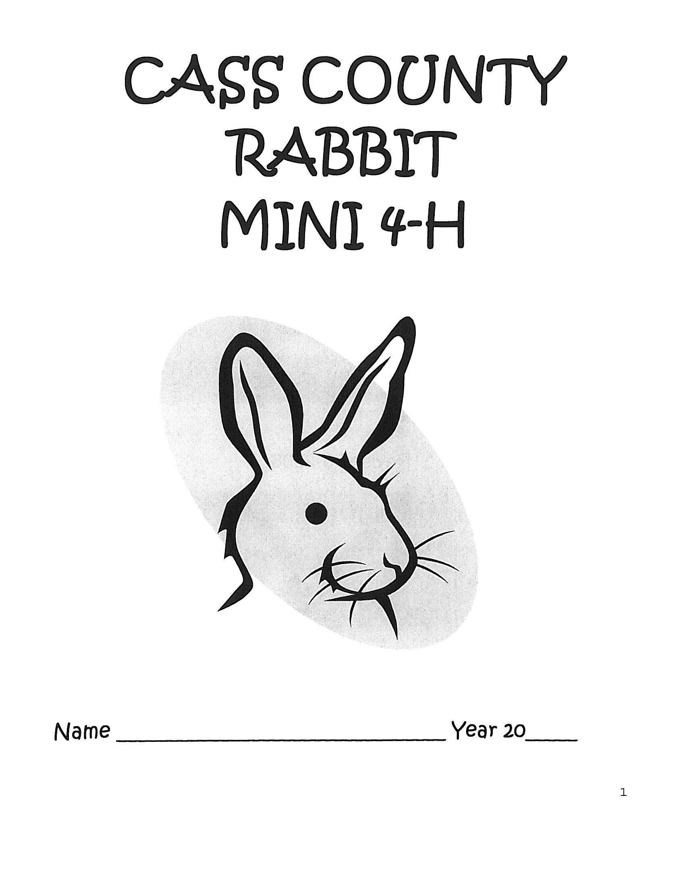

Name ______________________________ Year 20_______

Club ______________________________________________

*It is the policy of the Purdue University Cooperative Extension Service that all persons have equal opportunity and access to its educational programs, services, activities, and facilities without regard to race, religion, color, sex, age, national origin or ancestry, marital status, parental status, sexual orientation, disability or status as a veteran. Purdue University is an Affirmative Action institution. This material may be available in alternative formats.*

Revised 1-2023

01-2024

MINI 4-H RABBIT

GENERAL MINI 4-H RULES:

1. You must be in the 1st or 2nd grade at the time you sign up for this project.
2. You must enroll in the Mini 4-H Rabbit project.
3. Complete the Mini 4-H Rabbit enrollment form by May 15TH. (This will be sent to each member who enrolls in Mini 4-H Rabbit in April.)
4. As you exhibit your Mini 4-H Rabbit project, you will receive a Mini 4-H ribbon.
5. You are encouraged to attend 4-H Rabbit Club meetings and project workshops.

ACTIVITIES TO COMPLETE:

1. When talking to a 4-H’er enrolled in the 4-H Rabbit project, find out what is involved in caring for and showing rabbits.
2. Watch the 4-H Rabbit show at the fair this year.

COMPLETION GUIDELINES:

To complete your Mini 4-H Rabbit Project you must:

1. Complete the attached record sheet and check it in with the 4-H Rabbit Committee when the rabbits are checked in at the 4-H Fair.
2. Exhibit your rabbit in a special Mini 4-H class at the Cass County

4-H fair. (Optional)

1. If you decide to make a poster (14” X 22”) in addition to or instead of showing an animal, it will be entered in the Mini 4-H Farm Animal project in the Community Center. This poster will need to be turned in on the Saturday designated in the 4-H Handbook from 7:30-9 a.m.

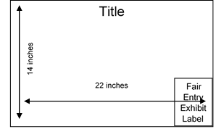MINI PROJECTS INVOLVING POSTERS - **14"X 22"** POSTERS SHOULD BE DISPLAYED HORIZONTALLY. IT IS A GOOD IDEA TO MOUNT YOUR POSTER ON PLYWOOD, FOAMBOARD, CARDBOARD, OR OTHER STURDY MATERIALS TO STIFFEN IT. POSTERS SHOULD ALSO BE COVERED WITH CLEAR PLASTIC TO PROTECT THEM. APROPRIDE-SIZED SLEEVES ARE AVAILABLE FROM THE EXTENSION OFFICE. **LEAVE A 5” X 6” SPACE IN THE LOWER RIGHT-HAND CORNER FOR THE EXHIBIT CARD THE PURDUE EXTENSION STAFF WILL PROVIDE AT FAIR CHECK-IN.**

[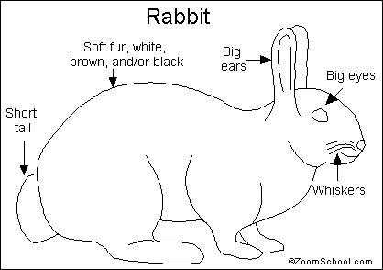](http://www.enchantedlearning.com/themes/rabbit.shtml)

Rabbits are fast-moving, big-eared [mammals](http://www.enchantedlearning.com/subjects/mammals/). There are about 25 different species of rabbits. They live in a variety of environments, including deserts, swamps, marshes, forests, grasslands, and prairies. Rabbits are found on every continent except Antarctica.

Most rabbits live for about a year in the wild. They are hunted by [dogs](http://www.enchantedlearning.com/subjects/mammals/dog/Wildcoloring.shtml), [foxes](http://www.enchantedlearning.com/subjects/mammals/fox/Foxprintout.shtml), [raccoons](http://www.enchantedlearning.com/subjects/mammals/raccoon/Raccoonprintout.shtml), [weasels](http://www.enchantedlearning.com/subjects/mammals/weasel/Weaselprintout.shtml), [bobcats](http://www.enchantedlearning.com/subjects/mammals/cats/bobcat/Bobcatprintout.shtml), [lynxes](http://www.enchantedlearning.com/subjects/mammals/cats/lynx/Lynxprintout.shtml), [hawks](http://www.enchantedlearning.com/subjects/birds/printouts/Redtailedhawkprintout.shtml), and [eagles](http://www.enchantedlearning.com/subjects/birds/printouts/Eaglecoloring.shtml). They have a fast reproductive rate.

**Anatomy**: Rabbits range in size from 1 to 2 feet (30 to 60 cm) long. They have very big and powerful hind legs which they use for hopping and for digging burrows.

**Diet**: Rabbits are **herbivores** (plant-eaters). They eat grass, leaves, bark, and twigs.

**Classification**: Kingdom Animalia (animals), Phylum Chordata (having a notochord), Class Mammalia ([mammals](http://www.enchantedlearning.com/subjects/mammals/)), [order Lagomorpha](http://www.enchantedlearning.com/subjects/mammals/lagomorphs/) (rabbits, hares, and pikas), Family Leporidae (rabbits and hares), many Genera.

RABBIT WORD SEARCH PUZZLE

F M S M H Z G W T R S X

E A B R O C H C B U H M

W J S V A I V F O F O H

U I O T S E W W K T R A

S P H K M D G H R F T R

I X E S Y O I I V O T E

H R U F X S V G B S A S

S L A M M A M I G X I X

T T I H B Q L U N I L G

H O P P I N G N X G N J

U D N M B T O X F F O G

H E R B I V O R E S C K

BIGEARS

DIGGING

FASTMOVING

HARES

HERBIVORES

HOPPING

MAMMALS

SHORTTAIL

SOFTFUR

WHISKERS

[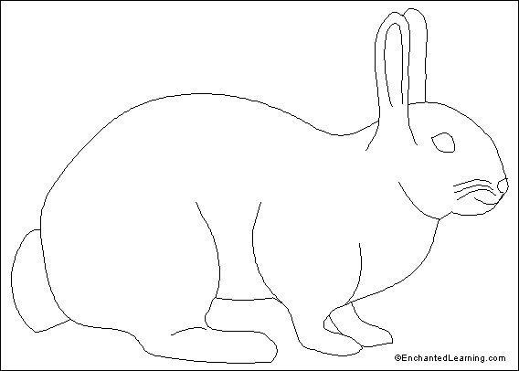](http://www.enchantedlearning.com/themes/rabbit.shtml)LABEL THIS RABBIT

Use these words to label this rabbit.

short tail

fur

long ears

big eyes

whiskers

Find the rabbit.

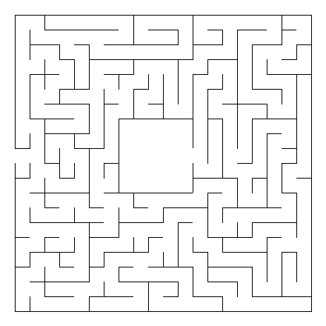

C:\Users\bhinkle\AppData\Local\Microsoft\Windows\Temporary Internet Files\Content.IE5\2A9Z0W3K\MC900250168[1].wmf

Start Here

See if you can solve the puzzle below.

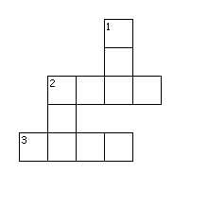

Across

2. I hear with these.

3. I hop with these.

Down

1. This is my coat.

2. I see with these.

MINI 4-H RABBIT RECORD SHEET

NAME_________________________________ GRADE_______________

ADDRESS___________________________________________________

4-H CLUB___________________________________________________

YEAR IN MINI 4-H (circle) 1st or 2nd

4-H MEMBER YOU WORKED WITH ______________________________

YOUR RABBIT'S NAME________________________________________

YOUR RABBIT'S AGE _________________________________________

WHAT DO YOU FEED YOUR RABBIT?____________________________

____________________________________________________________

WHAT DO YOU LIKE MOST ABOUT YOUR RABBIT?________________

____________________________________________________________

____________________________________________________________

DRAW A PICTURE OR ATTACH A PHOTO OF YOU AND YOUR RABBIT

BELOW:

MINI 4-H RABBIT RECORD SHEET

NAME_________________________________ GRADE_______________

ADDRESS___________________________________________________

4-H CLUB___________________________________________________

YEAR IN MINI 4-H (circle) 1st or 2nd

4-H MEMBER YOU WORKED WITH ______________________________

YOUR RABBIT'S NAME________________________________________

YOUR RABBIT'S AGE _________________________________________

WHAT DO YOU FEED YOUR RABBIT?____________________________

____________________________________________________________

WHAT DO YOU LIKE MOST ABOUT YOUR RABBIT?________________

____________________________________________________________

____________________________________________________________

DRAW A PICTURE OR ATTACH A PHOTO OF YOU AND YOUR RABBIT

BELOW: