Cass County

Kinder Clover 4-H Animals

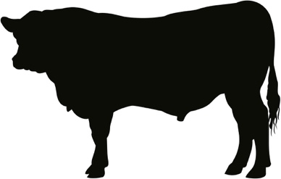
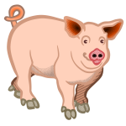
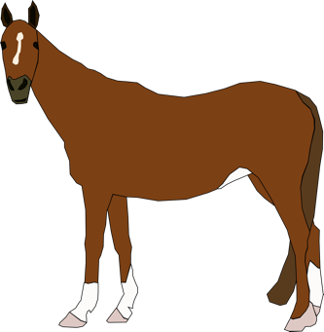
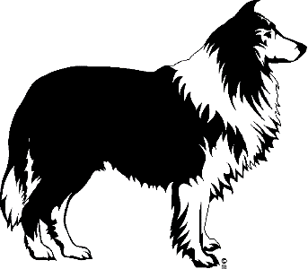
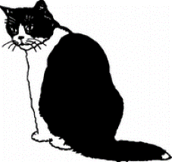
Adopted Kinder Clovers
Animals Project
February 2022
Updated January 2024

Materials and Design by Kendra Personett, 4-H Council Member
It is the policy of the Purdue University Cooperative Extension Service that all persons have equal opportunity and access to its educational programs, services, activities, and facilities without regard to race, religion, color, sex, age, national origin or ancestry, marital status, parental status, sexual orientation, disability or status as a veteran. Purdue University is an Affirmative Action institution. This material may be available in alternative formats.

Kinder Clover 4-H Helper’s Page

Welcome to the Cass County Kinder Clover 4-H program! Kinder Clover 4-H is designed for youth to explore a variety of project activity areas and to interact with caring adults and other children.

Children receive this project activity manual when enrolling in Kinder Clover 4-H – Animal Project. This manual and the manuals on various other topics will provide fun age-appropriate learning activities.

As a Kinder Clover 4-H adult helper, your job will be to guide and encourage your child through the activities. A wide range of activities are provided to allow you to choose the ones most appropriate for the children you are working with. It is highly suggested that you do not complete the activities for them. Instead, help them, guide them, work with them, and let them do all that they possibly can. 4-H believes in allowing children to learn by doing. The Kinder Clover 4-H project activities are hands-on learning opportunities designed to provide a meaningful educational experience for youth.

Additionally, the Kinder Clover 4-H program is set up to allow children to display a project activity that is based upon information within this manual. Most children will choose to exhibit their project at the 4-H fair. The 4-H fair is an exciting week that allows community youth to showcase their enthusiasm for learning.

Please help your child bring their Kinder Clover 4-H project to the fairgrounds during the designated Kinder Clover 4-H judging time. Each exhibit will need a Kinder Clover 4-H exhibit tag and their Kinder Clover 4-H Project Record Sheet. Kinder Clover 4-H exhibits are non-competitive meaning they all receive a special Kinder Clover 4-H ribbon. Once the fair is over, be sure to pick up the project during the 4-H Project Release.

Kinder Clover 4-H is fun! Children will certainly enjoy it. You can have fun too, by guiding and helping youth participate in the program. Encourage and praise your child as they have fun learning and sharing with you. If you have any questions regarding Kinder Clover 4-H or other 4-H programs, please feel free to contact Purdue Extension Cass County at 574-753-7750.

Kinder Clover 4-H Program Guidelines

The Kinder Clover 4-H program is designed to supplement and introduce kindergarteners to the Cass County 4-H program.

RULES
- Kinder Clover 4-H is open to any boy or girl who is enrolled in kindergarten on January 1st of the current 4-H year.

- Kindergarteners may enroll in one (1) to three (3) projects.

- Kinder Clover 4-H members are enrolled in a 4-H Club. Meetings are not required but encouraged to attend. The project(s) can be done at home.
- Kinder Clover 4-H projects include Animals, Crafts/Models, Bugs, Cookie Decorating, and Foods.

ALL POSTER EXHIBITS MUST:
  - Have a solid, stiff backing, which is 11” high by 14” wide. This can be 1/4” plywood, HEAVY cardboard, foam board, or Masonite.

  - Be positioned HORIZONTALLY.

  - Have a total exhibit board no larger than 11” high by 14” wide.

(Wildlife- 11”x 22”)

  - Be completely COVERED BY A CLEAR PLASTIC material, not plastic wrap. Poster sleeves are available in the Extension Office.

  - Leave a 5"x 6" space in the lower right-hand corner for the exhibit card the Purdue Extension staff will provide at Fair check-in.

Kinder Clover 4-H Animals

Welcome to Kinder Clover 4-H Animals. In this project, you will learn about animals. You do not need to have an animal to be in this project. You will be introduced to different types of animals and have some fun activities to complete (optional). Some of the animals may be large farm animals or small animals and/or pets (companion animals).
To find out more information about specific animals you may want to get a book from the library or visit a person who raises that type of animal through an internet search.

WHAT TO EXHIBIT:

- Read the Kinder Clover 4-H Animal Manual or have someone read it to you.

- Make an 11” x 14” poster, and choose one of the topics listed below.

- A picture that you have drawn of one of the animals in the book.
- 4 pictures and descriptions of animals you might care for.
- A collection of cut-out pictures of one or more types of animals listed in this manual or another animal you are interested in.

- Complete the Kinder Clover 4-H Animal record sheet and bring it with your exhibit to the 4-H fair.

- Leave a 5"x 6" space in the lower right-hand corner for the exhibit card the Purdue Extension staff will provide at Fair check-in.

Kinder Clover 4-H’ers Page

Kinder Clover 4-H’ers have lots of fun! There are many activities for you to explore. You can try new things, which you can share with your family and friends.

Here are some things to know about 4-H:

The 4-H Symbol: A four-leaf clover with an “H” on each leaf

The 4-H Colors: The 4-H colors are green and white. The four-leaf clover is green and the “H” in the leaf is white.

The 4-H Motto: “To make the best better.”
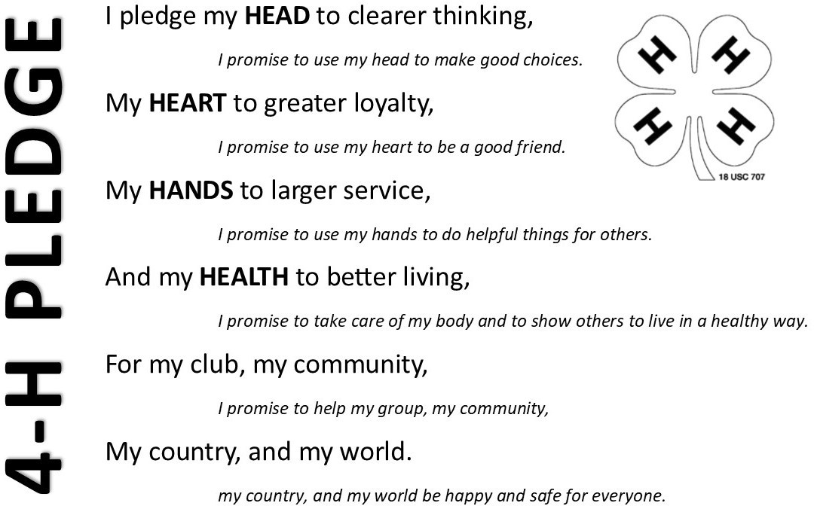

Beef Cattle

Beef cattle are raised for meat. They eat grass, hay, alfalfa, cracked corn, silage (the complete corn plant chopped into small chunks) protein supplements, and lick on salt and mineral blocks.

Beef cattle help America maintain a proper balance of our land and crops. 83% of our land is unsuitable for producing crops for human consumption, but nearly one-half of that land grows grass which feeds cattle.

Color the picture!

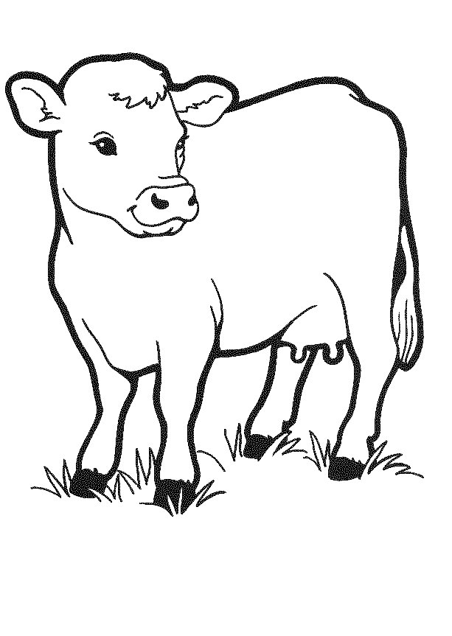

Dairy Cattle

Cows that are used to provide milk are called Dairy Cows. Dairy cows usually have one baby each year which is called a calf.

From a dairy cow’s milk, we get many foods which are the milk we drink, cheese, butter, yogurt, cottage cheese, and ice cream.

Circle are the words that are made from milk!

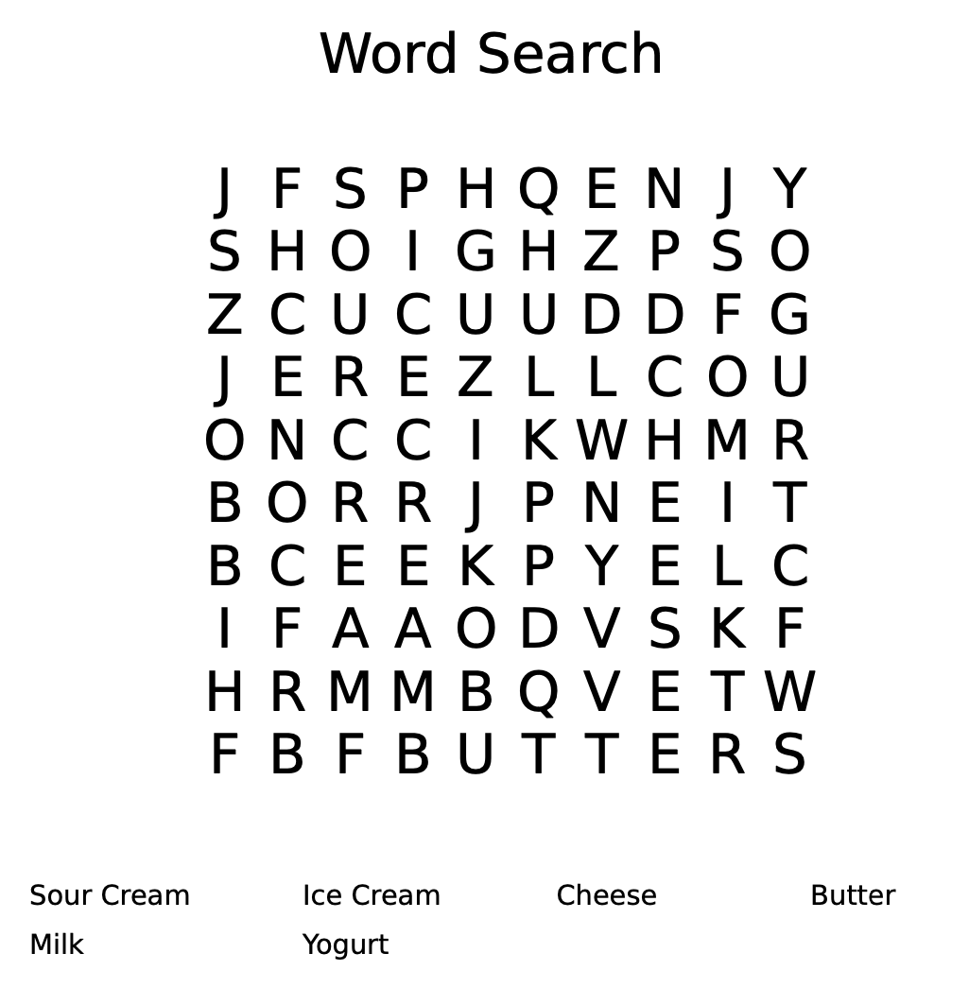

Goats

Goas can be raised for dairy, meat, or fiber. Goats do not require a lot of room, but they do like to have things to climb on, such as tree trunks, wood piles, or just a pile of dirt.
Doe goats usually have two babies, called kids, but can have from one to four at one time. They only have their young once a year and the kids are usually born in the spring.

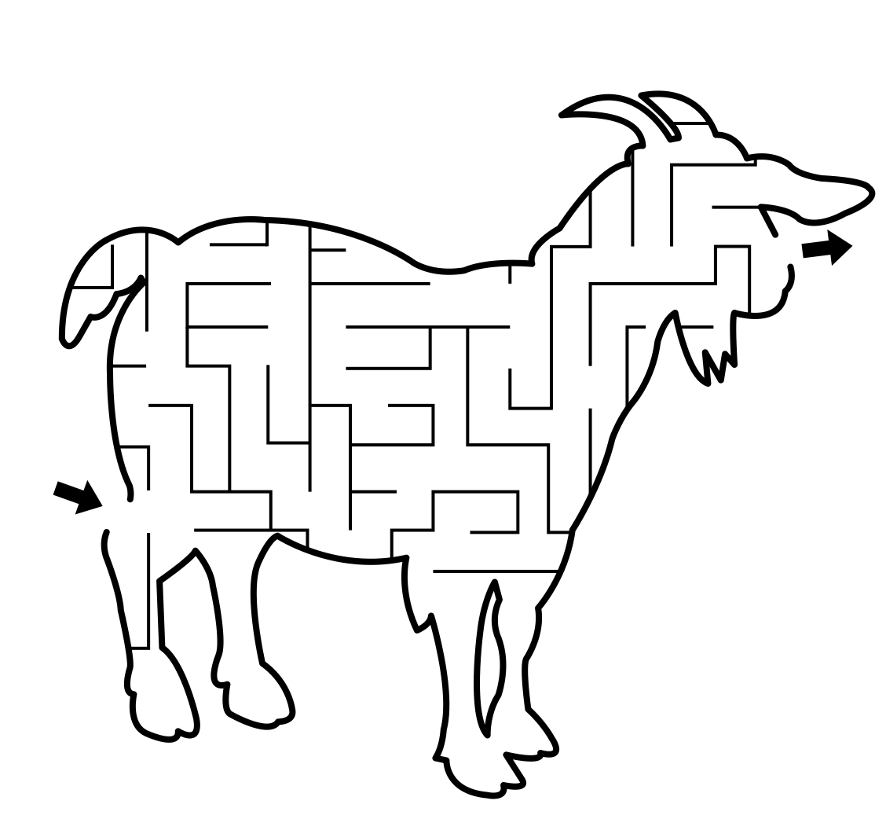

Swine

Many farmers have special buildings for farrowing, or the birth of baby pigs. These are called farrowing houses. If the female has never had babies, she is called a gilt. Male pigs are called boars and castrated males are called barrows. The sow can give birth to two or three litters of pigs each year, and each litter will average about 8 piglets.

Hog feed is usually cracked corn and supplement. When pigs are about six months old, they are ready for market and weigh about 220-250 pounds.

Trace the lines from the pig to the ear of corn!
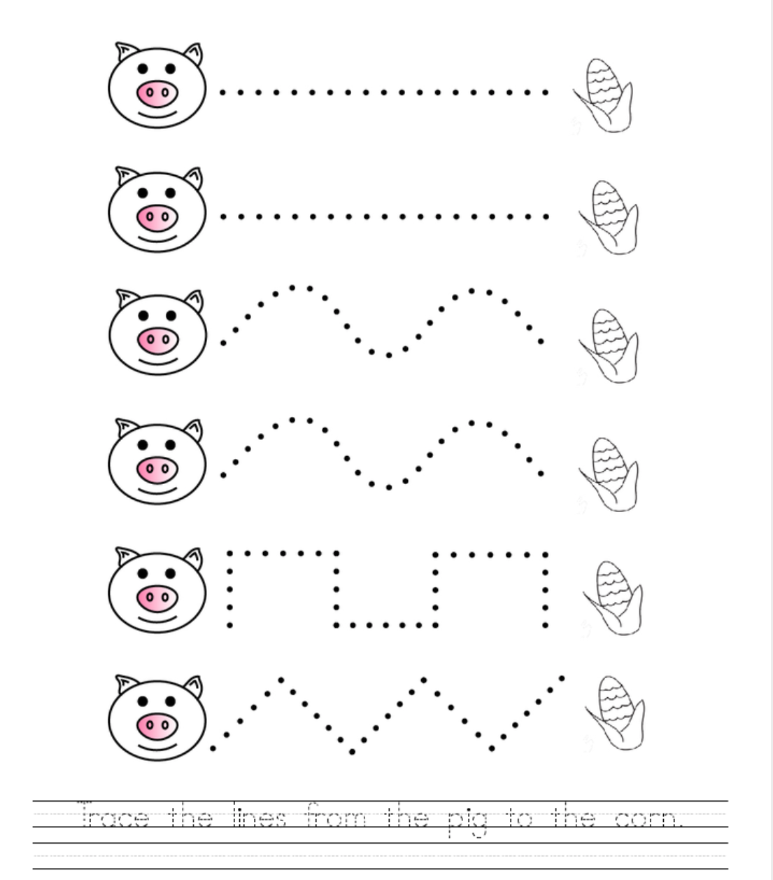

Sheep

Sheep provide food and clothing. Sheep are raised in all parts of the world, but Australia is the largest producer. Sheep vary greatly in size with ewes weighing from 100-200 pounds and the ram weighing up to 300 pounds.

Sheep can live about 13 years. They begin breeding at two years of age and have their young in the spring. They usually have two lambs. Sheep are sheared in the spring.

PomPom Sheep Craft

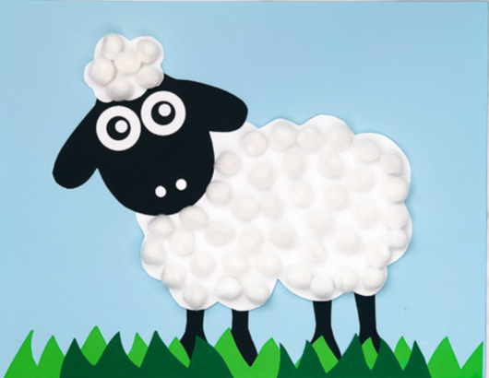
Materials
- Colored card stock (in sky blue, black, and green)
- White card stock
- Liquid glue (this one works best for gluing pom poms to paper)
- White pom poms
- Sheep template
- Standard Hole Punch
- Scissors

- Cut out the pieces.
- Glue the sheep's eyes and nostrils onto the face, like in the pictures.
- Glue the sheep's head onto the body and the black legs to the back of the body.
- Glue the sheep's head fluff to the top of the blackhead.
- Take the entire sheep and glue it to the light blue piece of paper.
- Cut out strips of grass and glue along the bottom of the paper. If you don't want to cut out grass you can also draw it on with markers.
- Use the liquid glue to make small circles of glue, then add a white pom-pom to each circle. Do this for the head fluff and the entire body.
- Let dry completely.

Left Blank For Pom-Pom Sheep Craft

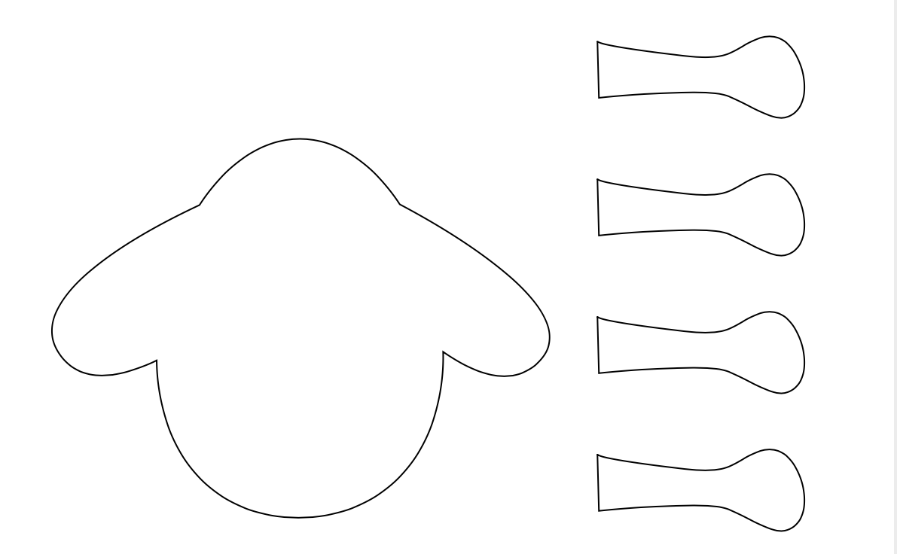

Left Blank For Pom-Pom Sheep Craft

Horse

A baby horse is called a foal. Horses can sleep standing up or lying down. Horses mostly eat hay and grasses. Horses can eat treats like apples or carrots.

Color the horse!

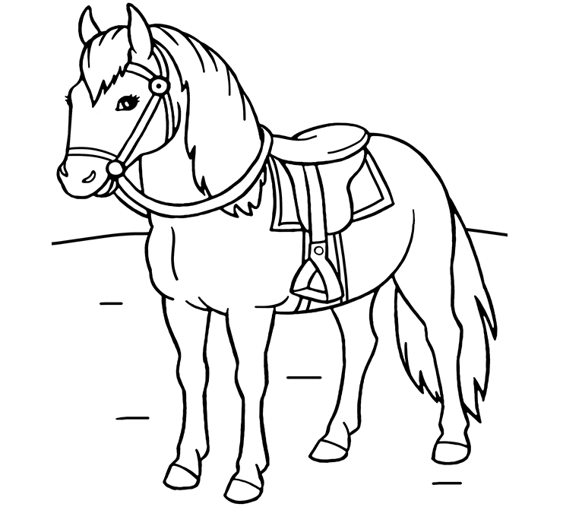

Rabbits

Rabbits are clean, gentle, easy to care for, and lovable. For a pet, you should buy a rabbit at the pet store or from a breeder. Young rabbits should be picked up with one hand under the chest and the other supporting the rump.

Feed your rabbit grains like bran or oats and stale bread. Rabbits are more active at night which means you should feed your pet more food in the evening. This meal should include vegetables and greens like romaine lettuce, dandelion leaves, spinach, cabbage leaves and carrots. Rabbit pellets are an easy way to give rabbits a balanced diet. Whether you feed your pet pellets or other grains and greens, always keep some fresh clover or alfalfa hay in its cage for rabbits to munch on.

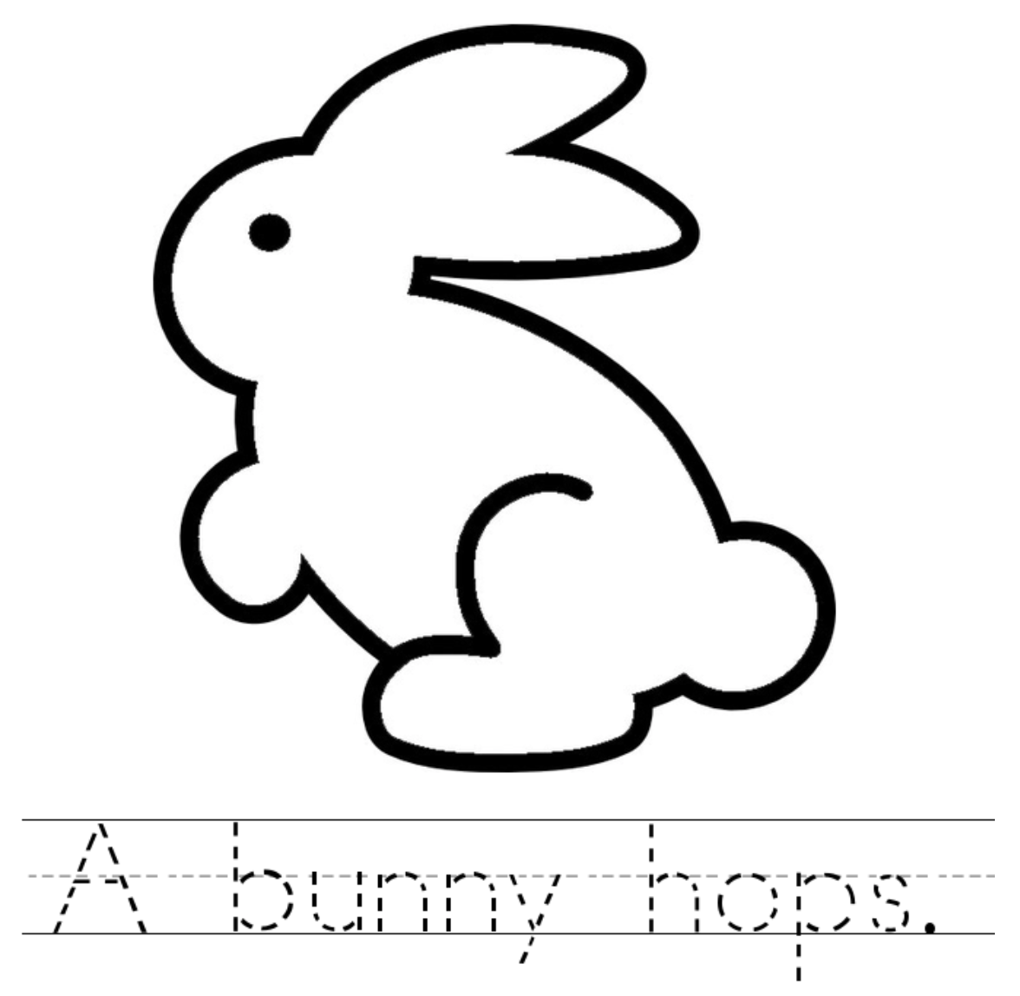
Color the rabbit after tracing the sentence!

Poultry

Poultry includes chickens, ducks, geese, and turkeys. Poultry provides meat and eggs. A chicken, bred to lay eggs usually lays about 225 eggs a year. When a hen makes a nest and lays eggs to hatch, she lays about eight eggs. All poultry require shelter at night to protect them against predators. Animals such as skunks, opossums, foxes, weasels, and dogs like to eat eggs and poultry. Chickens eat corn mashes and other small grains.

Complete the life cycle of a chicken by cutting and pasting each step!
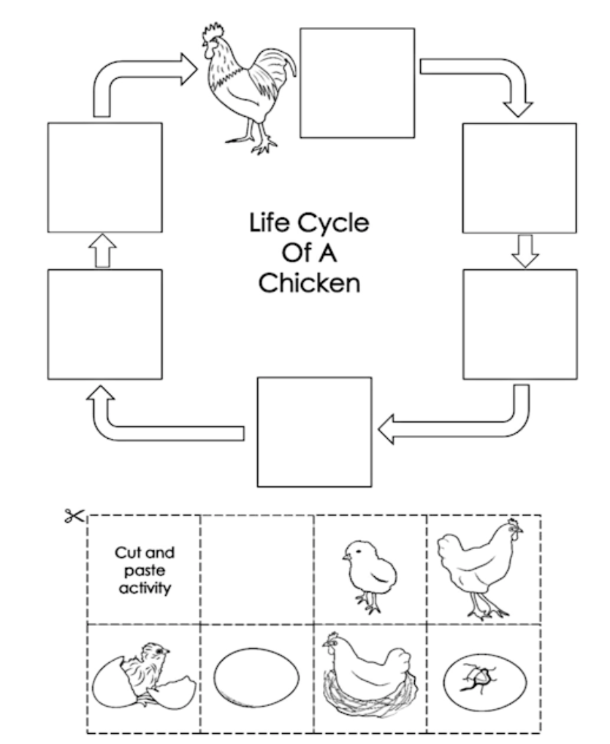

Left Blank for Poultry Activity Page Cutouts

Cats

A cat’s body is protected from cold and wet by its sleek fur. Cats should always have fresh water and dry food available. Canned cat foods contain not only meat but also grains, vegetables, and food yeast. A kitten should be fed two to four times a day, and a grown cat once or twice.

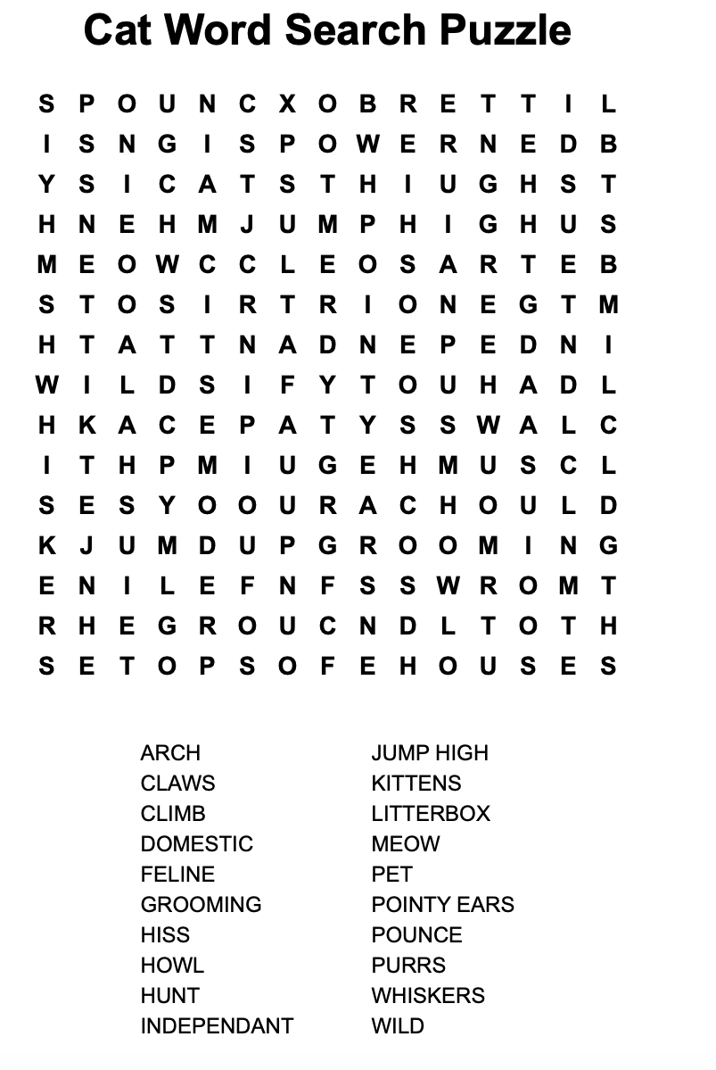

Dogs

The breeds of dogs are divided into six different groups. These groups are sporting dogs, hounds, terriers, working dogs, toy dogs, and non-sporting dogs. If you decide to keep your dog outside, you will need a doghouse and a pen.

Commercial dog foods usually provide adequate nourishment for a healthy dog. Dry or canned dog foods are equally good. Never give your dog small bones especially bones from pork or poultry. Bath your dog in warm soapy water as necessary for the health and comfort.
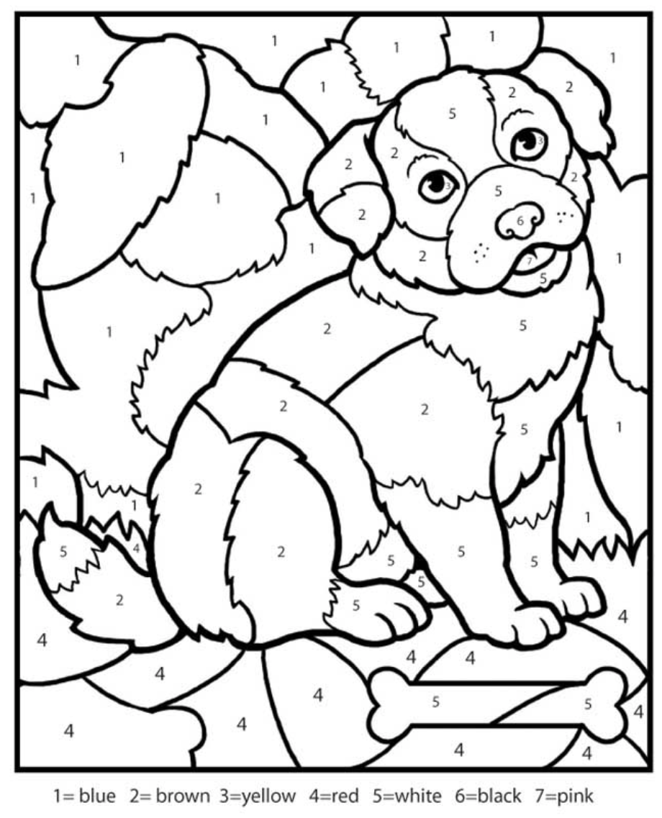
Hamsters

Hamsters are members of the rodent family. Other than fresh food and water, he should have an exercise wheel in the cage.

Guinea Pig

Adult guinea pigs weigh about 1 ¾ to 2 ½ pounds. They are vegetarians and are relativity easy to keep and reproduce rapidly. Feed your guinea pigs a balanced diet and supply them with fresh water every day. Ground oats and wheat bran can supply the grain portion of their ration.

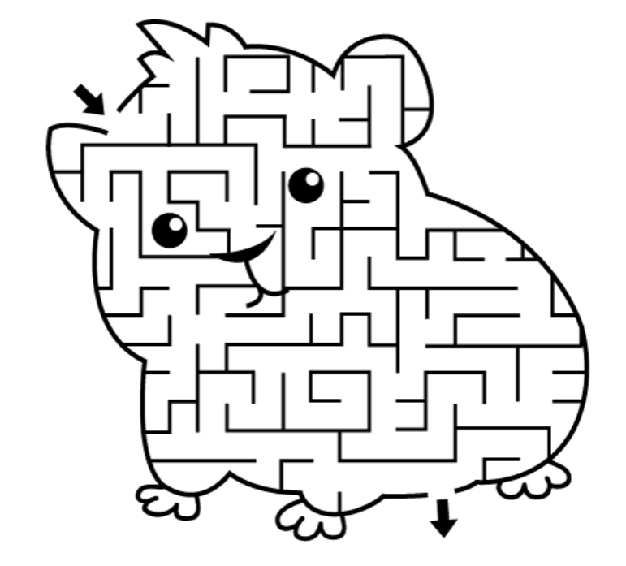

Record Sheet
Kinder Clover 4-H Animals
Name Grade

4-H Club
Please complete and bring with your Kinder Clover 4-H Exhibit.

I chose to exhibit _____________________________________. My favorite animal is

. I learned

. My favorite part of Kinder Clover 4-H this year was

.

List who helped you with the project

