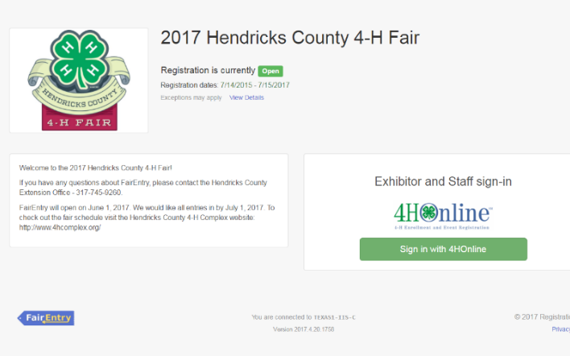
- Go to http://hendrickscounty.fairentry.com/
- Select your “Sign in with your 4-HOnline” account option- the GREEN box

- A separate box will pop up where you can enter the login email address and password from 4HOnline.
(If you don’t remember your password, you will need to select the “I forgot my password” option to get a temporary one emailed to you. If your email address has changed, log in using the old email address and change it in 4HOnline.)

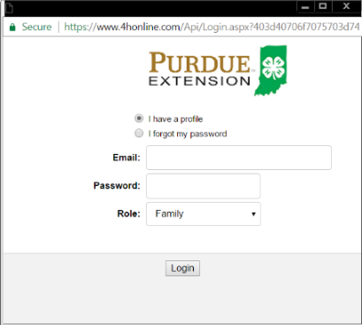
- Click the “Login” box.

Make sure “Family” is selected.

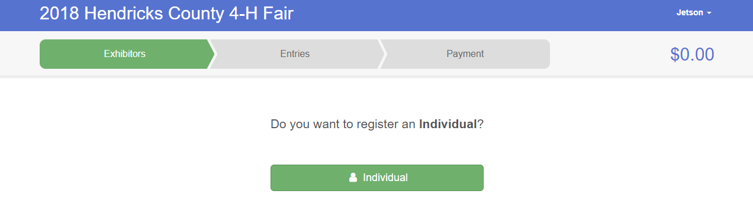
Section 1- Exhibitors Tab

- Choose to “Register an Individual.”
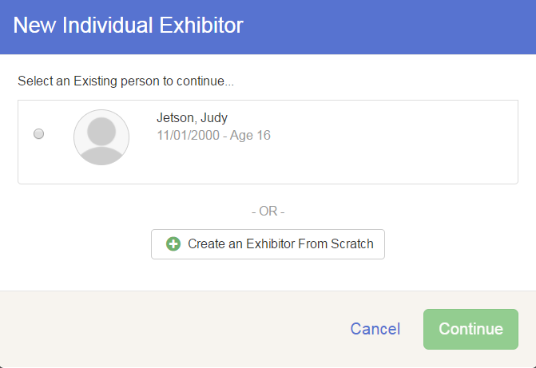
Note: Please do not create any exhibitors from scratch, as you will not be able to add exhibits for any projects.

- Answer any required questions and review the exhibitor registration information.

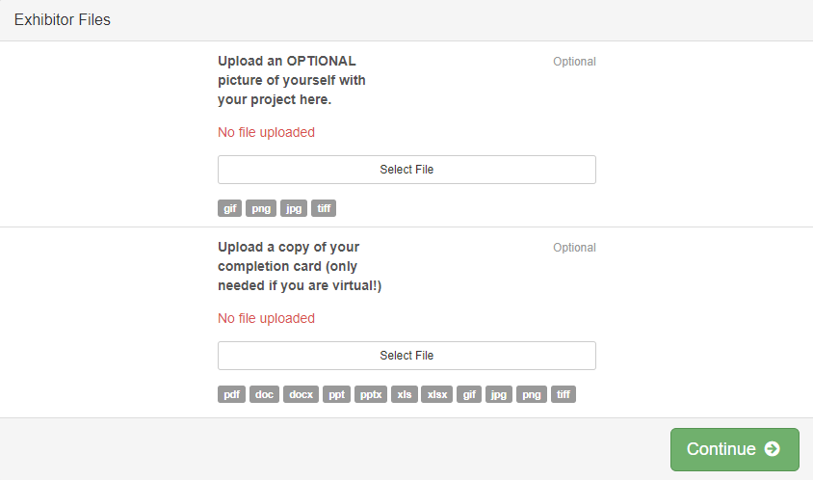
- Make any necessary corrections (using the edit boxes).
Remember that any corrections made here DO NOT
transfer back to your 4HOnline Account
- If Additional questions are required,
complete the questions and then select the green
“Continue” box.
*** If exhibiting virtually, please upload a picture
of your completion card here! ***

When you are taken back to the Exhibitor information page, click the green “Add an Entry” button
1
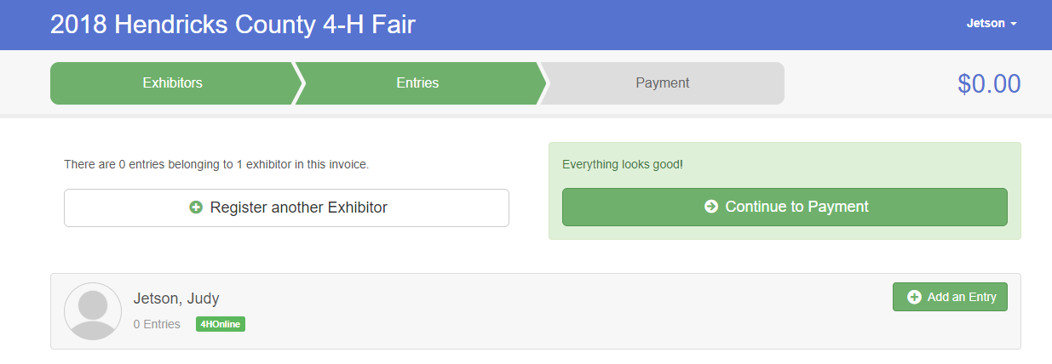

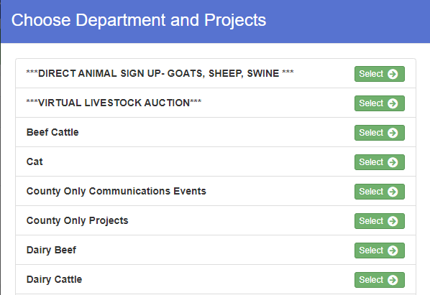

Section 2- ENTRIES
- Click the green “Select” box next to the Project you would like to enter. (For help finding your project, see the LAST PAGE of this guide for a “cheat sheet”!) You will only be able to enter projects that you have entered onto 4-HOnline. If you have INDOOR project, go to section 3. If you have a LIVESTOCK project, go to Section 4.

SECTION 3- INDOOR PROJECTS
- For Indoor Projects: Click the green “Select” box next to the class/division you are wanting to enter in.
Indoor projects will be listed one of four “Departments”:
- County Only Projects
- County Only Communications Projects
- State Garden
- State Projects
For help finding your project, see the LAST PAGE of this guide for a “cheat sheet”!

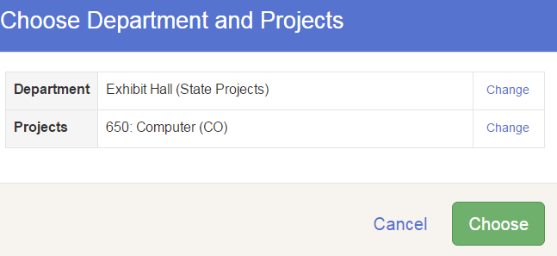
- Select the “Choose” button when you are sure this is the PROJECT you want.

- You will then go in and pick the division you will be exhibiting under. And It will ask you to verify.

- It will ask you to select your club. Then Continue.
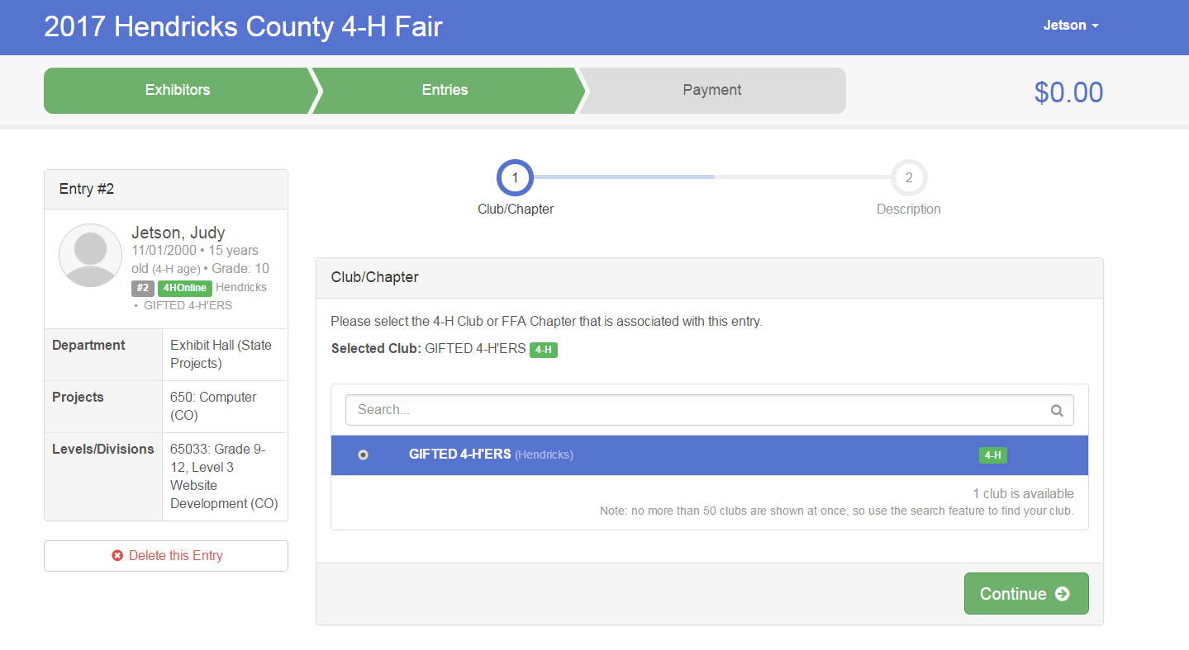

- Please enter in a description of your exhibit and click Continue– Be as specific as possible because this description for non-animal exhibits will be used to distinguish between exhibits. For example – don’t just type in “portfolio”, type “portfolio on website development for my mom’s new catering business.” Changes/corrections can always be made at a later date. If you do not know right now, please enter as specific of a description as possible.
5

NOTES FOR ENTRY DESCRIPTION:
- Photography 10-print posters should enter a description of your #1 photo, if known.
- Projects with more than one item should enter a description of your main display (i.e. first collection box, first entomology box, item you did for Home Environment, etc.).
- If you have MULTIPLE pieces to your display, please list total amount of items. For example if you have three boxes for display in Entomology, please put “Total # of boxes: 3.” We will then print additional tags for you to put on your items.

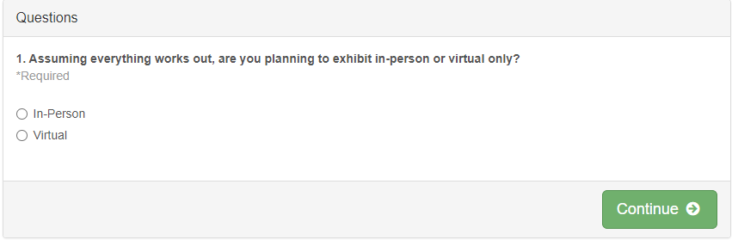
- Answer any additional questions and Continue on.

- After completing one entry, you can decide if you would like to:
  - Add another Entry (Allows you to add projects to the same exhibitor)
  - Register another Exhibitor (Go to a different 4-H Member of the same family.)
  - Continue to Payment (only do once after ALL members projects are entered)
Once you have entered all entries for all members you can continue to payment.

SECTION 4- LIVESTOCK PROJECTS
- If entering Livestock: Click the green “Select” box next to the class/division you are wanting to enter in.
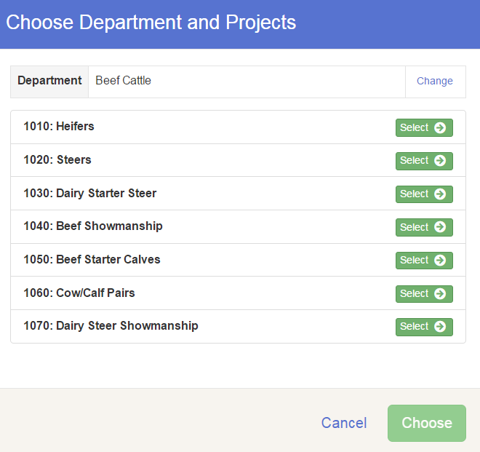

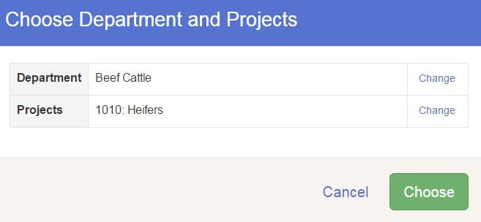
- Select the “Choose” button when you are sure this is the PROJECT/SPECIES you want.

- You will then go in and pick the class of the animal you are exhibiting and then hit continue.

- It will ask you to pick your club.
Then Continue.

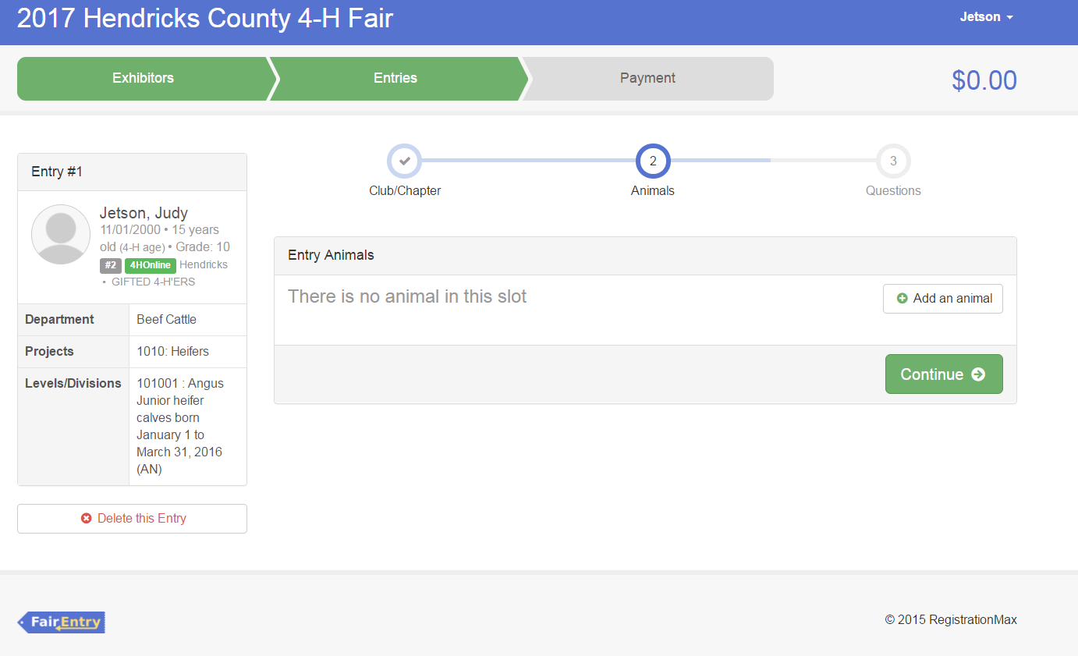
- You will need to “Add an Animal.” All livestock excluding Cat, Dog, or Poultry/Pigeons/Waterfowl will only be able to “Add an Existing Animal” from information found on 4-HOnline.

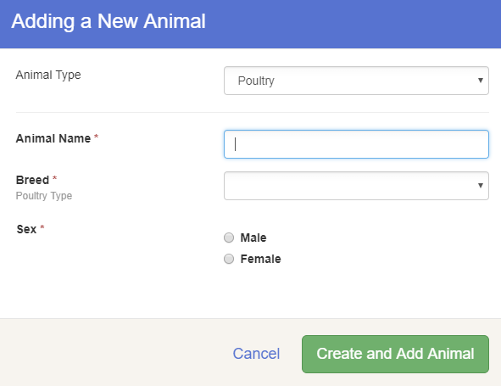
To enter a Cat, Dog, or Poultry/ Pigeons/Waterfowl animal, please select “Enter a New Animal Record”, and complete all applicable fields on the screen.

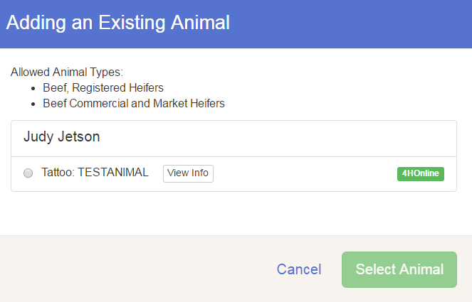

- A list of those animals that you have previously identified in 4-H Online that are eligible for that class are listed. Select the circle next to the animal you would like to enter. Then select the green “Select Animal” box. You can hit “View Info” to double check the Animal ID info!

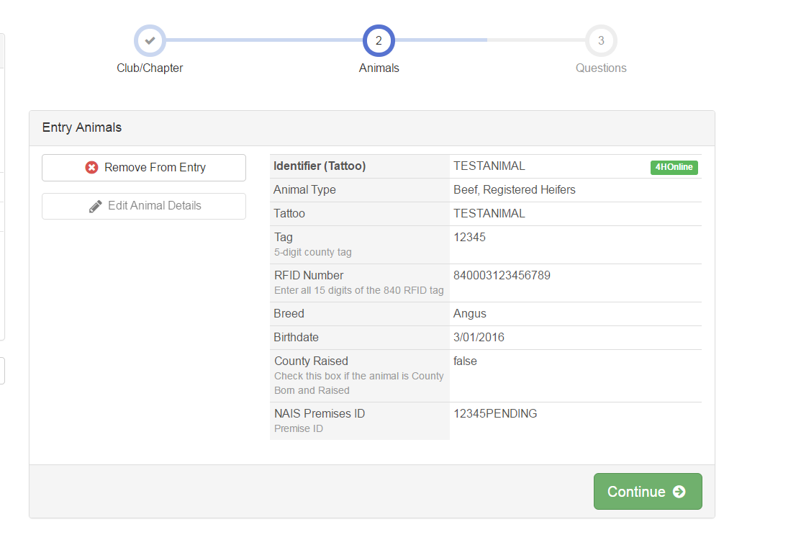
- All of the information about your animal will be pulled over from 4-H Online, so that you can check to make sure that is the correct animal. If you want to switch to a different animal, click on the “remove from entry box”. If it is correct, click the green “Continue” box.

- If there are any questions affiliated with this livestock, be sure to answer those. Examples may include pen requests, 10-year member information, or other information about you/your animal. Hit Continue.

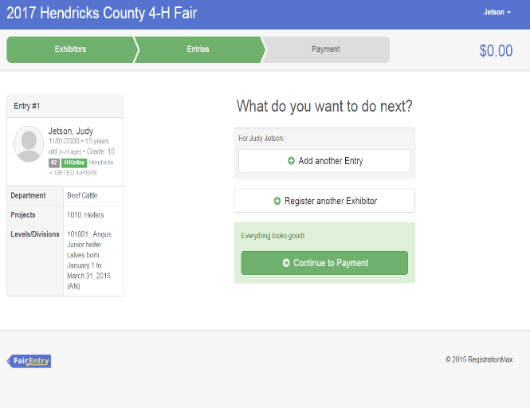
- After completing one entry, you can decide if you would like to:
  - Add another Entry (Allows you to add projects to that same exhibitor.)
  - Register another Exhibitor (Go to a different 4-H Member of the same family.)
  - Continue to Payment (Only do this once ALL members’ projects are entered.)

Select the box that best describes what you want to do.
***The payment section is a formality of the system. No payment is needed, but you must go through the steps to submit your entries. Only select this button after you have entered ALL of your projects for ALL Members!!!

Section 5- Virtual Auction
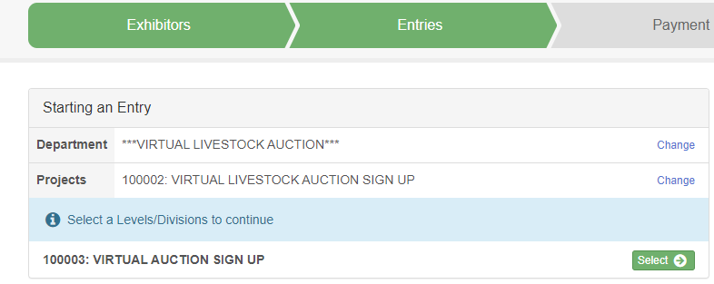
26. If you would like to sign one of your animals up for the auction go to the Exhibitors tab and click create entry. Click “***Virtual Livestock Auction***.”

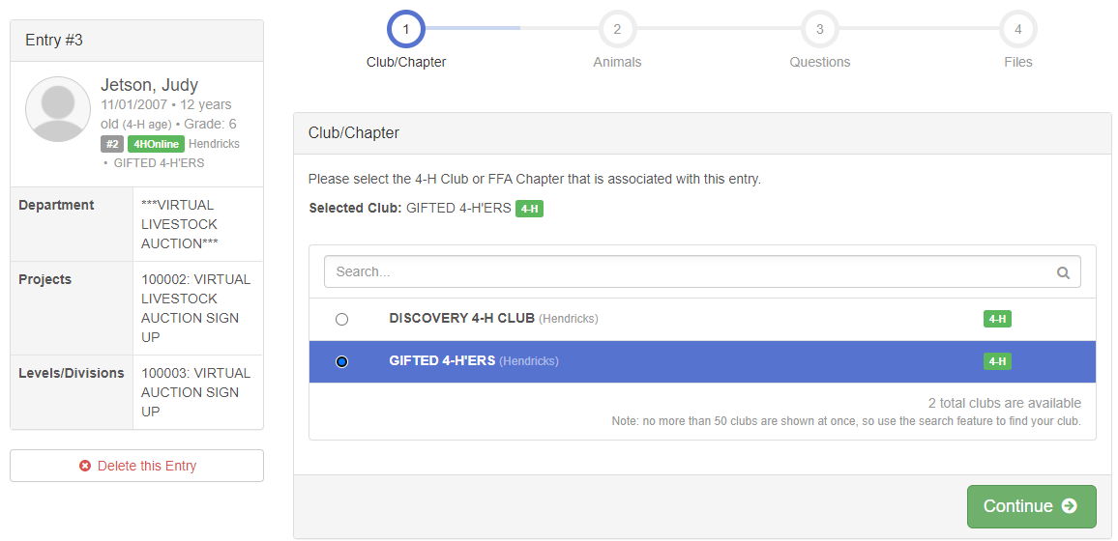
27. Select your 4-H club from the menu and then click continue.

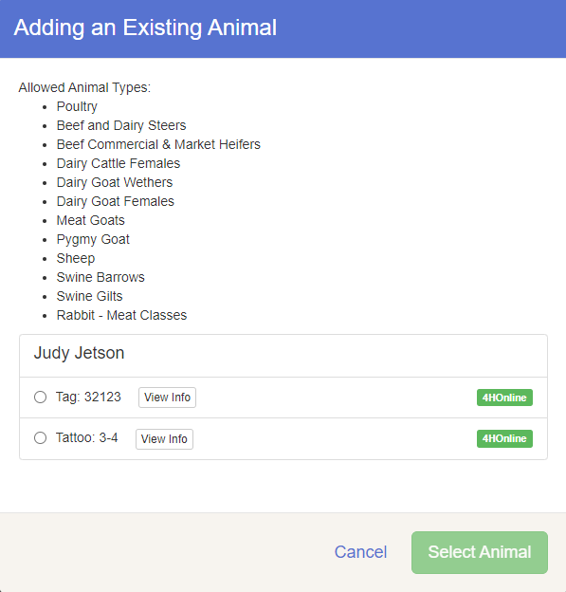
28. Select which animal you would like to place in the auction. Please note, animals sent through the virtual auction will be ineligible to compete at the Indiana State Fair 4-H Livestock Competition. Be sure to add a picture of your animal/species to your entry (see next step).

SECTION 6- DIRECT ANIMAL SIGN UP
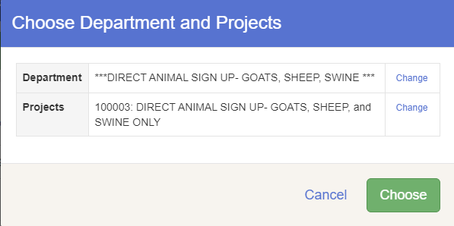
29. If you would like to sign one (or more) of your animals up for the direct truck, go to the Exhibitors tab and click create entry. Click “***DIRECT ANIMAL SIGN UP***.” Goat, Sheep, and Swine Only for 2021.

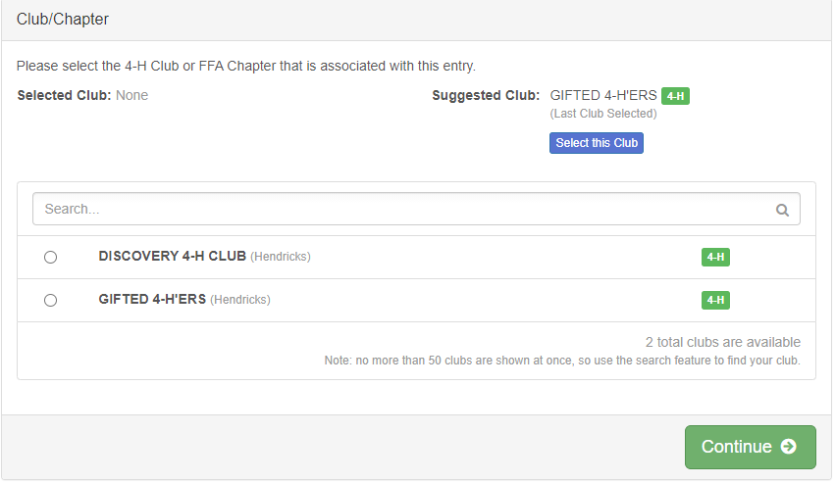
30. Select your club and click “Continue”.

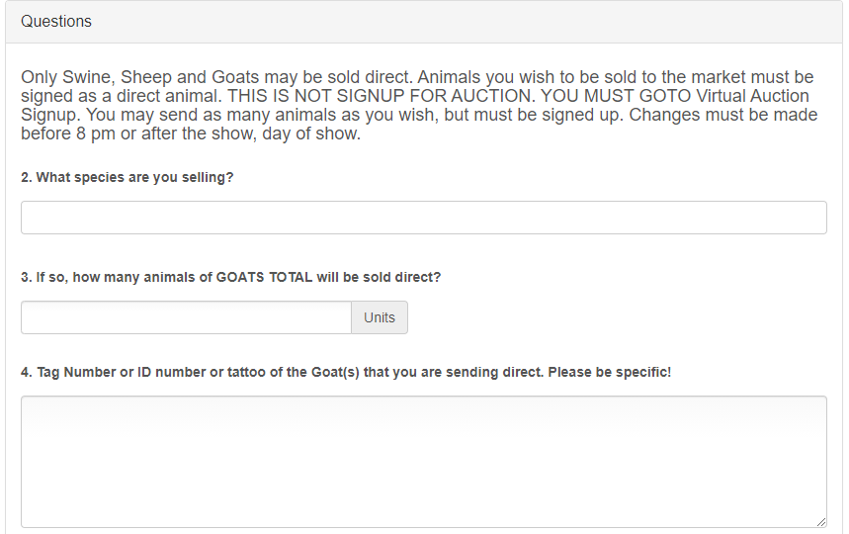
31. Answer the questions regarding the species and the TOTAL number of animals in each species that you are sending on the direct sale truck. Be sure to be SPECIFIC on which animal(s) that you would like to send. Once complete, click continue.

SECTION 7 - PAYMENT TAB
***The payment section is a formality of the system. No payment is needed to exhibit at the County Fair, but you must go through the steps to submit your entries. It is best to enter all entries for all exhibitors in your family before completing the Payment and submission steps.

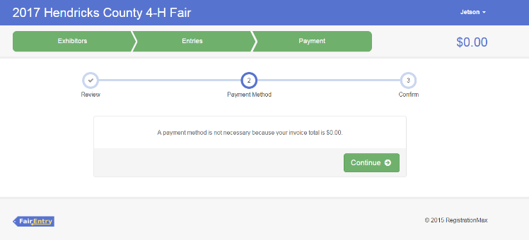
- Review your invoice, either in summary format or detail format. If it looks correct, click the green “Continue” box. If not, go back to the entries tab and fix what you need to. Under “payment” you should not see any payment charges. Click Continue.

- Confirm your entries one last time. You can see a summary of exhibitors in your family, or their entries in detail. Make sure all entries for each exhibitor in your family are listed before you submit the entries.

NOTE: Once you hit submit, you cannot edit your entries until approved by the County.
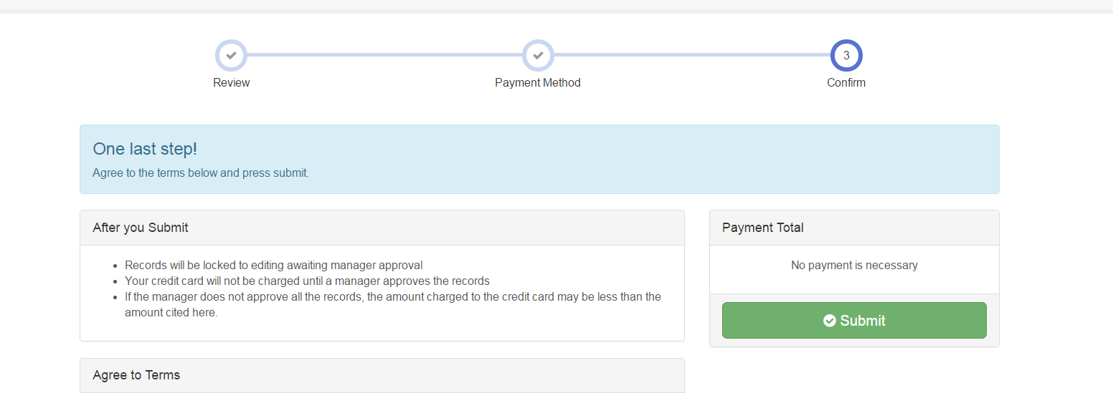
- Click “Agree to Terms” button, then select Submit. YOU MUST HIT THE SUBMIT BUTTON TO FAINALIZE YOUR ENTRIES!!

- You will receive a “Thanks!” message. You can choose the button to “Visit Dashboard” to see your entry or sign out. You will then be in “pending” status.

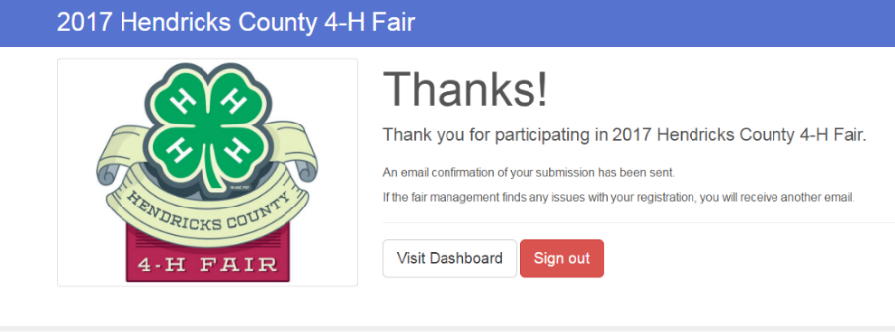

Please enter your projects into FairEntry by July 7, 2021!

You will receive an email from Fair Entry after your entry has been submitted. Once submitted, you will not be able to add additional information until your initial submission is approved.
You will also receive an email from Fair Entry letting you know if your entry was approved or rejected by the County Extension Staff. If part of your entry was rejected, a reason will be listed and you will be able to log in and fix the problem before submitting that entry again. Please contact the Hendricks County Extension Office if you have any problems with this process at 317-745-9260 or hendrces@purdue.edu.

Remember, we will have Extended Extension Office Hours on the following days to help you with any 4-H or FairEntry issues you may have:

June 22 – OPEN UNTIL 6 P.M.

July 7 – OPEN UNTIL 7 P.M.

