COWS IN MY HOUSE

The following items are all made from some part or by-product of cattle. See if you can locate them.
S | D | M | G | R | E | H | T | A | E | L | I
C | D | L | A | E | S | M | Z | S | W | S | A
I | M | O | D | R | L | B | I | X | A | P | C
T | N | F | O | I | G | A | M | G | X | A | E
S | X | R | F | F | N | A | T | O | M | O | R
A | M | G | V | N | T | A | R | I | C | S | A
L | S | H | O | R | T | E | N | I | N | G | M
P | F | Y | G | L | U | E | P | C | N | H | I
Q | A | S | E | M | U | F | R | E | P | E | C
M | C | R | A | Y | O | N | S | G | Q | E | S
F | R | P | A | I | N | T | S | I | U | C | R
T | W | M | Y | T | R | U | G | O | Y | M | X

CERAMICS | COMBS | CRAYONS
FILM | GELATIN | GLUE
GUM | LEATHER | MARGARINE
MAYONNAISE | PAINTS | PERFUMES
PET FOODS | PLASTICS | SHORTENING
SOAPS | WAX | YOGURT

1. The person or business that processes (slaughters) and sells the carcass whole or
as primal and wholesale cuts is called? __________________________________

2. The cuts of meat that the consumer buys at the store are called? ______________

3. The loin, rib and round together account for about ________% of the carcass weight
and about _________% of the carcass value.

4. Determine the expected Rib Eye Area (REA) for a hot carcass that weighs 850 lbs.
(Use chart in Beef Resource Handbook.) ___________ square inches

5. In cattle the “high priced cuts” come from where? ___________ and _____________

WHOLESALE CUTS OF BEEF
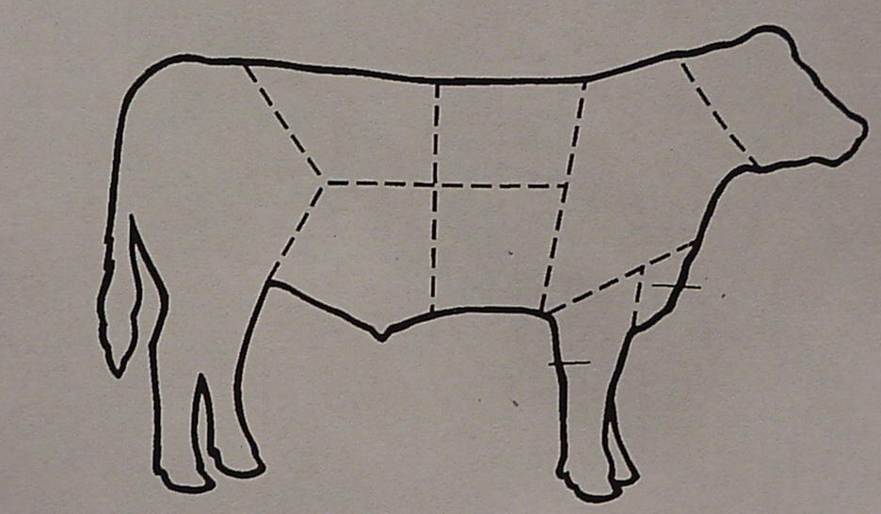

From the list below, identify the wholesale cuts of beef. Write the letter next to the cut.

A. Brisket E. Plate
B. Shank F. Flank
C. Chuck G. Loin
D. Rib H. Round

6. “Middle Meats” which are high priced cuts are made up of the _________ and the
____________ wholesale cuts.

