1. Parts of a Beef Animal
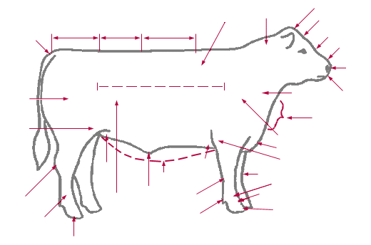
Label the parts from the words listed below:

Point of Shoulder Brisket Pastern Hock
Stifle Joint Crest Back Rear Flank
Poll Rear Quarter Hock Loin
Dew Claw Pin Forearm

2. Draw a line from the term to the current definition.
Sire Allowing cattle to have access to feed at all
times

Dam The father of a calf (bull)

Polled Breed The mother of a calf (cow)

Ration To remove the testes from a bull so that
it cannot reproduce

Castrate Cattle that do not grow horns

Free Choice Daily mixture of feed ingredients given to
cattle

KNOW YOUR BEEF BREEDS
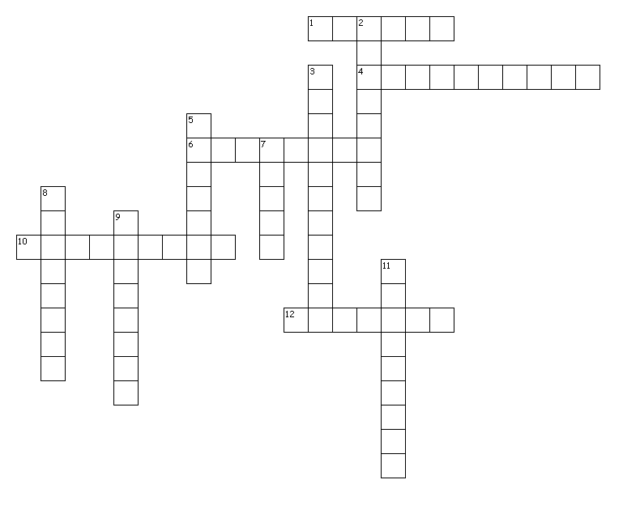
Across
1. Native to the south of France. Typically horned and dark mahogany red in color.
4. Originated in southern New South Wales, Australia. Preferred color is silver gray.
6. Originated in British Isles and the red color dates back to 1805.
10. Imported from Switzerland, France & Germany. Colored to dark red, spotted bodies with white to light straw faces.
12. Originated in the counties of Suffolk and Norfolk, England. They are polled and red in color.
Down
2. Originated in west central France. Solid to golden red in color with lighter circles around the eyes and muzzle.
3. Cattle originated in central and upper Belgium. Color can be white, blue roan or sometimes black.
5. Breed developed in US by crossing Zebu cattle from India with British breeds.
7. Black polled breed that originated in Scotland and is known for its mothering and carcass quality.
8. Developed in Italy, this breed can be very large in size.
9. Red and white breed from England, popular for its superior foraging ability, vigor, and hardiness.
11. Brought to the US in 1783 from England. Colors are red, white or roan.

