1. Parts of a Beef Animal
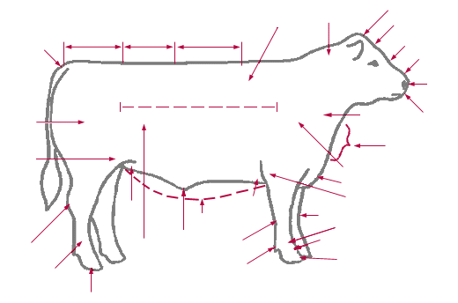
Label the parts from the words listed below.

Belly Loin Knee Throat Crest
Hoof Poll Brisket Rib Rump

2. Draw a line from the term to the correct definition:

Purebred Female kept to produce calves

Heifer An intact (non-castrated) male

Bull A young female beef or dairy animal that
has not calved (had a calf)

Feeder Calf Animal whose parents are from the same breed.

Brood Cow Young calf, 5 – 9 months old that is weaned
and started on feed.

3. The ideal mature market steer weighs ______________________ to
________________________ pounds.

4. Water is a very important part of an animal’s diet. Cattle will drink up to
_______________ gallons or more of water in one day, depending on their
weight and the environmental temperatures.

BEEF BREED WORD SCRAMBLE

Word Bank

Salers Chianina
Hereford Beef Master
Maine-Anjou Shorthorn
Simmental Pinzgauer
Brahman

EFRORHED ________________________________

EMFEBRATSE ________________________________

THROHNORS ________________________________

ELASSR ________________________________

ANCHANII ________________________________

NAJUO EAMIN ________________________________

METNAILSM ________________________________

NAPREZIGU ________________________________

ARBNHMA ________________________________

