BEEF SKELETAL PARTS
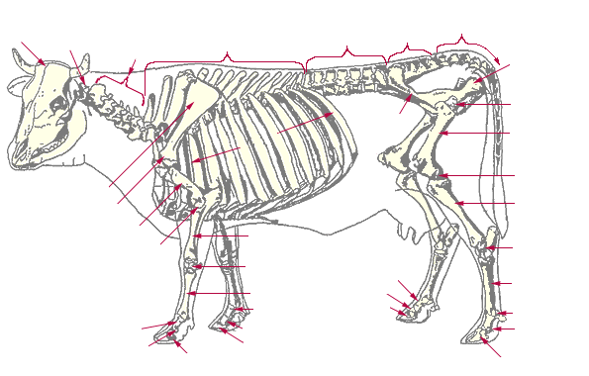
Locate these Beef Skeletal Parts
A. Scapula F. Cervical Vertebrae
B. Sacral Vertebrae G. Mandible
C. Ribs H. Stifle Joint
D. Femur I. Hip Joint
E. Tibia J. Radius
1. Beef carcass evaluation is accomplished through two grading systems:
____________________ grading and ____________________ grading.

2. The average dressing percentage for steers and heifers is ________%, but can
vary greatly with changes in the type of cattle.

3. Marbling is the small flecks of fat that are in meat. In cattle, marbling degrees (the
amount of fat) help to determine the Carcass Quality Grade (i.e. prime, choice, etc.).
Here are the degrees of marbling. Rank these in order of high to low degrees of
Marbling. Small, Traces, Slightly Abundant, Abundant, Modest, Slight, Practically
Devoid, Moderately Abundant, Moderate, and Traces.

High marbling ______________________________________

______________________________________

_________________ _____________________

______________________________________

__Modest______________________________

______________________________________

_______________________________________

_______________________________________

Low Marbling _______________________________________

4. Match these Retail Beef Cuts with the Wholesale Cut (where they come from).
Word Bank (can use these more than once) (See Retail Meat Chart in Book.)

Round Chuck Rib Sirloin
Shank Flank Short Loin Brisket Plate

Wholesale Cut Retail Cut

____________________ Beef Boneless Rump Roast
____________________ Beef T-Bone Steak
____________________ Tip Roast, Cap OFF
____________________ Arm Pot Roast
____________________ Top Sirloin Steak
____________________ Shank Cross Cut Roast
____________________ Boneless Shoulder Pot Roast
____________________ Beef Rib Eye Steak
____________________ Flank Steak Rolls
____________________ Back Ribs

