**BEEF SKELETAL PARTS**

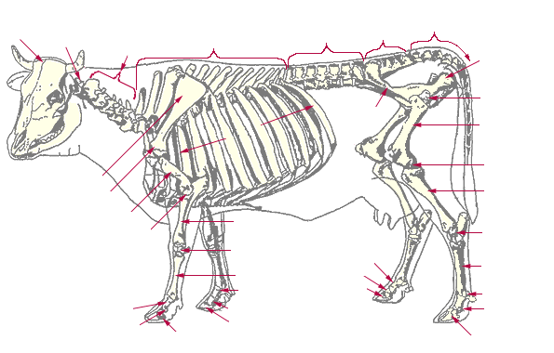

Locate these Beef Skeletal Parts

A. Scapula F. Cervical Vertebrae

B. Lumbar Vertebrae G. Cranial Bones

C. Thoracic Vertebrae H. Stifle Joint

D. Femur I. I. Metacarpus

E. Tibia J. Radius

1. Beef carcass evaluation is accomplished through two grading systems:

____________________ grading and ____________________ grading.

2. The average dressing percentage for steers and heifers is ________%, but can

vary greatly with changes in the type of cattle.

3. Marbling is the small flecks of fat that are in meat. In cattle, marbling degrees (the

amount of fat) help to determine the Carcass Quality Grade (i.e. prime, choice, etc.).

List the degrees of marbling found on the Quality Grade Chart.

highest ____________________________________

__Moderately Abundant___________________

_________________ _____________________

__Moderate_____________________________

______________________________________

______________________________________

___Slight_______________________________

_______________________________________

lowest _______________________________________

4. Match these Retail Beef Cuts with the Wholesale Cut (where they come from).

Word Bank (can use these more than once) (See Retail Meat Chart in Book.)

Round Chuck Rib Sirloin

Shank Flank Short Loin Brisket Plate

Retail Cut Wholesale Cut

Beef Rib Roast __________________________________

Beef Brisket Roast __________________________________

Beef Boneless Rump Roast __________________________________

Beef Cross Rib Pot Roast __________________________________

Beef Rib Eye Steak ____Rib___________________________

Beef Porterhouse Steak __________________________________

Beef Boneless Shoulder Pot Roast __________________________________

Beef Flank Steak __________________________________

Beef T-Bone Steak __________________________________

Beef 7-Bone Pot Roast __________________________________