Name: 4-H Club

- Find the genotype and phenotype of the following: Ram is an Rr and the Ewe is an Rr.

- Identify the male parts of the reproductive system.
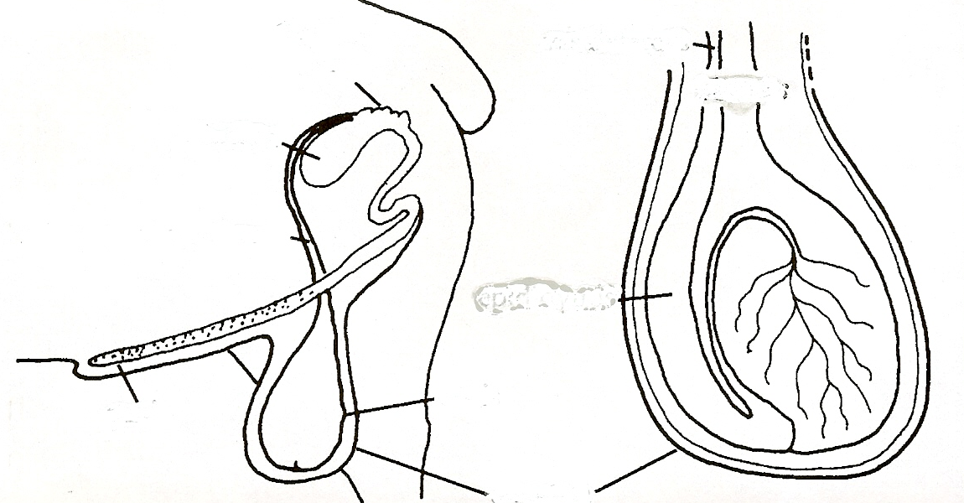

- Market lambs need to have ____ to ____ percent protein, while breeding ewes and rams lambs should be feed ____ to ____ protein levels.

- Because sheep are a ruminant they can digest ___________ .

Answers to all the questions can be found in the Sheep Resource Handbook 4-H 194R .
- Make a list of items that you will need to bring with you to the fair for your sheep project:

- Identify the following cuts of lamb:

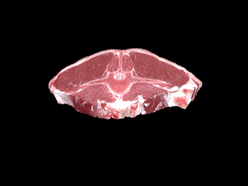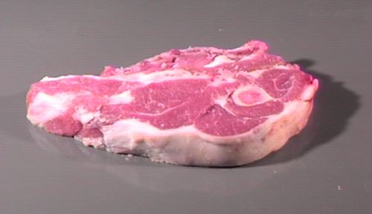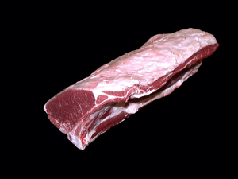

A. Arm Chop A. Arm Chop A. Shoulder Roast
B. Loin Chop B. Loin Chop B. Loin Roast
C. Double Loin Chop C. Sirloin Steak C. Whole Leg

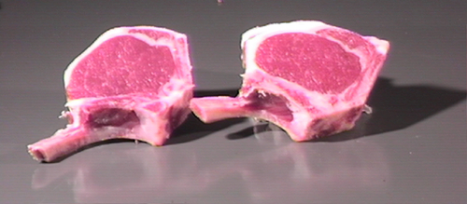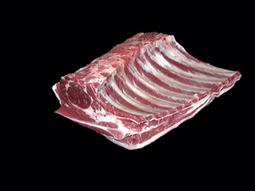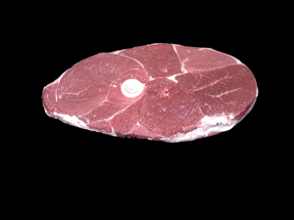

A. French Rib Chop A. Rack Roast A. French Rib Chop
B. Sirloin Steak B. Spareribs B. Center Slice
C. Arm Chop C. Riblets C. Sirloin Steak

- Match the treatment or prevention with the disease:

A. Enterotoxemia ______ Eliminate the conditions that cause it

B. Foot Rot ______ Vaccinate with antitoxin

C. Pneumonia ______ Vaccinate ewes when you can

D. Pregnancy Toxemia ______ Vaccinate with Clostridium type D

E. Sore Mouth ______ Good balance of calcium to phosphorus

F. Tetanus ______ Dry bedding and proper foot care

G. Urinary Calculi ______ Vaccinate the flock

H. Abortions ______ add a high energy concentrate

8. The meat from sheep at 35-42 pounds is referred to as _________________________.

