Name: 4-H Club

- Find the genotype and phenotype of the following: Ram is an Rr and the Ewe is an rr.

- Identify the male parts of the reproductive system.
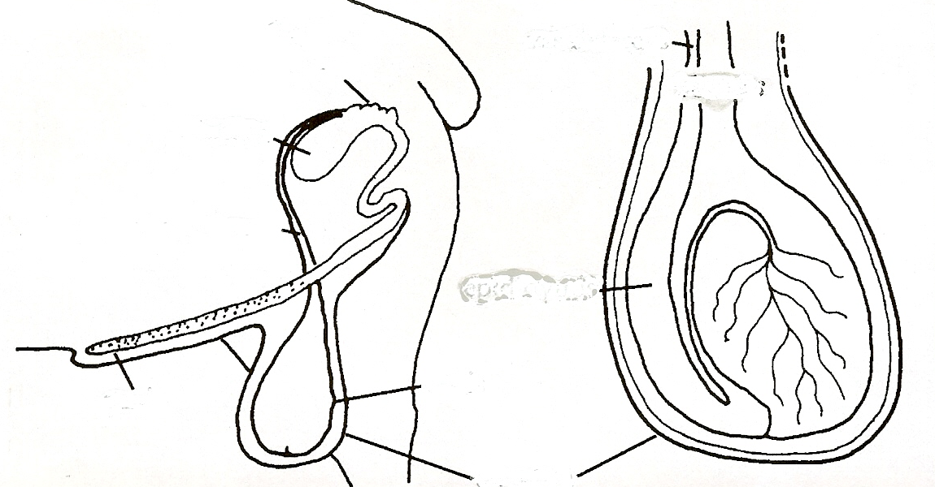

- Creep feeds need to have ____ to ____ percent protein, while lambs that reach 50-60 pounds require ____ to ____ protein levels.

- Never mix new arrivals with your flock for at least ____________________.
Answers to all the questions can be found in the Sheep Resource Handbook 4-H 194R.
- Make a list of items that you will need to bring with you to the fair for your sheep project:

- Identify the following cuts of lamb:

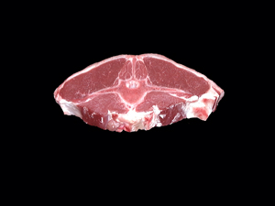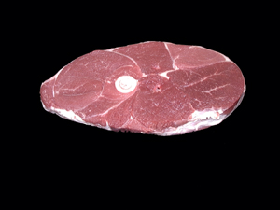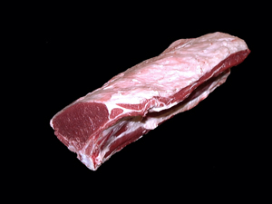

A. Arm Chop A. Arm Chop A. Shoulder Roast
B. Loin Chop B. Loin Chop B. Loin Roast
C. Double Loin Chop C. Center Slice C. Whole Leg

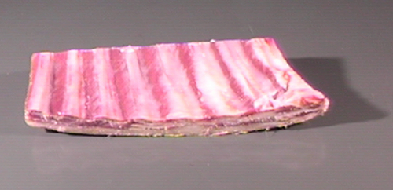
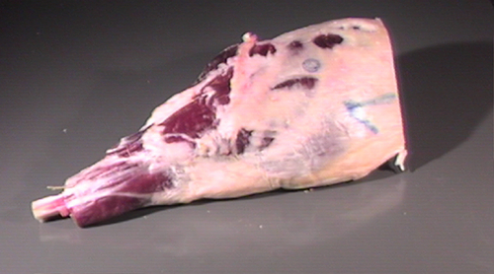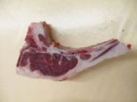

A. Shoulder Roast A. Rack Roast A. Center Rib Chop
B. Lion Roast B. Spareribs B. Center Slice
C. Whole Leg C. Riblets C. Sirloin Steak

- Match the treatment or prevention with the disease:

- Mastitis ______ Inject with Vitamin E and Selenium

B. Coccidiosis ______ Disinfect equipment regularly

C. Lamb Fungus ______ Apply iodine to the navel area at birth

D. Pregnancy Toxemia ______ Dip the sheep regularly with an insecticide

E. External Parasites ______ Vaccinate all of the lambs

F. Tetanus ______ Drugs and feed additives helps control

G. Stiff Lamb ______ Always check udder and milk flowing at lambing

H. Navel ill ______ add a high energy concentrate

8. The gene that causes heavy muscling in lambs is called _____________ by scientist.

