Name: 4-H Club

1. Label the following parts of the lamb: 1, 2, 6, 7, 9, 12, 17, 18. 20, 23,

2. Match the following sheep industry terms with their definition:

_____ Concentrate A. The meat from sheep older than 12 months of age.
_____ Flock B. A group of sheep that are managed together.
_____ Docking C. Trimming or shearing the wool away from the tail or dock area.
_____ Dipping D. A feed high in nutrients and low in fiber.
_____ Fleece E. Front teeth
_____ Grade F. The removal of the tail.
_____ Incisors G. Small horn buttons attached to the skin
_____ Mutton H. Immersing the entire sheep in medicated water to control
external parasites
_____ Scurs I. The wool from one sheep.
_____ Tagging J. A sheep that has only one purebred parent and one scrub.

3. In selection of sheep you must be careful that the sheep you select do not have a lower jaw that is too short called ________________ or too long called ________________________.

4. The temperature of a mature sheep will be about _______ degrees.
5. Label the following breeds according to the type of breed classification: Ram, Ewe, Dual Purpose

______ Dorset _____ Cheviot ______ Romney

______ Hampshire _____ Targhee ______ Oxford

______ Finn sheep _____ Montadale ______ Southdown

6. Find the following on the feed label:
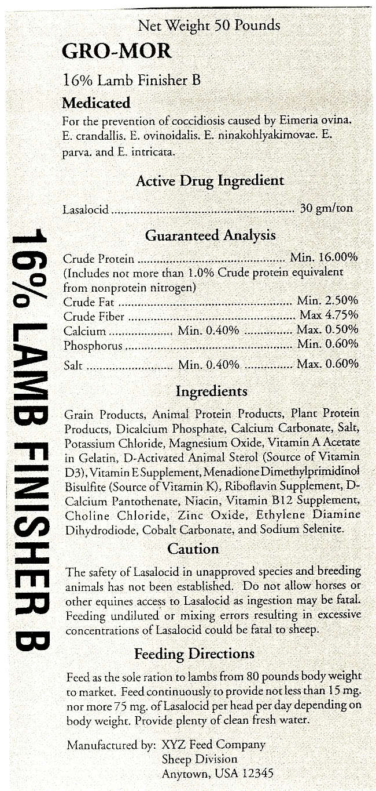

How much of the active drug do you put in a ton?
__________________

What is the maximum crude fiber?
__________________

What is the largest mineral in the feed?
__________________

Is Fluoride in the feed?
__________________

What animal should not consume this feed?
__________________

7 Identify the age of the following sheep
by their teeth
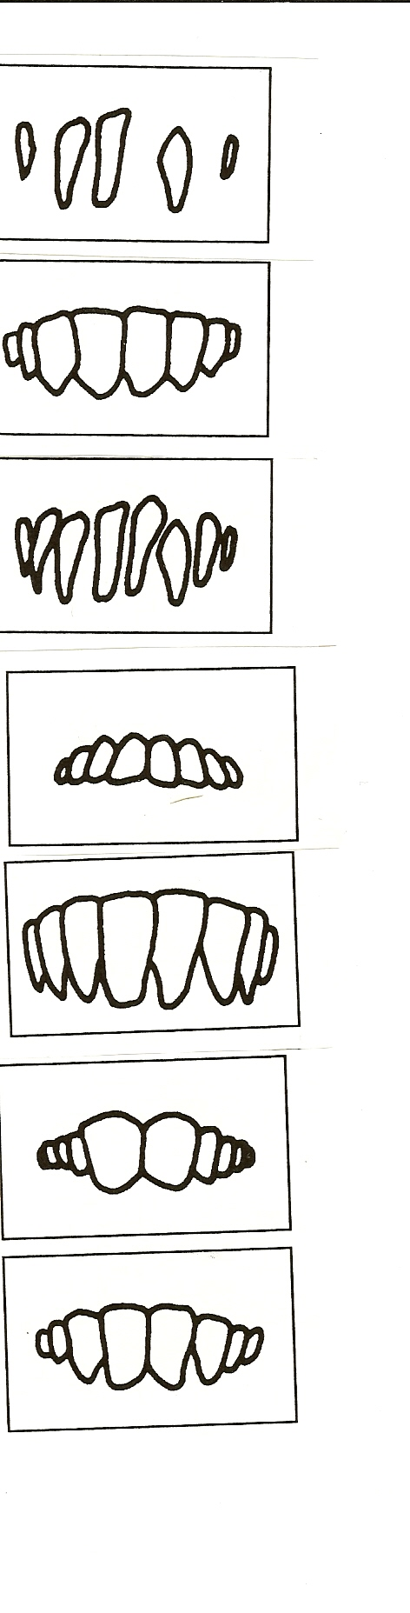
Lamb’s teeth

Yearling’s teeth

2-Year-old’s teeth

3-Year-old’s teeth

4-Year-old’s teeth

Older sheep

Broken Mouth
Answers to all the questions can be found in the Sheep Resource Handbook 4-H 194R

