Name: 4-H Club

1. Label the following parts of the lamb: 2,3,8,9,12,16,20,23,24,26

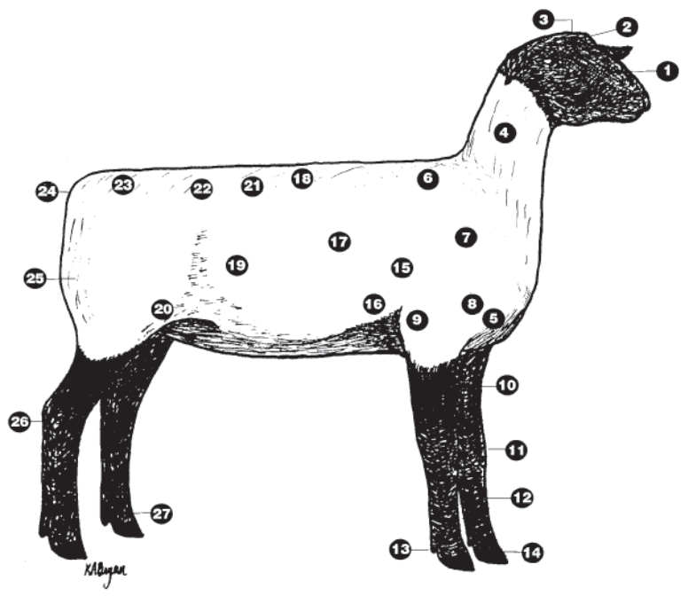

2. Match the following sheep industry terms with their definition:

_____ Castration A. The fat within the muscle
_____ Flock B. A castrated male sheep
_____ Yearling C. Sheep whose ancestry is so mixed it does not resemble any breed.
_____ Drenching D. Removal of the testicles.
_____ Parturition E. A sheep between the ages of 1 year and 2 years.
_____ Flushing F. A group of sheep that are managed together
_____ Scrub G. Sheep that have no horns
_____ Polled H. Oral dose of a dewormer to control internal parasites
_____ Marbling I. The process of giving birth.
_____ Wether J. The practice of conditioning ewes before breeding.

3. In selection of sheep you must be careful that the sheep you select do not have a lower jaw that is too short called ________________ or too long called ________________________.

4. The temperature of a mature sheep should be between _______ and _______ degrees.
5. Label the following breeds according to the type of breed classification: Ram, Ewe, Dual Purpose

______ Polypay _____ Cheviot ______ Columbia

______ Hampshire _____ Targhee ______ Oxford

______ Merino _____ Romney ______ Southdown

6. Find the following on the feed label:
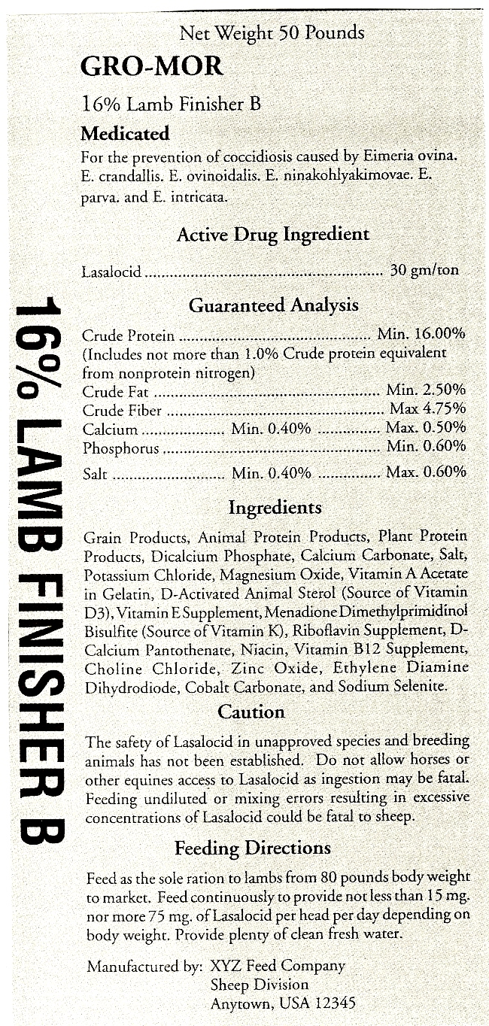

What is the active drug ingredient?
__________________

What is the salt content of the feed?
__________________

What is the highest ingredient in the feed?
__________________

What form of zinc is in the feed?
__________________

What are the minimum and maximum
Medication levels in the feed?
__________________

7 Identify the age of the following sheep
by their teeth
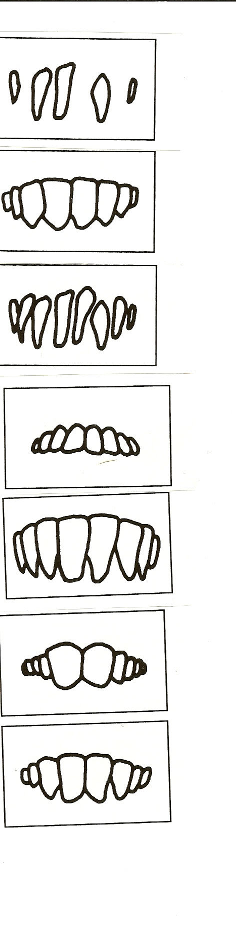
Lamb’s teeth

Yearling’s teeth

2-Year-old’s teeth

3-Year-old’s teeth

4-Year-old’s teeth

Older sheep

Broken Mouth
Answers to all the questions can be found in the Sheep Resource Handbook 4-H 194R

