
Boone County
Record Sheet D
Grade 3

Name: 4-H Club

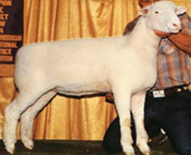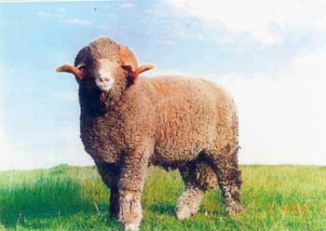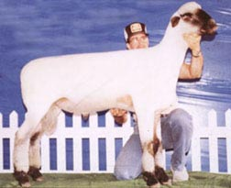

1. 2. 3.
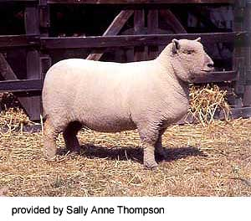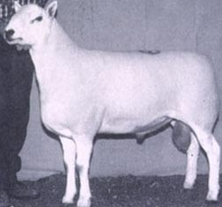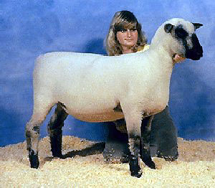

4. 5. 6.

_____ Southdown _____ Oxford _____ Cheviot

_____ Dorset _____ Shropshire _____ Rambouillet

7. A sheep that is a year old is called a _______________________.

8. Low quality wool is called _________________.

9. Match the following:

Ram Breed A. Superior mothering ability

Ewe Breed B. Either ram or ewe

Dual Purpose Breed C. Meat-type
Answers to all the questions can be found in the Sheep Resource Handbook 4-H 194R

10. Sheep Equipment
SS Y X V J P P Y R M D S X S H Used to identify sheep E_ _ T _ _ _
E Z X C Y R Q S W E S E L C E An instrument used to castrate E _ _ _ _ _ _ _ _ _
L S T H E R M O M E T E R S A Used to lead sheep around H _ _ _ _ _
A R B O S M S U A Y W L R D T This will keep lambs warm H _ _ _ L _ _ _
C E Y R O R A R F O M E A T L Used to remove hoof H _ _ _ T _ _ _ _ _ _ _
S M V C C G T S T K P D W H A You can weigh sheep with this S _ _ _ _ _
R M C L B A U X C P A R F D M A vial to give shots S _ _ _ _ _ _
X I J M G Q U U I U D Z X D P Used to take temperatures T _ _ _ _ _ _ _ _ _ _
H R H S B V E L A X L N I B S You may need to dry lambs with these T _ _ _ _ _
N T M I X D C H F L L A Z M W Used to cut off fleece W _ _ _ C _ _ _ _ _ _ _
M F D P D L H C V H O I T D O
K O D Y O S I O J P M S K O D
E O D O W B T L Z Q L M U X R
U H W G E G N I R Y S I T Z R
L W U Z L C M Y O A E W C T F

11. Match the following retail cuts with its wholesale part:

1. _____ Round Steak A. Shoulder
2. _____ Arm Chop B. Rack
3. _____ Riblets C. Loin
4. _____ Double Loin Chop D. Leg
5. _____ Rack Roast E. Breast

12. If you give a lamb medicine in a vein it is called ___________________.

13. Find the following items on a feed tag:
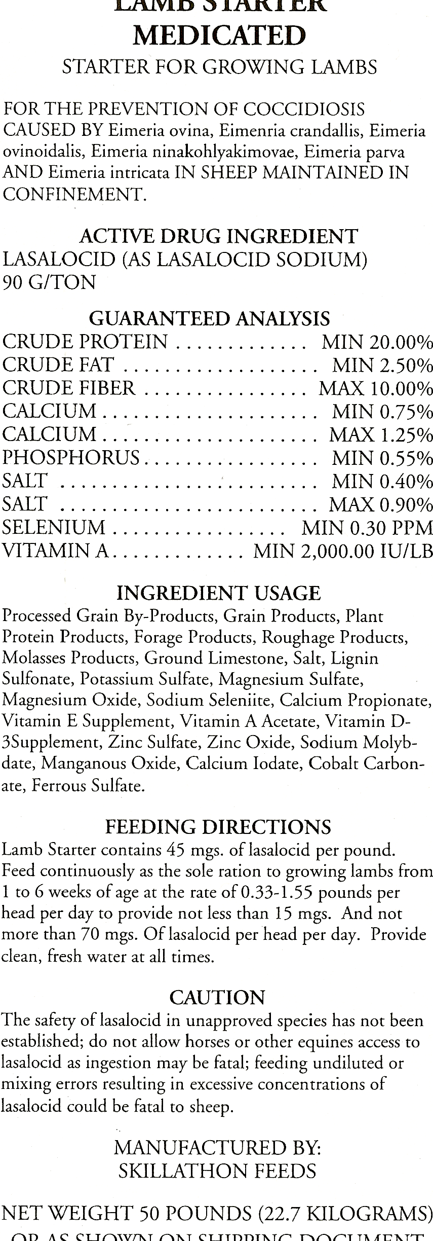
Active Drug Ingredient ________

Maximum mgs/day ___________

Minimum Calcium _______________

Minimum Phosphorus ___________

Crude Protein ___________

