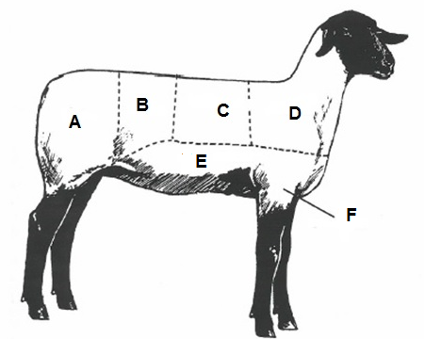

- Name the six wholesale cuts on this market lamb.

- Use your answers from question #1 to match the retail cuts below with the wholesale cut it comes from on the lamb (write the letter of the correct wholesale cut on the line).
American Style Roast
Blade Chop
Crown Roast
Loin Chop
Spareribs
- List three reasons why you should shear your market lamb before the fair.

- True or False? When showing your lamb, get as close to the next exhibitor as possible.

- True or False? When showing your lamb, move around the ring as fast as you can.
- Complete the crossword below on wool
Across:
6. This can happen to wool due to color or quality
7. Grouping fleeces that are alike by diameter or fineness
10. The removal of wool that does not match the bulk of the fleece
11. This converts raw wool into material

Down:
- This can be caused by things like burrs, baling twine, paint, plastic or worming medicine
- This process removes impurities from the grease wool
- This wool is the most common, using 90% of the raw wool in the USA
- These wools are used mostly for making fabric
- Do not shear sheep when they are .
8. System that microscopically measures the diameter of wool fibers.
9. Evaluating an individual fleece.
12. This is determined by the amount of yolk, moisture, dirt, etc. in the wool.
