- Unscramble the names of these common sheep parts:

  - olpl
  - nloi
  - deidlm
  - taenpsr
  - oerf klfna
  - ierbtsk

- Write the names of the parts from question 1 on the picture of the lamb
below.

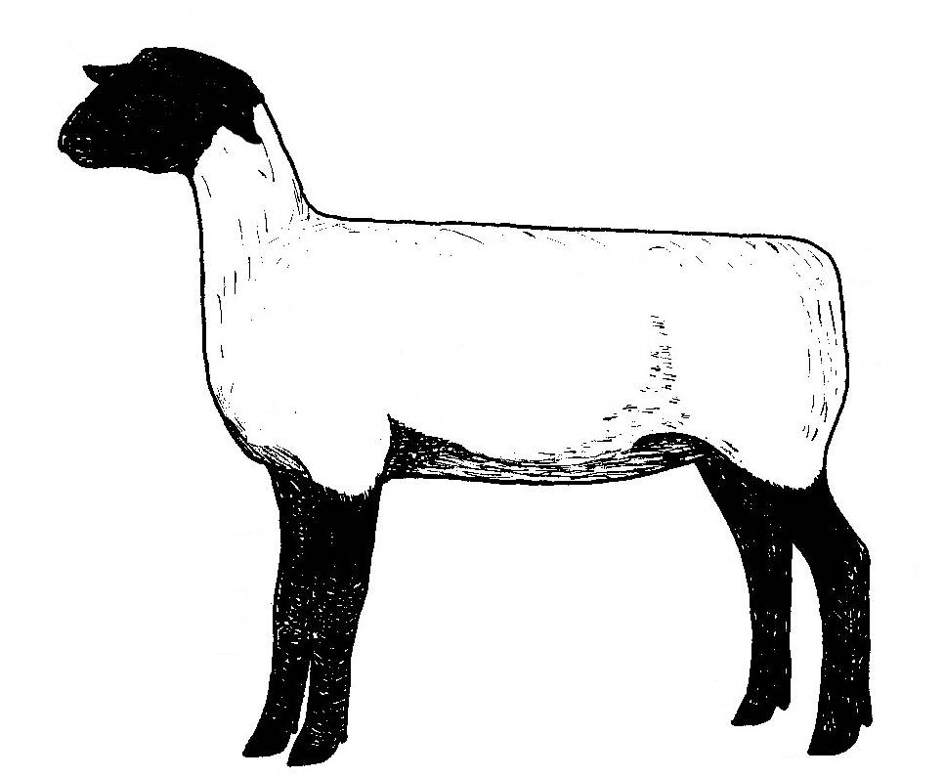

- True or False? Suffolk and Hampshire sired lambs are good selections for a 4-H market lamb project because they are ewe breeds.

- True or False? There are only 20 breeds of sheep in the United States.

- True or False? Ram breeds are best for Market Lamb projects because they are considered meat type breeds.

- True or False? Dual purpose breeds of sheep can be used as either ram or ewe breeds.

This life skill is important for all 4-H project members to learn and practice:

From the day you get your animal until it leaves your care it’s important to keep records on and .

- Two ways to permanently identify a lamb are:

Animal well-being is important because the image of agriculture and

4-H are affected by what two things:

Who should you call if you have questions about your animal’s

health?

What does VCPR stand for?

