- Name the parts labeled on the picture of the ram’s reproductive system below and define the functions of a, c and e.

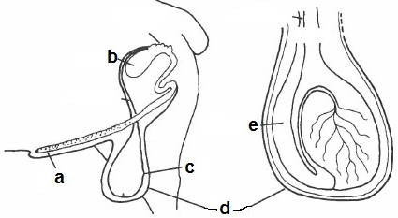

- True or False? Ram semen is extremely concentrated when compared to boar or bull semen?

- What is a Breeding Soundness Exam (BSE)?

- What age do ewes and rams normally reach puberty?

- What four factors can affect the age where sheep reach puberty?

- What is anestrus in ewes?

- What are three types of anestrus?

- What is the average length that estrus lasts in ewes?

- What are hormones?

- Match the following reproductive hormones with their function.

  - Estrogen
  - FSH
  - GnRH
  - Progesterone
  - Testosterone
maintains pregnancy
stimulates the production of sperm
development of sex organs in the ram
development of sex organs in the ewe
triggers the release of FSH and LH

- What are genetics?

- Write the heritability percentage on the line to the right, then rank the following heritability traits from 1-8 lowest (least heritable) to highest (most heritable).
Rank Trait Heritability (%)
birth weight
fleece yield
carcass weight
age at puberty
lamb survival
staple length
dressing percent
fleece color

