- Rabbit Diseases and Health: Fill in the blank.
1. Snuffles is the result of a bacterial infection caused by ____________________,

2. Mastitis is an infection that affects __________________ ___________.

3. Pneumonia affects the ______________ system.

4. Mange is caused by fur ___________.

5. Enterotoxemia can be prevented by strict ______________ practices.

- Feeding Systems: Which feeding system should you use?
For does with litters and weanling rabbits up to 10 weeks of age.
For all other types of feeding

- Rabbit Health: Answer the following Questions.
What is Creep Feeding? _______________________________________________________

What are the draw backs to creep feeding?
________________________________________

- Tell us about your rabbits.

How many rabbits do you have? _________________

What breeds do you have? ____________________________________________________

What is your favorite breed of rabbit and why? ____________________________________

__________________________________________________________________________

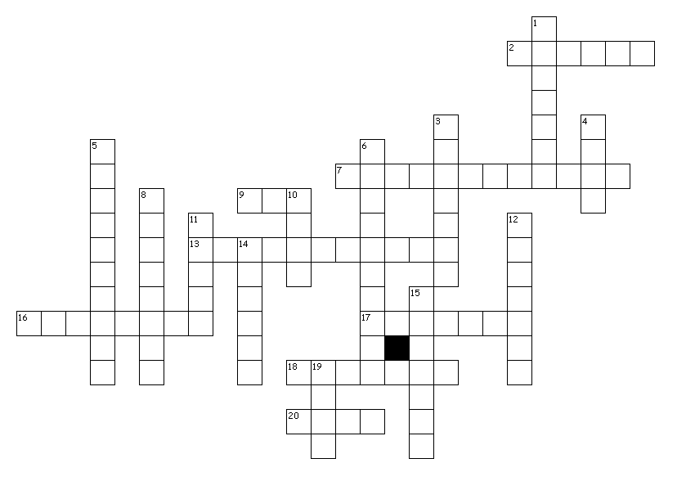
Vocabulary: Complete the following crossword puzzle.

Across
2. A mature germ cell (sex cell).
7. Having dissimilar alleles for the same traits.
9. Deoxyribonucleic acid.
13. Compounds produced by molds that inhibit the growth of bacteria.
16. Alteration of the DNA.
17. Determine if doe is pregnant.
18. A meat rabbit.
20. To remove the least desirable rabbits from the litter or herd.
Down
1. A hair shaft having a variety of color.
3. The body of a slaughtered rabbit.
4. Dark, sooty appearing color of hair.
5. Also called refection or cecotrophy.
6. Soft, moist cecal pellets that rabbits ingest directly from the anus.
8. Intestines.
10. American Rabbit Breeders Association
11. The French word for rabbit.
12. The internal organs of a rabbit located in the body cavity.
14. Permanent identification in the ear.
15. Genes that occupy corresponding positions on homologous chromosomes.
19. Egg

