Health & Diseases: List 5 facts for each of the following diseases
  - Ear Canker
  - __________________________________________
  - __________________________________________
  - __________________________________________
  - __________________________________________
  - __________________________________________
- Mange
  - __________________________________________
  - __________________________________________
  - __________________________________________
  - __________________________________________
  - __________________________________________
- Ringworm
  - __________________________________________
  - __________________________________________
  - __________________________________________
  - __________________________________________
  - __________________________________________
- Weepy Eye
  - __________________________________________
  - __________________________________________
  - __________________________________________
  - __________________________________________
  - __________________________________________

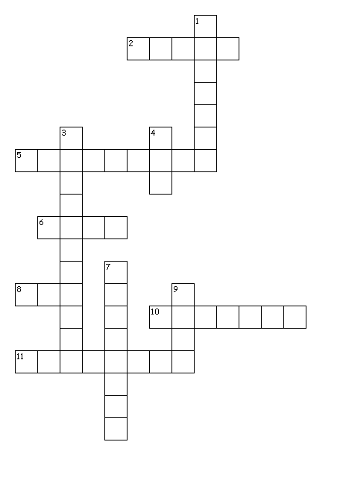
Housing and Equipment Crossword
Across
2. The most important nutrient for a rabbit.
5. Hutches should be built to protect the rabbit from ____________.
6. Cages constructed of this are used only indoors.
8. A baby rabbit.
10. Cages designed to house one or more rabbits while protecting the animals from
inclement weather and predators.
11. Outside rabbit hutches should be placed at the north side of an existing structure so they
do not receive direct ____________.

Down
1. Rabbits become frightened easily and are often very _____________.
3. The movement of fresh air to replace other air.
4. A female rabbit.
7. A separate building; an area in an existing building; or an outside area where rabbits are
housed is called _____________.
9. Choose a feeder with a screen or holes in the bottom to allow _______ to filter out of feed.

