1. **Step-by-step Processing of Rabbits**

**Place a number beside the step so that they are in the correct order that they would be completed.**

______ Refrigerate carcass for 24 hours prior to cutting into usable cuts.

______ Suspend the rabbit upside down.

______ Remove the heart and lungs by cutting from sternum to neck.

______ Separate the edges of the skin from the carcass, and pull the skin down over the

animal.

______ The heart, liver and kidneys are edible by-products of the carcass and can be

saved.

______ Remove the head at the atlas joint.

______ Render the rabbit unconscious.

______ Rinse the carcass with cool water and remove all blood clots.

______ Rinse carcass with cold water and soak in ice water to remove hairs and blood.

______ Using your knife, remove the tail.

______ Remove rear legs by snapping the leg bone with your fingers just below the hold

and cutting off with a knife.

______ Slit the abdominal wall of the carcass along the midline of the belly.

______ Slit the skin just below the hock of the suspended leg.

______ Remove the bladder whole and take out the entrails.

______ Remove the front feet.

1. Tell us your experience: Have you ever butchered your own rabbits? If yes, what did you learn from the experience?
2. **Mineral Functions: Complete the cross word puzzle.**

MCj02114920000[1]MCj02115280000[1]MCj03291700000[1]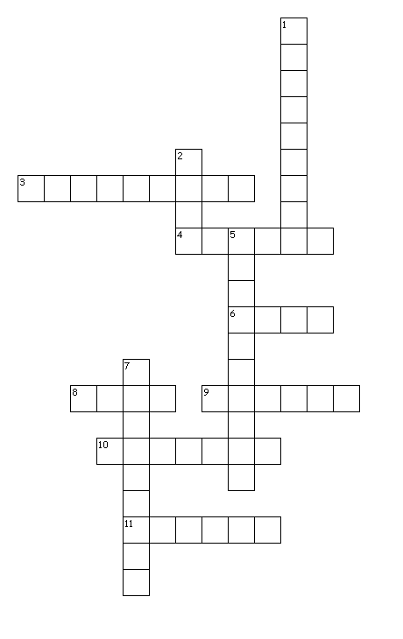

**Across**

3. Necessary for functioning of the nervous system.

4. Necessary for hemoglobin formation.

6. Assists with transfer of nutrient to the cells and removal of waste materials. Important in

making bile.

8. Enables blood to carry oxygen.

9. Constituent of Vitamin B-12.

10. Essential for development of normal bones and teeth.

11. Needed for thyroxin production.

**MCj02807480000[1]Down**

1. For proper function of mammary glands and normal reproduction.

2. Component of several enzyme systems.

5. Necessary for enzyme activation.

7. Essential for nerve function, and appetite.