1. **Digestive System:** Put the name of the organ/body part in the blank provided.

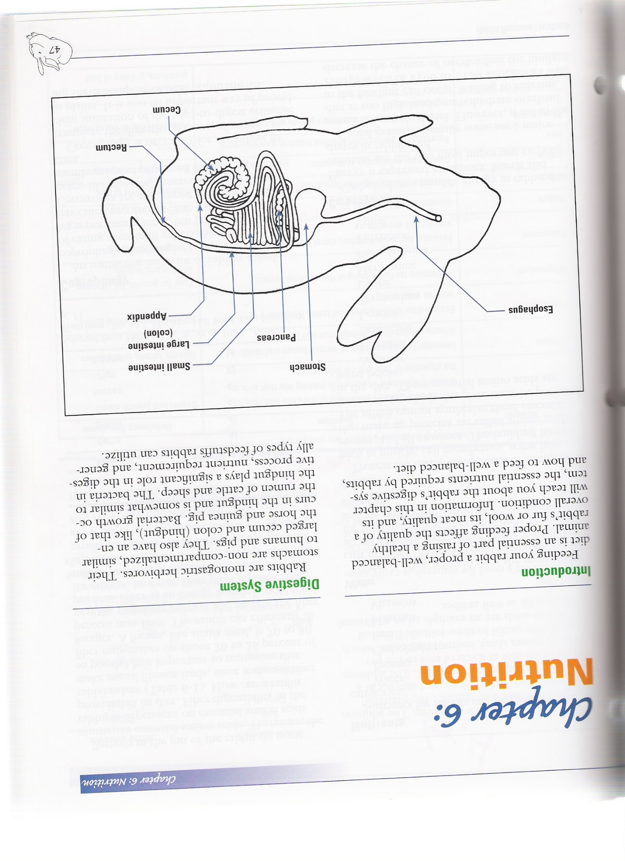

Pancreas

1. **Coprophagy**

An instinctive behavior of rabbits called Coprophagy is the act of eating their _______________. Two other names for this are: cecotrophy or ____________. Actually, the rabbit is not eating _________, but is eating cecal _________ called cecotropes. Cecotropes are also called _________ ________. Cecotropes are soft, moist pellets ___________ in grape-like clusters, covered by a ___________ ___________, and produced by the rabbit’s cecum. Coprophagy is necessary for the rabbit to complete the __________ process, allowing efficient utilization of the hard-to-digest cellulose in ______________. It is also an important way of providing the ____ complex vitamin requirements.

1. **Rabbit Communication, Behavior and Temperament:** describe the following
   1. A relaxed rabbit ______________________________________________

___________________________________________________________

* 1. A playful rabbit ______________________________________________

___________________________________________________________

* 1. A startled rabbit ______________________________________________

___________________________________________________________

* 1. A submissive rabbit ___________________________________________

___________________________________________________________

* 1. A fearful rabbit _______________________________________________

___________________________________________________________

* 1. An aggressive rabbit __________________________________________

___________________________________________________________

* 1. A stressed rabbit _____________________________________________

___________________________________________________________

1. **Your Rabbit Production:** How many years have you been in the 4-H rabbit project ____

What has been the most challenge to you _____________________________________

What has been the most rewarding __________________________________________

What advice do you have for new members just beginning in the project _____________

______________________________________________________________________

______________________________________________________________________