- Palpation: Fill in the blanks.
____________ is the process of determining if the doe is ____________ by feeling for developing _________ in the _________. This is done to allow breeders to ___________ non-pregnant (_______) does. Many days of ____________ are lost if an open doe goes the length of ____________ without being ____________ and rebred. Palpation also permits you to ____________ the efficiency of ____________ within the ____________. As a result of proper palpation, junior show ____________can be produced in a timely manner. Also, feeding ____________does that were assumed pregnant will decrease your feed ____________.
A doe can be ____________ palpated as early as the tenth day after breeding. A 10-day-old fetus is about the size of a ____________. A 14 to 17-day-old fetus is about the size of a ____________.
- Nutritional Value: Fill in the following chart. Be sure to look at the serving size.

Meat | Protein | Fat | Saturated Fat | Carbohydrates | Cholesterol | Calories
6 oz. rabbit | 50
3 oz. tuna

6 oz. beef |  | 26
6 oz. pork |  |  |  |  | 140
Chicken  1 thigh |  |  | 1.6

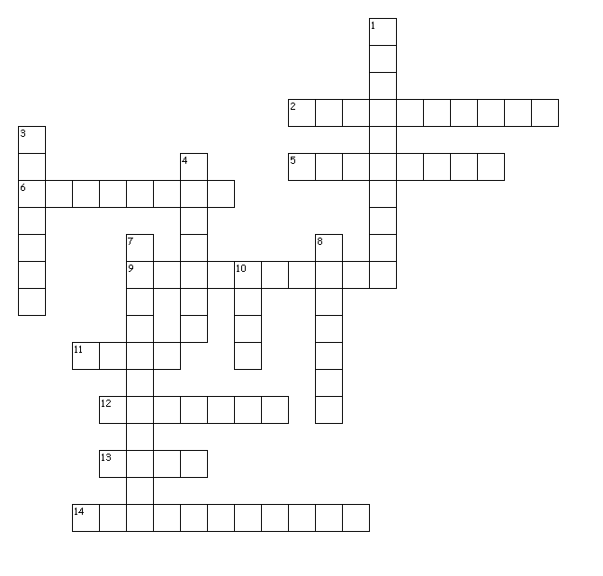Vocabulary: Complete the crossword puzzle.
Across
2. The mating of rabbits that are closely related.
5. The way rabbits mark their territory by rubbing their chins which leaves a small amount of secretion from the rabbit’s scent glands.
6. The intestines of an animal.
9. To remove the entrails of an animal.
11. One buck and one doe
12. The body of a slaughtered rabbit.
13. A buck used for breeding; the father of offspring.
14. Any deviation from the normally accepted condition of the body structure of a rabbit.

Down
1. Isolating new rabbits in an area away from established rabbits.
3. A person who raises a special breed or variety of rabbits.
4. A fault or defect detracting from the rabbit’s appearance.
7. A system or means of circulating air or providing fresh air.
8. For the doe to produce milk for her kits.
10. To remove the least desirable rabbits from the litter or herd.

