Herd Health Management

- Scrapie is a very serious disease that affects sheep and goats. Scrapie is considered a
____________________ disease, which means deterioration of neurons.

- Breeds, such as Boer and Kiko, have ____________________ as a breed standard.

- What are the contributing factors to ketosis?
__________________________________________________________________________________________________________________________________________________________________________________________________________________

- Explain the proper procedure for trimming the hooves of your goat.
__________________________________________________________________________________________________________________________________________________________________________________________________________________

- Identify the following:
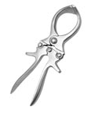
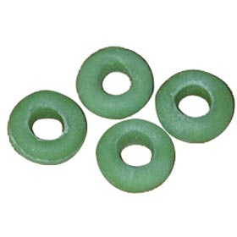
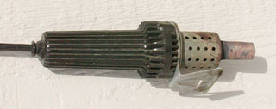

_______________ _________________ __________________

- When ear tagging your goats, the right ear identifies the ___________ and the left ear identifies the _________ year and ________.

- Match the following:

_____ Oral A. Injections given by inserting a needle just under the skin

_____ Subcutaneous B. Administering drugs straight into the muscle

_____ Intravenous C. Administering of drugs through the mouth

_____ Intramuscular D. Injections given directly into the bloodstream

- Identify this feedstuff and explain why it is important in your goat’s diet.

Feedstuff:
_______________

Importance in Diet:

________________________________________________________________________________________________________________________________________________

- Why can’t horns be sawed off after the animal is grown and the horns are large?

____________________________________________________________________________________________________________________________________________________________

- What are the ways that you can control the development of internal parasites in your goat herd?

__________________________________________________________________________________________________________________________________________________________________________________________________________________________________________

