Goats and Dairy Characteristics

- Identify the following parts
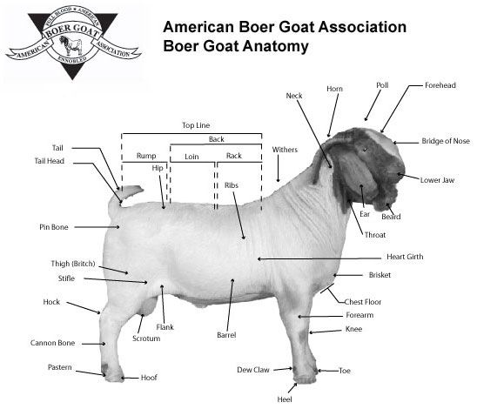

- Goats for the heavy chevon market must have enough muscle and lean growth to satisfy the consumer at their desired weight of _____________________________________________

- Match the following:

_____ Platter Style A. Medium to large goats used to prepare retail cuts that are attractive to the food service industry
_____ Roasting Style B. Intended for small to medium goats with sufficient weight for the Cabrito market
_____ Barbecue Style C. Medium size goats ideal for making cuts to be grilled and fabricated into one-inch chops
_____ Food Service Style D. Larger sized goats intended to make retail cuts similar to lamb
_____ Hotel Style E. Intended for smaller frame goats and served whole after cooking

- Describe two etnic markets for meat goats. ____________________________________________________________________________________________________________________________________________________________________________________________________________________________________________________________________________________________________________________

- Draw an example of a balanced, well-muscled meat goat.

