**Herd Management and Caring for Animals**

1. Match the Disease with the Time to Vaccinate for each:

____ Contagious Ecythma Booster A. 30 days prior to breeding

____ Chlamydia B. Annual or 2 months before the show season

____ Contagious Ecythma C. Kids 8-12 weeks of age if desired

____ Caseous Lymphadenitis D. Kids 4-6 weeks of age

1. Kids should be identified (at least temporarily) within the first _____ hours after birth.
2. Why is permanent identification especially important in the goat industry? ______________

_________________________________________________________________________

1. Identify the following:

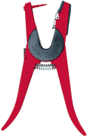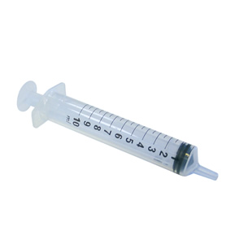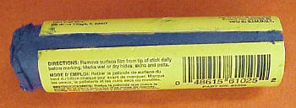

____________________ ____________________ ____________________

1. When ear tagging, what does the left ear represent ? _______________________________
2. Castration of the male kids usually occurs between _____ to ______ weeks of age.
3. A castrated goat is called a ____________.
4. Explain the process of castrating a male kid with an elastrator tool. ____________________  
   ____________________________________________________________________________________________________________________________________________________________________________________________________________________________________________________________________________________________________
5. Explain the proper procedure for trimming the hooves of your goat.

___________________________________________________________________________________________________________________________________________________________________________________________________________________________

1. Match the Disease with the Time to Vaccinate for each:

____ Contagious Ecythma Booster A. 30 days prior to breeding

____ Chlamydia B. Annual or 2 months before the show season

____ Contagious Ecythma C. Kids 8-12 weeks of age if desired

____ Caseous Lymphadenitis D. Kids 4-6 weeks of age

1. If a goat is sick with an infectious disease, what should be done in terms of pen and housing? ________________________________________________________________

________________________________________________________________________

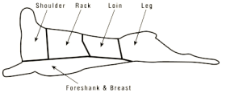12 - 20. Label the following: