Choosing An Animal

1-3. ID the following Breeds of Goats:

- ________________ 2. ________________ 3. ________________
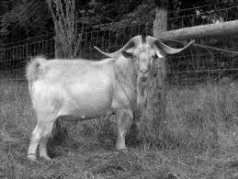
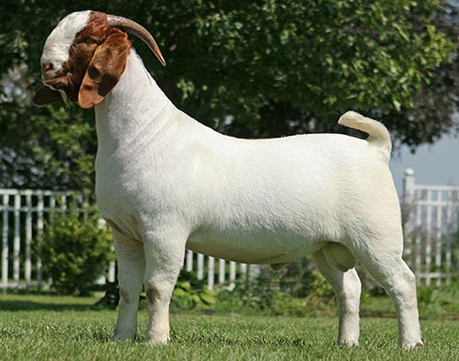
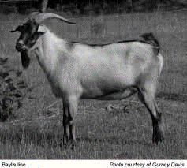

- What is the Latin name for goat? ___________________

- The ______________, a meat goat breed, was developed in New Zealand

- This goat is thought to be a descendent of the goat Spanish explorers brought to the United States as meat and milk producers. _______________________

16. This goat was selected for specific traits during development including rapid growth rate, increased fertility, good mothering skills and soundness in feet and legs. ___________

17-22. Label the following:

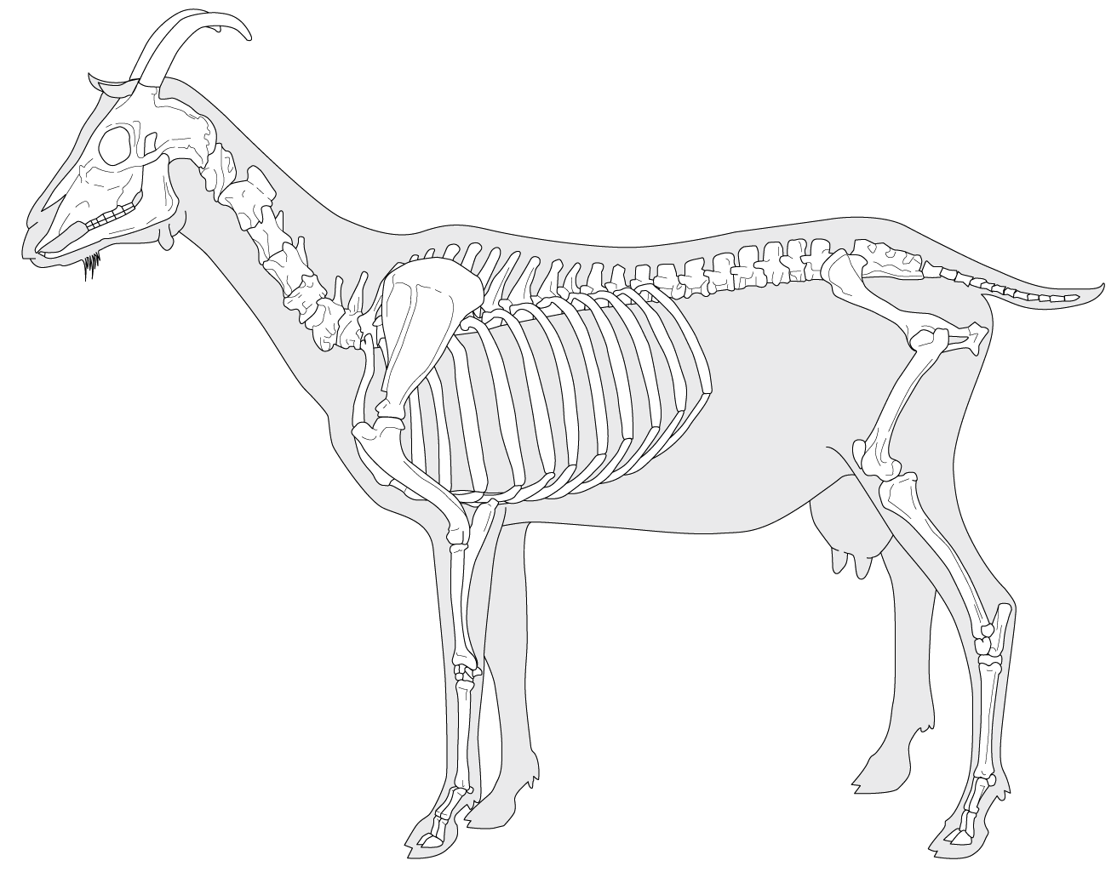

23. Circle which of the below pictures represent the idea leg structure of a goat.

Front Legs Back Legs
