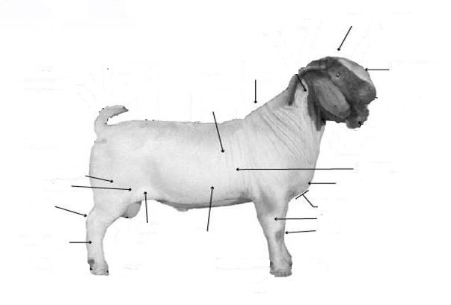
- ID the following Parts of a Boer Goat:
- What are ways that you can control the development of internal parasites in your goat herd? __________________________________________________________________________________________________________________________________________________________________________________________________________________
Maintain a good level of nutrition. Treat goats a couple of days before moving them from one pasture to another. Prevent manure from getting into the feed and water. Watch young animals at times of stress. May need to deworm the kids before weaning them. (pg. 89)

- Scrapie is a very serious disease that affects sheep and goats. Scrapie is considered a ___________________ disease, which means deterioration of neurons.

- Fat thickness is measured where? ________________________________________

- A 70 lb meat goat should be expected to have a carcass weight of ________ lbs. and a back fat measurement of _________ inches.

- Match the following Routes of Medication Administration:
____ Subcutaneous A. Administering drugs directly into the udder.
____ Intravenous B. Injections given by inserting a needle just under the skin.
____ Intramammary C. Administering of drugs through the mouth.
____ Oral D. Injections directly into the bloodstream.

- What does “withdrawal time” refer to?
_____________________________________________________________________
_____________________________________________________________________
_____________________________________________________________________

- Match the Following Medication Label Terms:
____ Name of Drug A. Manufacturer’s reference number to indicate
the day/batch which the product was made.
____ Storage B. Tells how the medication should be
kept while not in active use.
____ Expiration Date C. Brand or generic name of drug being prescribed.

____ Lot Number D. Tells when to discard the drug.

- _______________ diseases are illnesses that can be transmitted between humans and
animals. Examples of these diseases include Leptospirosis, Rabies, Ringworm

