- Match the following Routes of Medication Administration:
  - ____ Subcutaneous A. Administering drugs directly into the udder.
  - ____ Intravenous B. Injections given by inserting a needle just under the skin.
  - ____ Intramammary C. Administering of drugs through the mouth.
  - ____ Oral D. Injections directly into the bloodstream.

- All meat goats should be clipped approximately days prior to show.

- Match the Following:
  - ____ Doe A. Lack of difficulty in giving birth.
  - ____ Kid B. A castrated male kid.
  - ____ Kidding Ease C. A female goat.
  - ____ Buck D. An intact male goat.
  - ____ Wether E. A young goat less than 6 months of age.

- When administering medication to your goats, it is vital to use needles
  - and syringes and keep bottles and bottle caps __________.

- Goats are most comfortable between ___ ___ and ______ degrees F.

- This type of housing uses less bedding, houses animals that receive more individual care and are considered more labor intensive. __________________

- No matter what type of housing or operation you have, your goats must be in an area that is ____________, _________, and free from ______________.

- Good fencing is key with goats for two reason; name them.

________________________ and ____________________

- Label the Following:

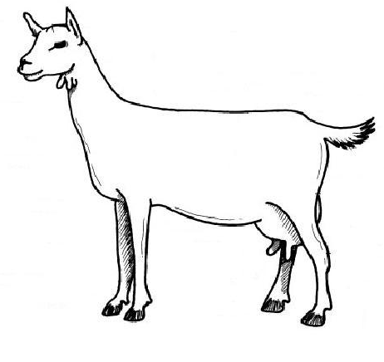

- Label the following:

