Reproduction

1- 9. Male Reproductive System – Identify the Following.

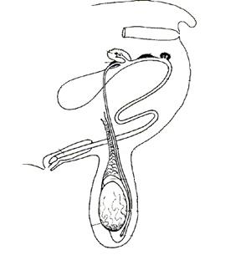

- An estrous cycle typically occurs every ______ days.

- The estrous cycles of goats are stimulated to begin when the days are becoming ____________ in the late ________ and fall.

- Does that are healthy and well managed nutritionally can be bred when? ____________

- Explain the importance of kids receiving colostrums within the first few hours of life. ____________________________________________________________________________________________________________________________________________

- The female reproductive system has two major roles; identify those: _______________
____________________________________________________________________________________________________________________________________________
- What are some signs of a doe approaching kidding? ____________________________
____________________________________________________________________________________________________________________________________________

- Describe the type of goat you would look for to show and why? ___________________
______________________________________________________________________
______________________________________________________________________

- Embryo transfer is a complex process to perform on does. Name some important benefits of this process that would make it worthy of performing___________________
______________________________________________________________________

- Complete the following: 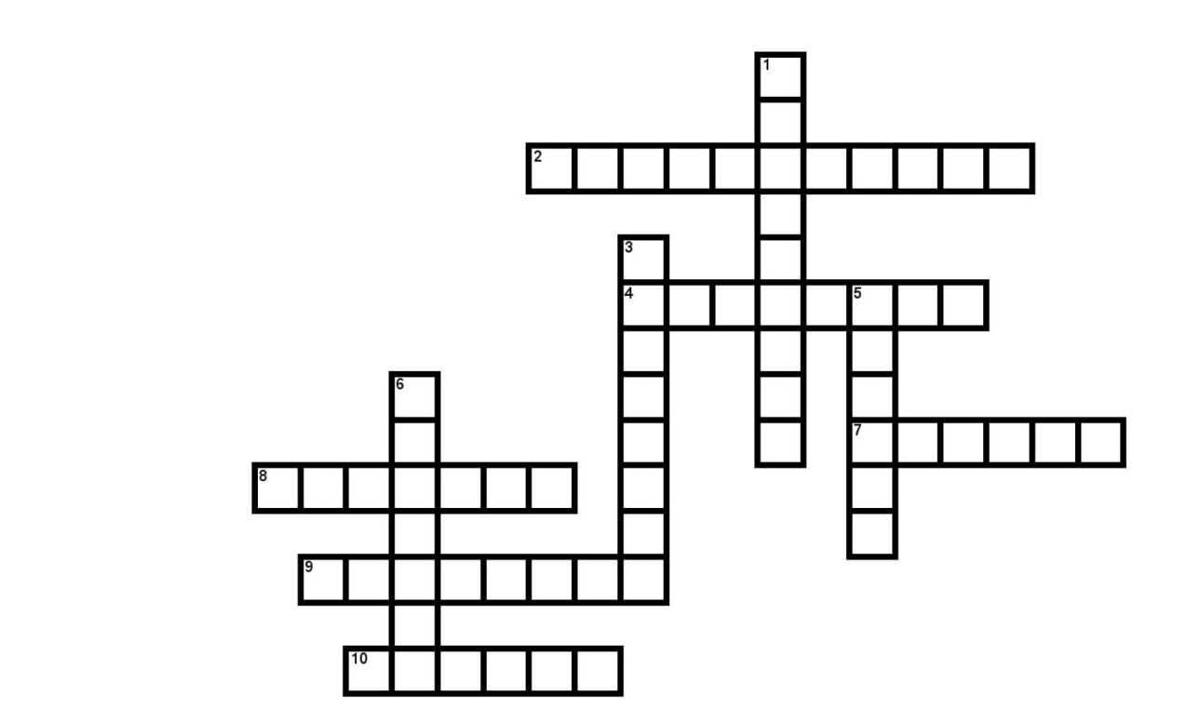

H

R
M

Across:
2. Site of production for Melatonin
4. This hormone stimulates muscular contractions of the uterus
7. Site in which sperm is deposited during natural mating
8. Hormone which causes tissues in birth canal to relax for ease of kidding
9. Small tubes leading from each ovary to uterus
10. Period of time when the doe is receptive to mating
Down:
- First milk produced by the doe after kidding.
3. Chemical compounds released into blood that control reproductive systems
5. Helps to protect the uterus
6. Produce eggs in follicles

