Reproductive Management and Genetics

- A successful reproductive program in a goat herd requires managers to properly detect estrus. Identify some of the obvious signs of estrus:_______________________________
________________________________________________________________________________________________________________________________________________________________________________________________________________________

- Explain Estrous Synchronization and give some benefits of using this method in your goat herd. ___________________________________________________________________
________________________________________________________________________________________________________________________________________________________________________________________________________________________
- Match the following: (Notice that Lutalyse and Prostaglandin will have 2 responses each)
____ PMSG A. Destroys the corpus luteum
____ ____ Lutalyse B. Prevents ovulation until removal
____ SynchroMate-B C. Destroys the corpus luteum
____ ____ Prostaglandin D. Stimulate ovulation

- What is the key reproductive hormone that is used to stimulate the growth of multiple follicles on the eggs? _______________________________________________________

- The birth of an animal where the rear legs are coming first instead of head or front feet first is known as a ____________ birth. Is assistance needed with this type of birth? ________

- Where does an animal get its genes from?
_____% from parents _____% from grandparents _____% great grandparents

- Explain what ETA is. _______________________________________________________
________________________________________________________________________________________________________________________________________________

- The estrous cycles of goats are stimulated to begin when the days are becoming ____________ in the late ________ and fall.
- Find the genotype and phenotype of the following: DoeRr BuckRr

Genotype:

Pheotype:

- Does that are healthy and well managed nutritionally can be bred when? ____________

11. Complete the Following:
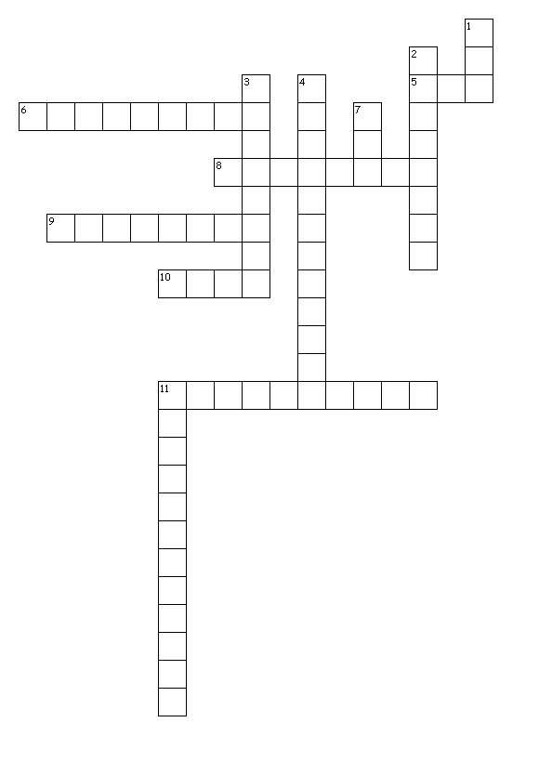

Across
5. Predicts the genetic potential of an offspring
6. A gene that is not dominate for a characteristic
8. One gene of the gene pair that determines a characteristic
9. The passing of genetic material from parents to offspring
10. Consists of a specific sequence of DNA
11. Two genes are the same

Down
1. Genetic material that controls a trait
2. Inherited characteristics and how they vary
3. Gene pair
4. Statistic used to describe the amount of variation within a population
7. Measure of type evaluations for selecting the best animal for breeding
11. Genes are different

