- Good Horse Sense!
Answer the following questions about the behavior of horses.

What part of the horse’s body will give you a good indication of what the horse is thinking?_________________

Do you train all horses the same? (If you answer no then tell why not.) ________________________________________________________________________________________________________________________________________________________________________________________________________________________

Match the horse and the behavior it is exhibiting.

Drowsiness Focused on behind the horse
Focused on what is in front of the horse Aggression

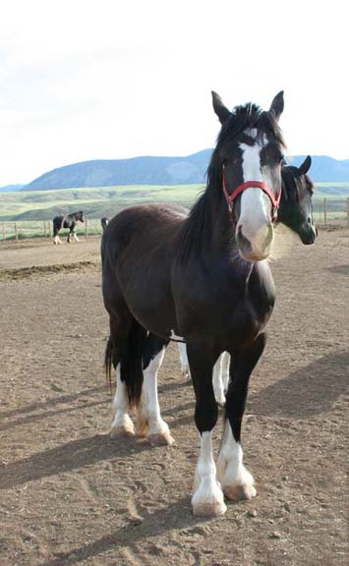
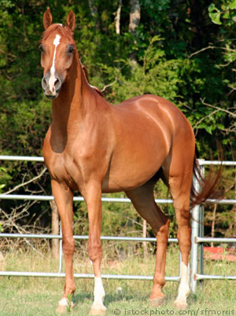
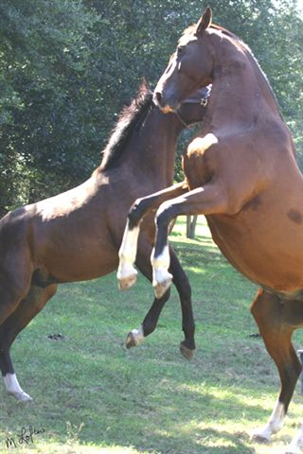

_______________ __________________ ________________
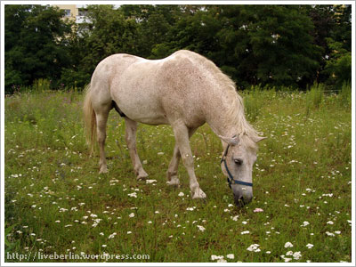

_______________________

- Parts of the hoof
Match the number on the hoof structure with the appropriate name of the part.

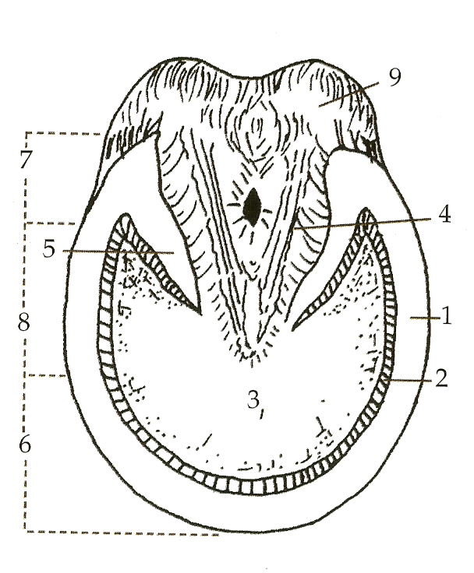

_____Bulb

_____Frog

_____Heel

_____Bar

_____Sole

____Quarter

_____Toe

_____White Lane

_____Wall

- Shoeing True or False

T F Putting shoes on a horse is always best for them.

T F If a horse wears shoes for too long of a time period the hoof can grow over the shoe.

T F In icy and muddy conditions shoes help the horse have more traction.

T F Shoeing helps minimize shock to a horse’s ligaments and tendons.

T F A person who does shoeing is called a farrier.

