- Parts of a Horse

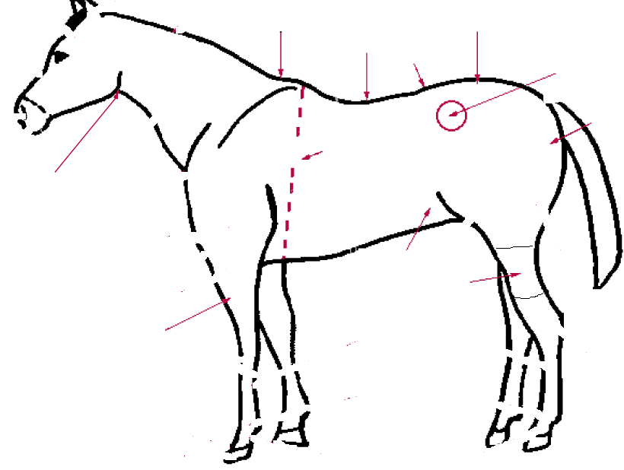
4
1
7
6
5
3
2
11
10
9
8
Place the number from the above picture with the matching body part.

___ Back ___ Flank ___ Throat Latch
___ Buttocks ___ Forearm ___ Loin
___ Crest ___ Gaskin ___ Point of Hip
___ Croup ___ Heart Girth

- Match the coat colors with the correct description
Dun Has irregular patches in more than one color
Paint White intermingled with one or more based colors.
Roan Deluded body color
Chestnut The body color can range from light yellow to bright copper.
Palomino A shade of red

- Grooming Supplies
Name the grooming supply shown below.



