Herd Management and Disease

- Why is it important to have a veterinarian client-patient relationship? __________________
_________________________________________________________________________

- Match the Following:
____ Name of Drug A. Manufacturer’s reference number to indicate the
day/batch which the product was made.
____ Storage B. Tells when to discard the drug.
____ Expiration Date C. Brand or generic name of drug being prescribed.
____ Lot Number D. Tells how the medication should be kept when not in use.

- ________________ is extremely important when dehorning, castrating, giving injections and tattooing in the attempt to avoid tetanus taking the life of your goat.

- What are ways that you can control the development of internal parasites in your goat herd? ___________________________________________________________________________________________________________________________________________________________________________________________________________________________
T
E
T
E
N
U
F
E
C
E
KE
T
R P
C O C C I D I O S I S
S
N
G
WORM
N
KEYE
E N T E R O T O X E M I A
S
- Caprine arthritis encephalitis (CAE) is a disease that can be transferred to the kid via ________________.

- Explain why all kids should have their navels dipped in 7% iodine after birth.
_______________________________________________________________________

- Why can’t horns be sawed off after the animal is grown and the horns are large? ______________________________________________________________________________________________________________________________________________

- When are kids normally dehorned? ___________________________________________

- A castrated male goat is called a _____________.

- Identify the Following:
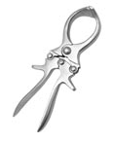
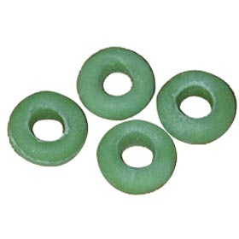
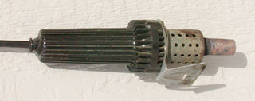

________________ ________________ ________________

- Explain the identification process of kids. How early should identification be done and what methods can be used? ________________________________________________
______________________________________________________________________________________________________________________________________________

- When ear tagging your goats, the right ear identifies the _________ and the left ear identifies the ________year and ________.

- Explain how to control the development of internal parasites. ______________________
______________________________________________________________________________________________________________________________________________

- Goats are susceptible to urinary calculi. What causes this condition and can it be fatal?
______________________________________________________________________________________________________________________________________________

- This fungus is contagious, easy to spread and is a zoonotic disease. ________________

- Describe what can be done prior to kidding to assist in preventing ketosis. ____________
______________________________________________________________________________________________________________________________________________

- Match the Following:
____ Oral A. Injections given by inserting a needle just under the skin.
____ Subcutaneous B. Administering drugs straight into the muscle.
____ Intravenous C. Injections given directly into the bloodstream.
____ Intramuscular D. Administering of drugs through the mouth.

