Herd Management

- Why is permanent identification especially important in the goat industry? ______________
_________________________________________________________________________

- This type of housing uses less bedding, houses animals that receive more individual care and are considered more labor intensive. ________________________________________

- Match the Following

____ Warm Housing A. Building that is uninsulated, has natural ventilation and
near temperatures similar to outside temperatures.
____ Loose Housing B. Environmentally controlled building, keeping temperatures
above freezing, regardless of outside temperatures.
____ Stall Housing C. Where animals are confined to their box or tie stalls.
____ Cold Housing D. Normally used for dairy goats including freestalls.

- Complete the following:

Across Down
3. This band serves as a safe 1. A castrated male goat
method to castrate goats
4. The easiest dehorning method used 2. This paste can be used
5. The removal of testicles to disbud.

- If a goat is sick with an infectious disease, what should be done in terms of pen and housing? ________________________________________________________________
________________________________________________________________________
- Match the Disease with the Time to Vaccinate for each:
____ Contagious Ecythma Booster A. 30 days prior to breeding
____ Chlamydia B. Annual or 2 months before the show season
____ Contagious Ecythma C. Kids 8-12 weeks of age if desired
____ Caseous Lymphadenitis D. Kids 4-6 weeks of age

7 - 20. Label the following:

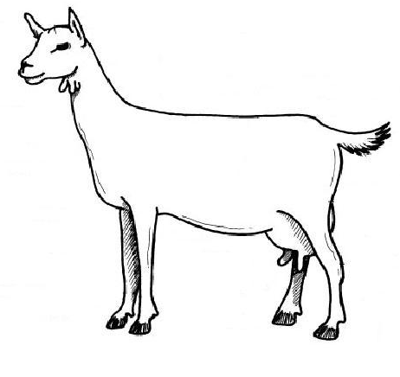

21. If a producer sells a 130 pound live weight meat wether for $2.00 per pound and it costs him $85.00 to raise the goat. What is his profit? (show your work)_____________________
_________________________________________________________________________

- Match the Following:

____ Doe A. A female goat.
____ Kid B. Small horn buttons attached to the skin.
____ Kidding Ease C. The practice of conditioning does before breeding.
____ Buck D. Removal of the testicles.
____ Wether E. A young goat less than 6 months of age.
____ Castration F. Treating the doe for internal parasites orally.
____ Flushing G. An intact male goat.
____ Drenching H. A castrated male kid.
____ Scurs I. Lack of difficulty in giving birth.

