Choosing An Animal

1-3. ID the following Breeds of Goats:

- ________________ 2. ________________ 3. ________________
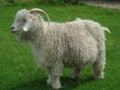
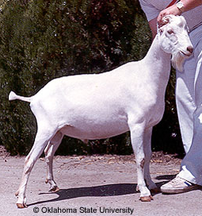
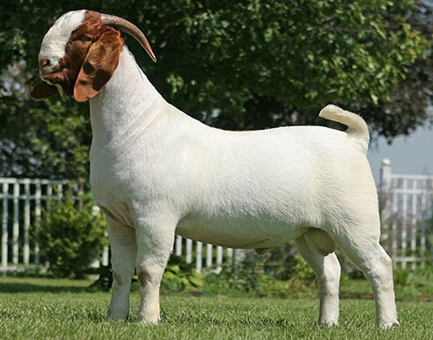

- Selection of an animal depends on your project ___________, as well as on what breed, size and quality of animal you would like.

- What is the Latin name for goat? ___________________

- The ______________, a dairy goat breed, is the oldest known registered breed in the world.

- True or False Purchasing animals at high prices guarantees success.

- Worldwide, goat meat is consumed more than any other red meat and is a staple in many countries for ______________ and ______________

- ______________ are known for being excellent milkers, with large, well-shaped udders.

- LaManchas have two types of ears
  - _____________ ear; very little and no _____________
  - _____________ ear; maximum of _____ inches in length.

- The _____________ is a large animal and is more heavily muscled than other dairy breeds. This heavier muscling makes this breed __________________ as a meat goat.

- This breed is of the Swiss origin and is a medium sized dairy goat. ________________

- Angora – The fleece grows year-round at the rate of _____ to _____ inch per _______.

8-14. Label the Following:
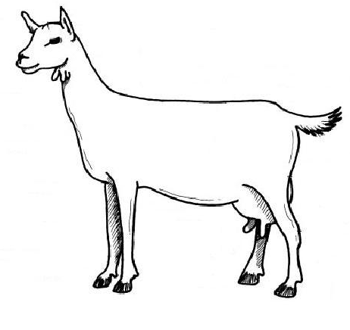

15-19. Label the following:

