Caring for Your Animals

Your duty as a 4-H member is to properly care for your animals. You need to understand the privileges, responsibilities, and rewards that you can expect from the 4-H program.
1. Determine if the following 5 statements are:
P – Privilege R – Responsibility W – Reward

_______ To be willing to learn/participate in training programs/meetings.
_______ To make new friends and have fun.
_______ To be given experiences relating to project work.
_______ To feel good about producing a wholesome, consumable product.

- Match the Following:
____ Doe A. Lack of difficulty in giving birth.
____ Kid B. A castrated male kid.
____ Kidding Ease C. A female goat.
____ Buck D. An intact male goat.
____ Wether E. A young goat less than 6 months of age.

- When giving medication to market animals, it is important to follow
_____________ times.

- You should always check with your before administering medication to your goat. A. Brother B. Stuff Animal “Bob” C. Veterinarian

- What does “withdrawal time” refer to?
________________________________________________________________________________________________________________________

- When administering medication to your goats, it is vital to use ____________ needles and syringes and keep bottles and bottle caps __________.

- All goats need to be taught to use a lead and to be set up. This training needs to start several _______________ before showing.

- When showing your goat:
Always keep one eye on your __________ and one eye on the judge.
Keep the animal between you and the _____________.
Keep enough distance between _________ and the animal in front of you.

- Label the following:
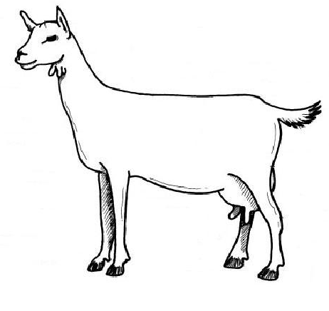

- ID the following Breeds of Goats:

- ________________ 2. ________________ 3.______________
