Nutrition

- Explain how the rumen converts feed. _________________________________________
________________________________________________________________________________________________________________________________________________________________________________________________________________________

- A kid’s resistance to disease is influenced by the quality of __________.

- What is the most common means of providing forage for goats? ________________

- Identify the correct part of the ruminant digestive system which does the following:
  - Mixes/Stores, serves as a fermentation vat _____________________
  - Catches large particles of feed for further digestion _____________________
  - Produce and secrete digestive enzymes and acids _____________________
  - Squeeze and absorb water from the feed _____________________

- What is a result of Vitamin C deficiency? _________________ , ___________________ , _________________ and ___________________ ,

- This Vitamin may be need to supplemented to animals that are stressed or sick. ________

- How does a Vitamin D deficiency affect the bones/joints of an animal? _______________ , ________________ and ____________________________________________________

- Select 2 minerals necessary in a diet of a goat and indicate the function of the mineral and ways to provide the mineral into the diet.
  - Mineral __________________
Function _________________________________________________________
Ways to Provide in Diet _____________________________________________
  - Mineral __________________
Function _________________________________________________________
Ways to Provide in Diet _____________________________________________
- What are Ionophores? Explain their role in the goat’s feed ration. ____________________
________________________________________________________________________________________________________________________________________________________________________________________________________________________

- What does a buck need during the breeding season for proper nutrition?
________________________________________________________________________

- You have 10lbs of hay at 90% Dry Matter (DM) that you are feeding your doe each day. Calculate how many lbs of DM this doe is eating per day.

- You have a wether that you want to feed at 1% protein. You are mixing a 34% protein pellet with 8.9% cracked corn. You want 300 pounds of feed when you are done. Using the Pearson Square, how much of each will you need to mix to get the desire protein content?

- Identify the Following Feed Ingredients:

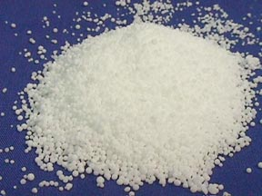
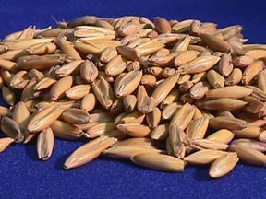
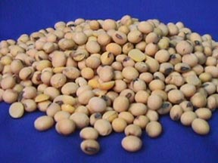

A. _______________ B. _______________ C. _______________

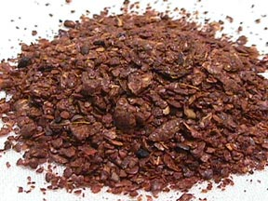
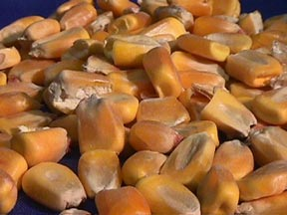
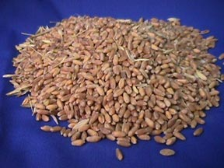

D. _______________ E. _______________ F. _______________

