Herd Management, Nutrition and Disease

- Explain the proper procedure for trimming the hooves of your goat. ___________________
___________________________________________________________________________________________________________________________________________________________________________________________________________________________

- When is the best time to treat pregnant does for parasites? __________________________

- Explain how urinary calculi comes about and tell how to prevent this condition.___________ ___________________________________________________________________________________________________________________________________________________________________________________________________________________________

- ________________ is extremely important when dehorning, castrating, giving injections and tattooing in the attempt to avoid tetanus taking the life of your goat.

- What are the contributing factors to ketosis? _____________________________________
__________________________________________________________________________________________________________________________________________________

- Ketosis is more common in first _________________.

- What are ways that you can control the development of internal parasites in your goat herd? ___________________________________________________________________________________________________________________________________________________________________________________________________________________________

- Scrapie is a very serious disease that affects sheep and goats. Scrapie is considered a ____________________ disease, which means deterioration of neurons.

- Why does milk fever occur? __________________________________________________

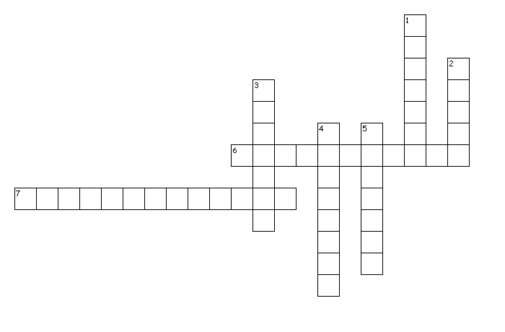
- Complete the following:

Across
6. Caused by a parasite, symptoms include bloody diarrhea and loss of appetite.
7. Overeating disease, can cause sudden death in animals.

Down
1. This bacteria is usually fatal once the symptoms appear.
2. Where young kids usually pick up the Coccidiosis organism.
3. This pregnancy-related disease is caused by inadequate energy in the ration.
4. Caused by a fungus and results in scaly or hairless patches on the head, ears, and neck.
5. Animals with this eye disease are not eligible to show at fair.

- Identify this feedstuff and explain why it is important in your goat’s diet.
Feedstuff: ________________

Importance in Diet: _________________________________________________________________________________________________________________________________________________________________________________________________________________________________________________________________________

