Choosing An Animal

- ID the following Parts of Goats:

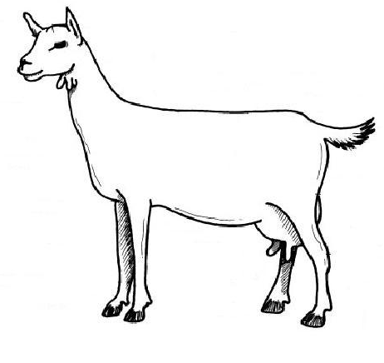

- Explain the roles of the mammary gland. _____________________________________
__________________________________________________________________________________________________________________________________________________________________________________________________________________

- Explain the pathway of oxytocin release in milk letdown. _________________________
__________________________________________________________________________________________________________________________________________________________________________________________________________________

- Once oxytocin is stimulated, full milk letdown takes how long to respond? ___________

- Draw an example of a good teat structure you would prefer in your female goats, draw an example of a poor teat structure and explain why you would not want it in your herd.

Ideal Teat Poor Teat Structure

What makes this example undesirable?
_________________________________________________________

- Explain the difference between “acute mastitis” and “chronic mastitis”. _____________
____________________________________________________________________________________________________________________________________________

- What should teats be dipped in immediately after milking? _______________________
- Complete the following:
Across
4. Causes mastitis
5. This is known as high temp
short-time pasteurization
6. Responsible for milk letdown

Down
1. Fight or flight hormone
2. Milk proteins
3. Infection of the mammary gland
4. Act of giving birth to young

