**Goats, Goats, and more Goats**

1. Match the Following:

____ Doe A. The practice of conditioning does before breeding.

____ Kid B. Treating the doe for internal parasites orally.

____ Kidding Ease C. A female goat.

____ Buck D. Removal of the testicles.

____ Wether E. A young goat less than 6 months of age.

____ Castration F. Small horn buttons attached to the skin.

____ Flushing G. An intact male goat.

____ Drenching H. A castrated male kid.

____ Scurs I. Lack of difficulty in giving birth.

1. Fat thickness is measured where? __________________________________________
2. A 70 lb meat goat should be expected to have a carcass weight of ________ lbs. and a back fat measurement of _________ inches.
3. What are the four wholesale cuts of goat?

________________ ________________ ________________ ________________

1. Match the following retail cuts with its wholesale part:

____ Rolled Shoulder A. Fore Shank/Breast

____ Rolled Leg B. Shoulder

____ Rib Roast C. Rack

____ Blade Chop D. Loin

____ Chop E. Leg

1. Identify the following (Cuts of Chevon):

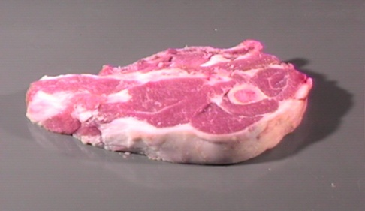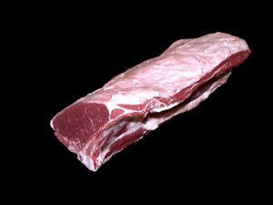

1. Shoulder Chop A. Loin Roast
2. Arm Chop B. Shoulder Chop
3. Rib Roast C. Fore Shank
4. Complete the Following:

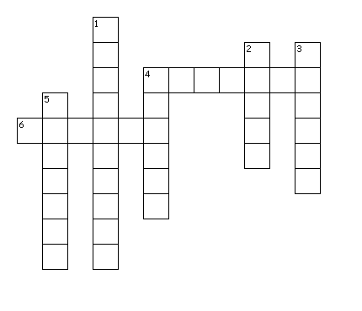

**Across**

4. Goat carcass that weighs   
15-30 lbs used in Hispanic populations

6. A wide-framed goat most

likely has more of this

**Down**

1. This correctness is an evaluation of the skeletal system/bone structure
2. An estimate of the amount of saleable product from the carcass
3. Refers to the length and depth of the goat
4. Goat Meat
5. Palatability or taste
6. Describe the type of goat you would look for to show and why? ___________________  
   ______________________________________________________________________  
   ______________________________________________________________________
7. Explain a market for your meat goats; include the appropriate specifications desired by that market. ____________________________________________________________

____________________________________________________________________________________________________________________________________________