**Herd Management**

1. Kids should be identified (at least temporarily) within the first _____ hours after birth.
2. Permanent identification helps with quality assurance, ___________ _______________ and ____________ ________.
3. Why is permanent identification especially important in the goat industry? ______________

_________________________________________________________________________

1. Identify the following:

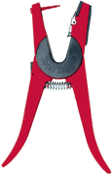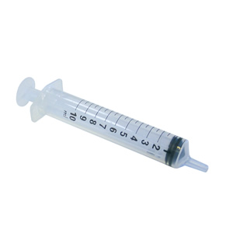

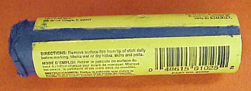

____________________ ____________________ ____________________

1. When ear tagging, what does the left ear represent ? _______________________________
2. Complete the following:

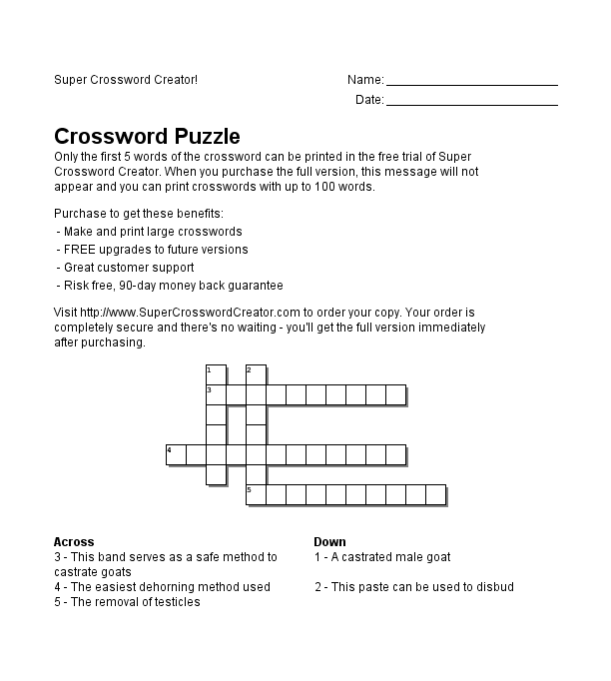

**Across** **Down**

3. This band serves as a safe 1. A castrated male goat

method to castrate goats

4. The easiest dehorning method used 2. This past can be used

5. The removal of testicles

1. Overgrown hooves can cause what ? __________________________________________ ,

_______________________________ and ______________________________________

1. Hooves should be trimmed every ____ or _____ months.
2. Explain the proper procedure for trimming the hooves of your goat. ___________________

___________________________________________________________________________________________________________________________________________________________________________________________________________________________

1. Match the Disease with the Time to Vaccinate for each:

____ Contagious Ecythma Booster A. 30 days prior to breeding

____ Chlamydia B. Annual or 2 months before the show season

____ Contagious Ecythma C. Kids 8-12 weeks of age if desired

____ Caseous Lymphadenitis D. Kids 4-6 weeks of age

1. If a goat is sick with an infectious disease, what should be done in terms of pen and housing? ________________________________________________________________

________________________________________________________________________

12 - 25. Label the following:

