Choosing An Animal

1-6. ID the following Breeds of Goats:

- ________________ 2. ________________ 3. ________________
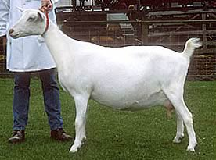
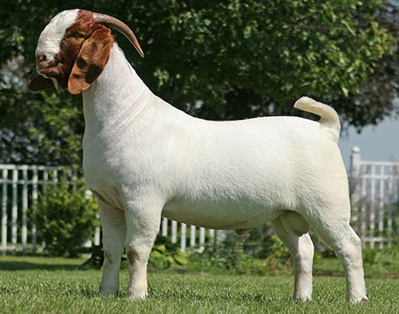
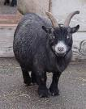

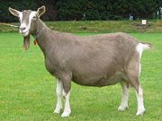
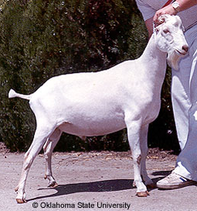
4. ________________ 5. ________________ 6. ________________
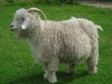
- Originated in the Alps region, a fairly large and rangy goat. _____________

- Medium-sized animal, many color combinations and developed in the US. ______________

- Much smaller than the standard dairy goat breeds, known to produce approximately 1 quart
of high fat milk per day for up to 10 months. _____________________

- This large goat was selected for specific traits during development including rapid growth rate, increased fertility, good mothering skills and soundness in feet and legs. ___________

- Sable – Mature does must be at least _____ inches tall at the withers and weigh ______ lbs.
Mature bucks must be at least ____ inches tall at the withers and weigh ______ lbs.

- Angora – The fleece grows year-round at the rate of _____ to _____ inch per __________.

- Pygmy – A doe in milk can be expected to produce 1 _____ of high fat milk twice a day for
_____ to _____ months.

  - Label the Following:

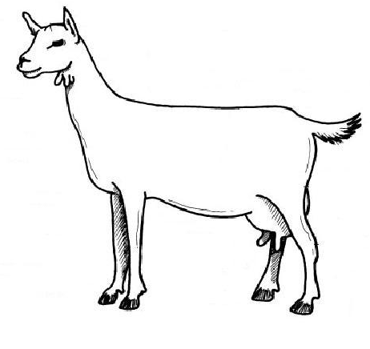

  - Label the following:

