Nutrition

- Because goats are ruminant animals, they can digest _____________.
- How many stomach compartments does a goat have? _______
- The rumen is the first and the ____________ compartment of the goat’s digestive system. The rumen acts as a large __________________ vat which ______ and stirs up the food. The rumen can hold about 6 ___________ of material.

- Explain how the rumen converts feed. _________________________________________
________________________________________________________________________________________________________________________________________________________________________________________________________________________

- Match the following:
____ Rumen A. Produce and secret digestive enzymes and acids
____ Reticulum B. Regurgitation of food for rechewing
____ Omasum C. Catches large particles of feed for further digestion
____ Abomasum D. Squeeze and absorb water from the feed
____ Rumination E. Mixes/stores, serves as fermentation vat

- What is the most important nutrient needed to survive?__________________ and how much of a goat’s body is composed of this nutrient? ______ - ______ %

- Explain the importance of protein in a goat’s diet. ____________________ , ___________
______________________ , _____________________ and ________________________

- A 100 pound goat that is not producing milk consumes about ________ of water per day.

- A kid’s resistance to disease is influenced by the quality of __________.

- What is the ideal time to wean a kid from its mother? _____________

- What is the most common means of providing forage for goats? ________________
- Match the mineral with its function and deficiency sign.
Mineral Functions and Deficiency Signs

- Co-factor for major enzymatic reaction
- Rickets in growing animals
- Decreased intake, weight loss, reduced milk yield
- Reduced animal performance and reduced fiber digestion
- Helps to transport material across cell walls
- Muscular activity; osmotic pressure of body fluid
- Muscle contraction, proper skeletal structure, and milk production
- Eating anything containing salt, lack of appetite
- Required by rumen microbes for fiber digestion
- Grass tetany or staggers

Function Deficiency
Sign
_____ Calcium _____
_____ Magnesium _____
_____ Potassium _____
_____ Salt _____
_____ Sulfur _____

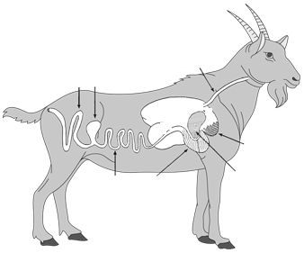
- Identify each part of the ruminant digestive system.
8
7
6
5
4
3
2
1

- _________________
- _________________
- _________________
- _________________

- _________________
- _________________
- _________________
- _________________

