Choosing An Animal

1-6. ID the following Breeds of Goats:

- ________________ 2. ________________ 3. ________________
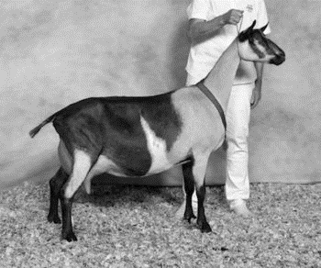
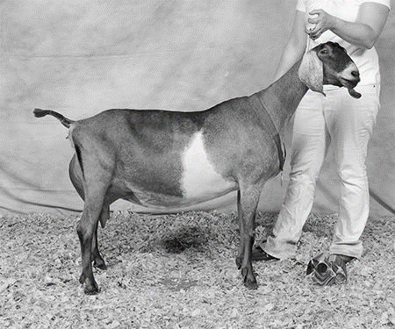
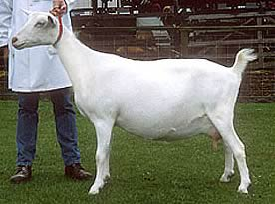

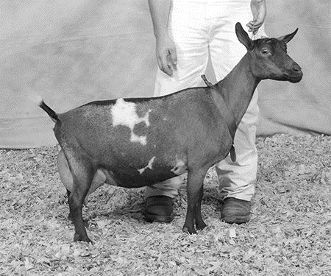
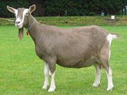
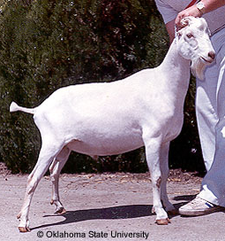
4. ________________ 5. ________________ 6. ________________

- Originated in the Alps region, a fairly large and rangy goat. _____________

- Medium-sized animal, many color combinations and developed in the US. ______________

- Much smaller than the standard dairy goat breeds, known to produce approximately 1 quart
of high fat milk per day for up to 10 months. _____________________

- Sable – Mature does must be at least _____ inches tall at the withers and weigh ______ lbs.
Mature bucks must be at least ____ inches tall at the withers and weigh ______ lbs.

11.-17. Label the Following:

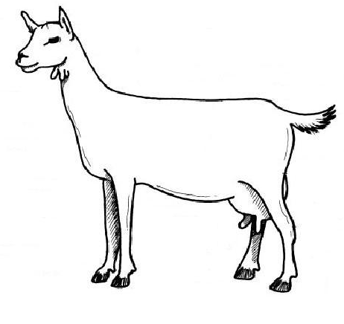

18.-23. Label the following:

