Choosing An Animal, Working Safely with Goats, and Caring for Animals

- A designated feeding area should be kept free of , , and .

- Training animals and acquainting yourself with them needs to begin when?

________________________________________________________________________________________

- Match the following Routes of Medication Administration:
____ Subcutaneous A. Administering drugs directly into the udder.
____ Intravenous B. Injections given by inserting a needle just under the skin.
____ Intramammary C. Administering of drugs through the mouth.
____ Oral D. Injections directly into the bloodstream.

- All dairy goats should be clipped approximately days prior to show.

- Dairy females are and have poor depth .

- Match the Following:
____ Doe A. Lack of difficulty in giving birth.
____ Kid B. A castrated male kid.
____ Kidding Ease C. A female goat.
____ Buck D. An intact male goat.
____ Wether E. A young goat less than 6 months of age.

- Goats were often taken on early voyages as a and source.

- You should always check with your before administering medication to your goat.
- Brother B. Stuffed Animal “Bob” C. Veterinarian

- When administering medication to your goats, it is vital to use needles
and syringes and keep bottles and bottle caps __________.

- What does “withdrawal time” refer to?
_____________________________________________________________________
_____________________________________________________________________

- Match the Following Medication Label Terms:
____ Name of Drug A. Manufacturer’s reference number to indicate
the day/batch which the product was made.
____ Storage B. Tells how the medication should be
kept while not in active use.
____ Expiration Date C. Brand or generic name of drug being prescribed.
____ Lot Number D. Tells when to discard the drug.

- This breed has been nicknamed the “Queen of the Dairy Goats” since it has the highest
milk production of all the dairy goat breeds. _______________

- _______________ diseases are illnesses that can be transmitted between humans and
animals. Examples of these diseases include Leptospirosis, Rabies, Ringworm

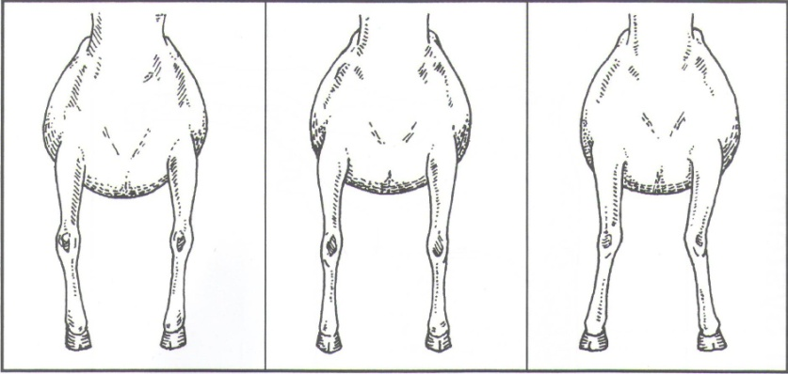
- Circle which of the below pictures represent the ideal front leg structure of a goat.

- Referring to use of the animals flight zone, answer the follow:
  - When in front of the animals shoulder, the animal moves ________________.
  - If you are behind the point of balance, the animal moves ________________.

- A castrated male goat is called.
- Caprine B. Buck C. Wether D. Kid

- Nubian does should be _______ inches tall and weigh ________ lbs.

- Nubian bucks should be _______ inches tall and weigh ________ lbs.

- When selecting a goat for show, what characteristics do you look for? ______________
______________________________________________________________________

