Answer Key

Tulips, London England, Purr, Daylight, Poinsettia, Carnivorous,
Darkness, 230, Sinus Hair, Daffodils

- Cats are ________________, which means they eat meat.

- The first cat show was in _______________ _______________ on July 13, 1871.

- Cats can see in nearly total ____________ and in total ____________.

- How many bones do cats have in their bodies? ____________.

- Cats have special sensitive hairs, called ____________________, located on their muzzle, above their eyes and on their foreleg.

- Cats are the only animals that can ________________.

- Name three decorative house plants that are poisonous to your cat.

- _____________________________

- _____________________________

- _____________________________

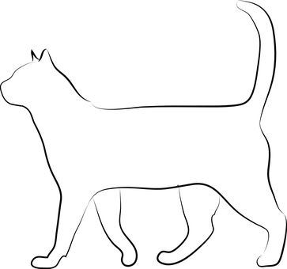

Label the body parts of a cat.

Lower Jaw Mouth
Nose Knee
Belly Metatarsals
Flank Spine
Thigh Metacarpals
Cheek Loin
Ears Phalanges

