COWS IN MY HOUSE

The following items are all made from some part or by-product of cattle. See if you can locate them.
J C S P Z M R Y S T W N S L F
P T O O A E L Y E E A V O B O
R L Y S H I E I N X L Z A N C
D D A T M K N A F T L M P T S
M D A S O E H T C I P A S T E
G E O N T P T O S L A E X N L
L H A Q O I M I D E P R Z E D
T I K L R B C G C S E C T G N
P K L S S Z B S Y S R G X R A
M E I N S U L A T I O N V E C
C K C O R T E E H S G I S T E
K M U E L O N I L N U V J E Y
C R A Y O N S E U L G A W D N
K P E R F U M E S C H H G K P
G C Z A Z E F E D G H S Y Y R

CANDLES GLUE PLASTICS
CELLOPHANE INSULATION SHAVING CREAM
COMBS LEATHER SHEET ROCK
COSMETICS LINOLEUM SOAPS
CRAYONS PAINTS TEXTILES
DETERGENT PERFUMES WALLPAPER
FILM PIANO KEYS

1. The person or business that buys primal or wholesale cuts and then processes and
packages retail cuts for the consumer is called? ___________________________

2. The person or business that processes (slaughters) and sells the carcass whole or
as primal and wholesale cuts is called? __________________________________

3. The cuts of meat that the consumer buys at the store are called? ______________

4. A grade that reflects palatability (flavor, tenderness, and juiciness) and is determined
by estimating the amount of marbling and the physiological age is called?
___________________________________________________________________

5. The loin, rib and round together account for about ________% of the carcass weight
and about _________% of the carcass value.

6. Carcass Weight x 100 = ________________________________________________
Live Weight

7. In cattle the “high priced cuts” come from where? ___________ and _____________

WHOLESALE CUTS OF BEEF
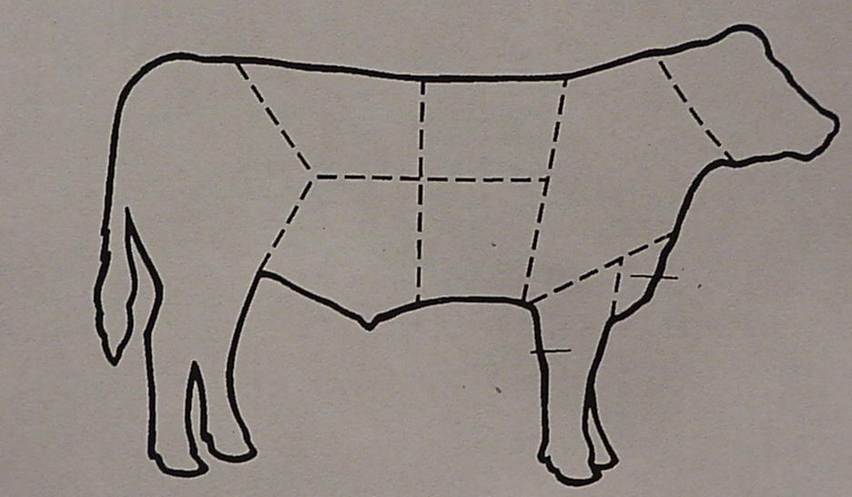

From the list below, identify the wholesale cuts of beef. Write the letter next to the cut.

A. Brisket E. Plate
B. Shank F. Flank
C. Chuck G. Loin
D. Rib H. Round

8. Beef by-products can be edible (eaten) or inedible (not eaten). Gelatins are one of the
edible by-products. List at least four uses for gelatins:

_______________________________ __________________________________

_______________________________ __________________________________

