COWS IN MY HOUSE
Match the household item with the cattle inedible by-product. You may use the by-product more than once.

_____ 1. Cosmetics A. Fat/s fatty acids and
protein meals
_____ 2. Crayons

_____ 3. Camera & Movie Film B. Hide

_____ 4. Wallpaper C. Hooves & Horns

_____ 5. Combs D. Collagen-based adhesives

_____ 6. Soaps E. Gelatin

_____ 7. Floor Wax F. Hair

_____ 8. Piano Keys

_____ 9. Pet Foods

_____ 10. Leather Sporting Goods

_____ 11. Paints

_____ 12. Emery Boards

_____ 13. Linoleum

_____ 14. Artist Brush

_____ 15. Glue

_____ 16. Bandages

_____ 17. Shoe Cream

_____ 18. Insecticides

1. The person or business that buys primal or wholesale cuts and then processes and
packages retail cuts for the consumer is called? _______________________

2. The person or business that processes (slaughters) and sells the carcass whole or
as primal and wholesale cuts is called? ______________________________

3. The cuts of meat that the consumer buys at the store are called? ___________

4. A grade that reflects palatability (flavor, tenderness, and juiciness) and is determined
by estimating the amount of marbling and the physiological age is called?
________________________________________________________________

5. The loin, rib and round together account for about ____ of the carcass weight and
About _____ of the carcass value.

6. Carcass divided by Live Weight x 100 = _________________________________

7. In cattle the “high priced cuts” come from where? ______ and ______.

WHOLESALE CUTS OF BEEF

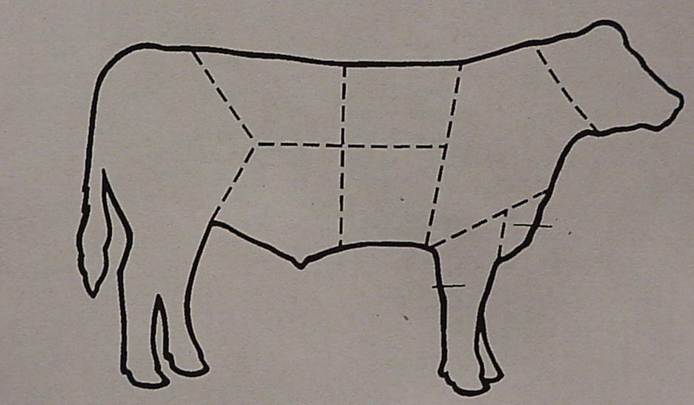

From the list below, identify the wholesale cuts of beef. Write the letter on the cut.

A. Round E. Brisket
B. Loin F. Rump
C. Rib G. Plate
D. Chuck H. Flank

